

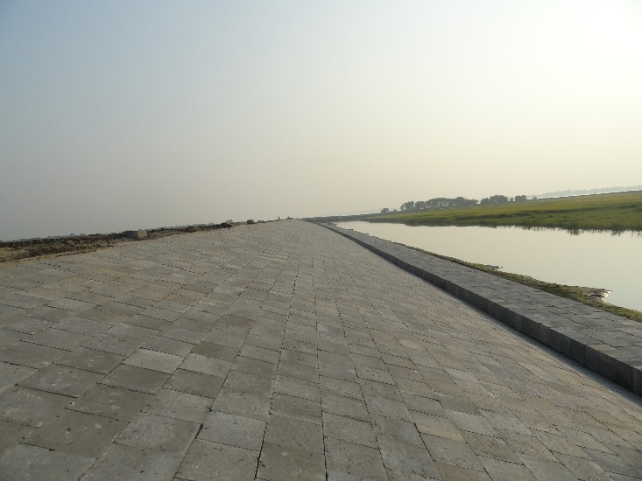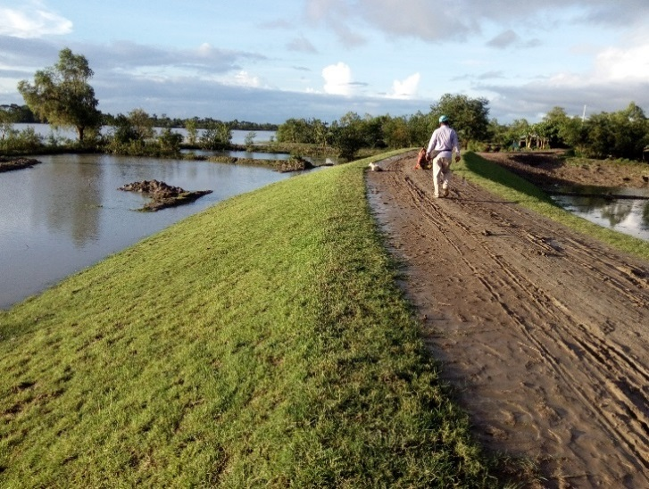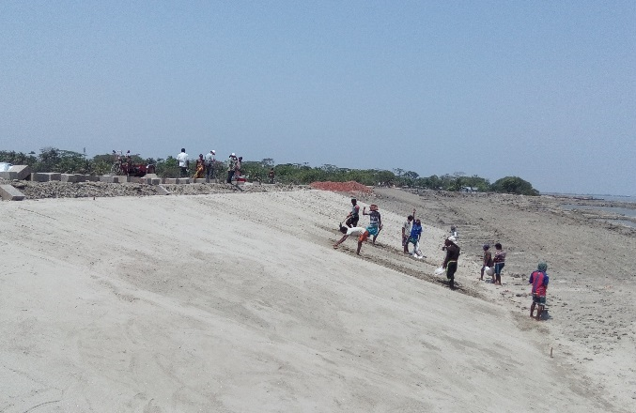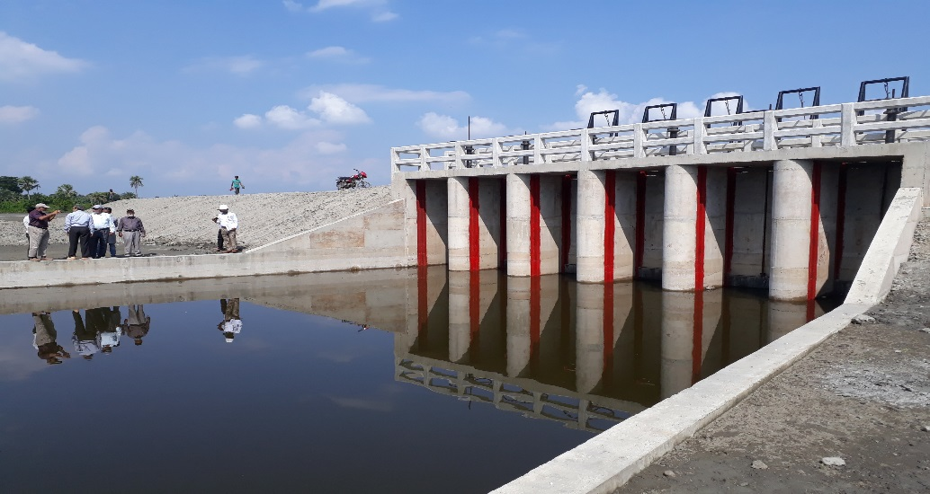

**Progress Report No. 49**

**Month of May 2019**

**Consultancy Services for Detailed Design, Construction Supervision and Project Management Support**

**Coastal Embankment Improvement Project, Phase-1 (CEIP-1)**

**Government of the People’s Republic of Bangladesh**

**Bangladesh Water Development Board (BWDB)**

Table of Contents

[Table of Contents i](#_Toc11143601)

[List of Tables iv](#_Toc11143602)

[List of Figures vi](#_Toc11143603)

[Abbreviations and Acronyms 1](#_Toc11143604)

[1. Executive Summary 4](#_Toc11143605)

[1.1 General 4](#_Toc11143606)

[1.2 Implementation of works under Package-1 and Package-2 4](#_Toc11143607)

[1.2.1 Package-1 implementation 4](#_Toc11143608)

[1.2.2 Package-2 implementation 5](#_Toc11143609)

[1.3 Other tasks of Consultants 6](#_Toc11143610)

[1.4 Key challenges and risks and recommendations 6](#_Toc11143611)

[1.4.1 Key challenges and risks 6](#_Toc11143612)

[1.4.2 Recommendations 7](#_Toc11143613)

[1.5 Action Log 7](#_Toc11143614)

[1.6 DDCS&PMS Contractual Tasks 9](#_Toc11143615)

[2. Summary of Key Achievements during the reporting month 10](#_Toc11143616)

[2.1 Package-1 10](#_Toc11143617)

[2.2 Package-2 12](#_Toc11143618)

[2.3 Package-3 14](#_Toc11143619)

[2.4 DDCS&PMS Consultancy Services 14](#_Toc11143620)

[3. Project Progress 15](#_Toc11143621)

[3.1 Task A: Review and updated the designs budding documents and related environmental and social plans (EIAs, EMPs and RAPs) already prepared 15](#_Toc11143622)

[3.1.1 Review and updated of Design of Package-1 15](#_Toc11143623)

[3.1.2 Bid Documents of Package-1 15](#_Toc11143624)

[3.1.3 RAP Implementation Package-1 15](#_Toc11143625)

[3.1.4 Status of Physical and Commercial Displacement/Relocation (Non-titled) 19](#_Toc11143626)

[3.1.7 Progress in relocation of the Titled Affected households in package-1 20](#_Toc11143627)

[3.1.8 Grievance Redress Mechanism (GRM) 24](#_Toc11143628)

[3.1.9 Consultation and Participation (Citizen Engagement) 25](#_Toc11143629)

[3.1.10 Status of Land Acquisition of Package-1 26](#_Toc11143630)

[3.1.11 Land Acquisition for Package-2 27](#_Toc11143631)

[3.1.12 Updating of RAP for Package-2 28](#_Toc11143632)

[3.1.13 Preparatory Activities 28](#_Toc11143633)

[3.1.14 Implementation RAP for Package-2 28](#_Toc11143634)

[3.1.15 Payment & Resettlement Benefits for Package-2 29](#_Toc11143635)

[3.1.16 Payment of Compensation under Law (CUL), Package-2 30](#_Toc11143636)

[3.1.17 Relocation Status of Package-2 after compensation payment of First Indent 31](#_Toc11143637)

[3.1.18 Status of Physical and Commercial Displacement/Relocation (Non-titled) 33](#_Toc11143638)

[3.1.21 Grievance Redress Mechanism (GRM) 34](#_Toc11143639)

[3.1.22 Focus Group Discussion for Package-2 35](#_Toc11143640)

[3.1.23 Distribution of Information Brochure and GRM Leaflet of Package-2 35](#_Toc11143641)

[3.1.24 Database Preparation of Package-2 35](#_Toc11143642)

[3.1.25 Formation of PAVC & GRC Committee Package-2 36](#_Toc11143643)

[3.1.26 Video Filming of Affected Properties for GRC and PRAC 36](#_Toc11143644)

[3.1.27 Devised ID number of the Non-Titled EPs 36](#_Toc11143645)

[3.1.28 Preparation of EIA 36](#_Toc11143646)

[3.2 Task B: Prepare Design, Bid Documents, EIAs, RAP, etc. for Package- 2 Polders 37](#_Toc11143647)

[3.2.1 Data processing & reviewing the shop drawings 37](#_Toc11143648)

[3.2.2 Bid Documents of Package-2 37](#_Toc11143649)

[3.2.3 Design status of Package-2 37](#_Toc11143650)

[3.2.4 Field Visit of EIA Team 38](#_Toc11143651)

[3.2.5 Monitoring of EHS Compliance 38](#_Toc11143652)

[3.2.6 Information on some environmental issues (Package-1) 40](#_Toc11143653)

[3.2.7 Noise measurement (Package-1) 41](#_Toc11143654)

[3.2.8 Information on some environmental issues (Package-2) 42](#_Toc11143655)

[3.2.9 Noise measurement (Package-2) 43](#_Toc11143656)

[3.2.10 Training report of Package-2. CEIP-1 48](#_Toc11143657)

[3.2.11 Meetings held during the month of May 48](#_Toc11143658)

[3.2.12 Progress of Mechanical Work 48](#_Toc11143659)

[3.3 Task B: Prepare Design, Bid Documents, EIAs, RAP, etc. for Package-3 Polders 49](#_Toc11143660)

[3.3.1 Design 49](#_Toc11143661)

[3.3.2 Bidding Document 50](#_Toc11143662)

[3.3.3 RAP Preparation for Package-3 50](#_Toc11143663)

[3.3.4 LAP Preparation for Package-3 50](#_Toc11143664)

[3.4 Task C: Supervise Construction & Administer Contract of Package-1 51](#_Toc11143665)

[3.4.1 Introduction 51](#_Toc11143666)

[3.4.2 Staffing 51](#_Toc11143667)

[3.4.3 Equipment Mobilization 51](#_Toc11143668)

[3.4.4 Finances of Contractor Package-1 52](#_Toc11143669)

[3.4.5 S-Curve of Package-1 53](#_Toc11143670)

[3.4.6 Physical Progress (Mile Stone Matrix) 54](#_Toc11143671)

[3.4.7 Emergency Works in Package-CEIP-1/W-01 72](#_Toc11143672)

[3.5 Task C: Supervise Construction & Administer Contract of Package-2 84](#_Toc11143673)

[3.5.1 Introduction 84](#_Toc11143674)

[3.5.2 Physical Progress (Mile Stone Matrix) 85](#_Toc11143675)

[3.5.3 Advance Payments 99](#_Toc11143676)

[3.5.4 Equipment mobilization 99](#_Toc11143677)

[3.5.5 Plans for execution of works 105](#_Toc11143678)

[3.5.6 Construction of Regional of Building at Patuakhali and others building at Kalapara and Pathorghata 106](#_Toc11143679)

[3.5.7 Emergency works in Polder-40/2, 41/1, 47/2 & 48: 106](#_Toc11143680)

[3.5.8 Finance (Invoices) Contractor Package-2 111](#_Toc11143681)

[3.5.9 Contract Modifications 111](#_Toc11143682)

[3.5.10 S-Curve of Package-2 111](#_Toc11143683)

[3.5.11 RAP implementation 113](#_Toc11143684)

[3.5.12 LAP implementation 113](#_Toc11143685)

[3.5.13 Progress on Purchase of vehicles 113](#_Toc11143686)

[3.6 Task D: Project Management Support Services 113](#_Toc11143687)

[3.6.1 Financial Projection 113](#_Toc11143688)

[3.6.2 Modification of Consultancy Contract 114](#_Toc11143689)

[3.6.3 Support to PMU 114](#_Toc11143690)

[3.7 Consultant Inputs 114](#_Toc11143691)

[3.7.1 Staffing and staff changes approved or in process during the month 114](#_Toc11143692)

[3.7.2 Monthly Forecast of Payment for Consultancy Services: 116](#_Toc11143693)

[3.7.3 Finance (Invoices) RHDHV/DDCS&PMS Consultants 117](#_Toc11143694)

[Annex 1: Updated Physical Site Works: Package-1 & 2 118](#_Toc11143695)

[Annex 3: Labour Influx Report 120](#_Toc11143696)

[Annex 3: Key Performance Indicators and Targets per PAD/DPP 132](#_Toc11143697)

List of Tables

[Table 1‑1: Action Log 7](#_Toc11143516)

[Table 3‑1: Updated numbers of Non-titled entities up to May 2019 16](#_Toc11143517)

[Table 3‑2: Polder- wise payment made by DCs Khulna & Bagerhat till May 2019 16](#_Toc11143518)

[Table 3‑3: Substantial progress report in payment of compensation under law till May 2019 17](#_Toc11143519)

[Table 3‑4: Update Relocation Status as of May 2019 19](#_Toc11143520)

[Table 3‑5: Physical displacement and Economical displacement (non-titled) of Package-1 19](#_Toc11143521)

[Table 3‑6: Relocation Status of Residence (Physical Displacement) in Package-1 19](#_Toc11143522)

[Table 3‑7: Status Relocation Status of Economical/Commercial Displacement (non-titled) 20](#_Toc11143523)

[Table 3‑8: Polder wise Number of relocated of Titled EP (Residence and Commercial Awardees) compensation under law 20](#_Toc11143524)

[Table 3‑9: Organogram of GRC 24](#_Toc11143525)

[Table 3‑10: The status of complaints/cases received and resolved by GRC 24](#_Toc11143526)

[Table 3‑11: Status of land acquisition for four Polders under Package-1 26](#_Toc11143527)

[Table 3‑12: Status of land acquisition for Package-2 27](#_Toc11143528)

[Table 3‑13: Polder-wise numbers of Entitled Persons 28](#_Toc11143529)

[Table 3‑14: Status of ID card preparation for Implementation in Package-2 28](#_Toc11143530)

[Table 3‑15: Status of up to date progress of Polder wise EP ID Cards preparation of Package-2 29](#_Toc11143531)

[Table 3‑16: Payment of Resettlement Benefit in package-2 30](#_Toc11143532)

[Table 3‑17: Polder- wise payment made by DCs Khulna & Bagerhat till May 2019. 30](#_Toc11143533)

[Table 3‑18: Status of relocation in Package 2 32](#_Toc11143534)

[Table 3‑19: Physical displacement and Economical displacement (non-titled) of Package-2 33](#_Toc11143535)

[Table 3‑20: Relocation Status of Residence (Physical Displacement) in Package-2 34](#_Toc11143536)

[Table 3‑21: Status Relocation Status of Economical/Commercial Displacement (non-titled) 34](#_Toc11143537)

[Table 3‑22: Organogram of GRC 34](#_Toc11143538)

[Table 3‑23: The status of complaints/cases received and resolved by GRC 35](#_Toc11143539)

[Table 3‑24: Status on FGDs as of May 2019 35](#_Toc11143540)

[Table 3‑25: Status of up to date progress of PAVC activities of Package-2 36](#_Toc11143541)

[Table 3‑26: Status of Design for Package-2 37](#_Toc11143542)

[Table 3‑27: Information for the month of May, 2019 40](#_Toc11143543)

[Table 3‑28: Pankhali Automatic CC Block Manufacturing Plant [1] 41](#_Toc11143544)

[Table 3‑29: Tafalbari Automatic CC Block Manufacturing Plant 41](#_Toc11143545)

[Table 3‑30: Daratana Automatic CC Block Manufacturing Plant 42](#_Toc11143546)

[Table 3‑31: Various environment related information/data 42](#_Toc11143547)

[Table 3‑32: Noise level in Polder 39/2C-1 43](#_Toc11143548)

[Table 3‑33: Noise level in Polder 39/2C-2 44](#_Toc11143549)

[Table 3‑34: Noise level in Polder 40/2 45](#_Toc11143550)

[Table 3‑35: Noise level in Polder 41/1 45](#_Toc11143551)

[Table 3‑36: Noise level in Polder 43/2C 46](#_Toc11143552)

[Table 3‑37: Noise level in Polder 47/2 47](#_Toc11143553)

[Table 3‑38: Noise level in Polder 48 47](#_Toc11143554)

[Table 3‑39: Month-wise number of workers, who have been imparted training on EHS issues 48](#_Toc11143555)

[Table 3‑40: Status of Design for Package-3 49](#_Toc11143556)

[Table 3‑41: Update Status of Package-3 50](#_Toc11143557)

[Table 3‑42: List of Polder-wise Manpower Deployed to Site of Package-1 51](#_Toc11143558)

[Table 3‑43: List of Equipment 51](#_Toc11143559)

[Table 3‑44: Monthly Forecast of Payment for Package-W/-01 is furnished below 52](#_Toc11143560)

[Table 3‑45: Physical Works of Package-1 as on 31 May 2019 54](#_Toc11143561)

[Table 3‑46: Physical Works Polder Wise of Package-1 as on 31 May 2019 55](#_Toc11143562)

[Table 3‑47: Detailed information of Construction Status of Embankment of Package-1 56](#_Toc11143563)

[Table 3‑48: Detailed information of Construction Status of Drainage Channel of Package-1 60](#_Toc11143564)

[Table 3‑49: Detailed information of Construction Status of Drainage Sluices of Package-1 61](#_Toc11143565)

[Table 3‑50: Detailed Information of Construction Status of Flushing Sluices of Package-1 62](#_Toc11143566)

[Table 3‑51: Detailed Information of Repair of Drainage & Flushing Sluices of Package-1 63](#_Toc11143567)

[Table 3‑52: Detailed Information of Slope Protection Works of Package-1 64](#_Toc11143568)

[Table 3‑53: Detailed Information of Bank Protection Works of Package-1 65](#_Toc11143569)

[Table 3‑54: Detailed Information of Construction of Closure Dam of Package-1 65](#_Toc11143570)

[Table 3‑55: Progress as on May 2019 68](#_Toc11143571)

[Table 3‑56: CC Blocks Production as on May 2019 69](#_Toc11143572)

[Table 3‑57: Information of Repair of Flushing Sluices and Drainage Sluices 71](#_Toc11143573)

[Table 3‑58: List of Flushing Sluices Dropped from the repairing Program 72](#_Toc11143574)

[Table 3‑59: Summary of Emergency works under the head of “Environmental Mitigation Works” 72](#_Toc11143575)

[Table 3‑60: Summary of Emergency works under the head of “Physical & Price Contingency” 73](#_Toc11143576)

[Table 3‑61: Details of Emergency Works under the head of “Environmental Mitigation Works” 74](#_Toc11143577)

[Table 3‑62: Detailed of Emergency Works under the head of “Physical & Price Contingencies” 77](#_Toc11143578)

[Table 3‑63: Physical Works of Package-2 as on 31 May 2019 85](#_Toc11143579)

[Table 3‑64: Detailed Information Polder Wise for Package-2 86](#_Toc11143580)

[Table 3‑65: Detailed Information of Construction of Embankment for Package-2 87](#_Toc11143581)

[Table 3‑66: Detailed Information of Construction of Drainage Channel for Package-2 91](#_Toc11143582)

[Table 3‑67: Detailed Information of Construction Status of Drainage Sluice for Package-2 92](#_Toc11143583)

[Table 3‑68: Detailed Information of Construction Status of Flushing Sluice for Package-2 93](#_Toc11143584)

[Table 3‑69: Detailed Information of Repair of Drainage & Flushing Sluice for Package-2 94](#_Toc11143585)

[Table 3‑70: Detailed Information Slope Protection Work for Package-2 95](#_Toc11143586)

[Table 3‑71: Detailed Information Bank Protection Work for Package-2 95](#_Toc11143587)

[Table 3‑72: Detailed Information Construction of Closure Dam for Package-2 95](#_Toc11143588)

[Table 3‑73: Progress of Package-2 as on May 2019 98](#_Toc11143589)

[Table 3‑74: CC Blocks Production as on May 2019 99](#_Toc11143590)

[Table 3‑75: Contractor Staffs available in Package-2 99](#_Toc11143591)

[Table 3‑76: Mobilisation List of Equipment for Package-2 100](#_Toc11143592)

[Table 3‑77: Summary of Emergency works under the head of “Environmental Mitigation Works” 107](#_Toc11143593)

[Table 3‑78: Summary of Emergency works under the head of “Physical & Price Contingency” 108](#_Toc11143594)

[Table 3‑79: Detailed of Emergency Works under the head of “Provisional Sum” 109](#_Toc11143595)

[Table 3‑80: Detailed of Emergency Works under the head of “Physical & Price Contingency” 110](#_Toc11143596)

[Table 3‑81: Tentative forecast of Payment of Package-2 113](#_Toc11143597)

[Table 3‑82: Overview of Staffing (including Proposed Replacements) 114](#_Toc11143598)

[Table 3‑83: Tentative information on financial of payment for DDCS & PMS Consultants 116](#_Toc11143599)

[Table 3‑84: Overview of Consultants Invoices since Project Inception 117](#_Toc11143600)

List of Figures

[Figure 3‑1: FGD in Polder 32 at Starkhali 17](#_Toc11143437)

[Figure 3‑2: FGD in Polder 33 at Chunkuri 17](#_Toc11143438)

[Figure 3‑3: FGD at Rajoir in Polder 35/1 18](#_Toc11143439)

[Figure 3‑4: FGD at Rajapur in Polder 35/1 18](#_Toc11143440)

[Figure 3‑5: FGD by LAP/RAP team for payment of CUL by DC, Khulna for Polder-32 & 33 18](#_Toc11143441)

[Figure 3‑6: FGD by LAP/RAP team for payment of CUL by DC, Bagerhat for Polder-35/1 & 35/3 18](#_Toc11143442)

[Figure 3‑7: HH 187 Before relocation of Polder-35/1 20](#_Toc11143443)

[Figure 3‑8: HH 187 After relocation of Polder-35/1 20](#_Toc11143444)

[Figure 3‑9: HH 367 Before relocation of Polder-32 21](#_Toc11143445)

[Figure 3‑10: HH367 After relocation of Polder-32 21](#_Toc11143446)

[Figure 3‑11: HH 189 Before relocation of Polder-35/1 21](#_Toc11143447)

[Figure 3‑12: HH 189 After relocation of Polder-35/1 21](#_Toc11143448)

[Figure 3‑13: Before Relocation HH 193 in Polder 35/1 21](#_Toc11143449)

[Figure 3‑14: After relocation HH 193 in Polder 35/1 21](#_Toc11143450)

[Figure 3‑15: Group Relocation site: Meeting at CEIP Village, Uttar Kamarkhola under Polder-32 22](#_Toc11143451)

[Figure 3‑16: Group Relocation site: Chunkuri (Dangapara) CEIP-1 Resettlement Village under Polder-33 22](#_Toc11143452)

[Figure 3‑17: Group Relocation site at Jhilbunia of polder 35/1 22](#_Toc11143453)

[Figure 3‑18: Group Relocation site at khontakata of polder 35/1 22](#_Toc11143454)

[Figure 3‑19: Relocation site at Mollikerber Madrasha Bazar in Polder-35/3 23](#_Toc11143455)

[Figure 3‑20: Market Relocation for Joynagar Bazar at Polder 32 23](#_Toc11143456)

[Figure 3‑21: Market Relocation for Anando Bazar, Razapur at Polder 35/1 24](#_Toc11143457)

[Figure 3‑22: Two different Group relocation sites of Pochim Kuakata of Polder 48 32](#_Toc11143458)

[Figure 3‑23: Khajura village Group relocation of Polder-48 32](#_Toc11143459)

[Figure 3‑24: Another group of relocation of Pochim Kuakata of Polder 48 32](#_Toc11143460)

[Figure 3‑25: HH 226 before relocation in Polder-41/1 33](#_Toc11143461)

[Figure 3‑26: HH 226 after relocation in Polder-41/1 33](#_Toc11143462)

[Figure 3‑27: HH 226 before relocation in Polder-41/1 33](#_Toc11143463)

[Figure 3‑28: HH 226 after relocation in Polder-41/1 33](#_Toc11143464)

[Figure 3‑29: Graphical Presentation of List of Equipment Contractor of Package-1 52](#_Toc11143465)

[Figure 3‑30: S-Curve of Package-1 53](#_Toc11143466)

[Figure 3‑31: Construction/Re-sectioning of Embankment of Package-1 66](#_Toc11143467)

[Figure 3‑32: Drainage Channel of Package-1 66](#_Toc11143468)

[Figure 3‑33: Construction of Drainage Sluices of Package-1 66](#_Toc11143469)

[Figure 3‑34: Construction of Flushing Sluice of Package-1 67](#_Toc11143470)

[Figure 3‑35: Construction of Slope Protection of Package-1 67](#_Toc11143471)

[Figure 3‑36: Construction of Bank Protection of Package-1 67](#_Toc11143472)

[Figure 3‑37: CC Blocks Production of Package-1 68](#_Toc11143473)

[Figure 3‑38: Graphical Presentation of CC Block Production for Package-1 69](#_Toc11143474)

[Figure 3‑39: DS-4 of Polder-33 69](#_Toc11143475)

[Figure 3‑40: DS-7 of Polder-33 69](#_Toc11143476)

[Figure 3‑41: DS-13 of Polder-33 70](#_Toc11143477)

[Figure 3‑42: DS-9 of Polder-33 70](#_Toc11143478)

[Figure 3‑43: DS-10 of Polder-33 70](#_Toc11143479)

[Figure 3‑44: DS-12 of Polder-33 70](#_Toc11143480)

[Figure 3‑45: FS-17 of Polder-33 70](#_Toc11143481)

[Figure 3‑46: DS-5 of Polder-35/1 70](#_Toc11143482)

[Figure 3‑47: DS-6 of Polder-35/1 71](#_Toc11143483)

[Figure 3‑48: FS-2 of Polder-35/1 71](#_Toc11143484)

[Figure 3‑49: FS-13 of Polder-35/1 71](#_Toc11143485)

[Figure 3‑50: DS-1 of Polder-35/3 71](#_Toc11143486)

[Figure 3‑51: DS-3 of Polder-35/3 71](#_Toc11143487)

[Figure 3‑52: FS-2 of Polder-32 71](#_Toc11143488)

[Figure 3‑53: Construction / Re-sectioning of Embankment of Package-2 96](#_Toc11143489)

[Figure 3‑54: Construction of Drainage Channel of Package-2 96](#_Toc11143490)

[Figure 3‑55: Construction of Drainage Sluice of Package-2 96](#_Toc11143491)

[Figure 3‑56: Construction of Flushing Sluice of Package-2 97](#_Toc11143492)

[Figure 3‑57: Construction of Slope Protection of Package-2 97](#_Toc11143493)

[Figure 3‑58: Construction of River Bank Protection of Package-2 97](#_Toc11143494)

[Figure 3‑59: CC Blocks Production of Package-2 98](#_Toc11143495)

[Figure 3‑60: CC Blocks dumping for slope protection work (KM51+041-53+418) in Polder 39/2C 101](#_Toc11143496)

[Figure 3‑61: *Manufactured CC Blocks piled at the permanent storing yard #A2 in Polder 39/2C* 101](#_Toc11143497)

[Figure 3‑62: *Completed section of slope protection work (KM51+041-53+418) in Polder 39/2C* 101](#_Toc11143498)

[Figure 3‑63: *Form dismantling for slope protection work of DS-02 in Polder 40/2* 101](#_Toc11143499)

[Figure 3‑64: *Form work for end sill of DS-05 in Polder 40/2* 102](#_Toc11143500)

[Figure 3‑65: *CC Blocks manufacturing at yard #2 (KM13+000) in Polder 41/1* 102](#_Toc11143501)

[Figure 3‑66: Excavation / Re-sectioning for drainage channel of DS-04 (KM0+000-0+260) in Polder 41/1 102](#_Toc11143502)

[Figure 3‑67: *Repairing for FS-02 in Polder 41/1* 102](#_Toc11143503)

[Figure 3‑68: *Earth work for embankment KM0+900-1+300 in Polder 43/2C* 102](#_Toc11143504)

[Figure 3‑69: *Excavation / Re-sectioning for drainage channel of DS-07 (KM0+000-2+440) in Polder 43/2C* 102](#_Toc11143505)

[Figure 3‑70: *RCC for floor (R/S) of DS-07 in Polder 43/2C* 103](#_Toc11143506)

[Figure 3‑71: *Excavation / Re-sectioning for drainage channel of DS-03 in Polder 47/2* 103](#_Toc11143507)

[Figure 3‑72: CC Blocks placing for loose apron (C/S) & slope of DS-01 in Polder 47/2 104](#_Toc11143508)

[Figure 3‑73: *CC Blocks manufacturing at yard #1 (KM7+000) in Polder 47/2* 104](#_Toc11143509)

[Figure 3‑74: *Discuss with EPs in chainage km 44+000 to km 44+500* 104](#_Toc11143510)

[Figure 3‑75: *Back filling for DS-01 in Polder 48* 104](#_Toc11143511)

[Figure 3‑76: *Earth work for embankment KM16+134-17+000 in Polder 48* 104](#_Toc11143512)

[Figure 3‑77: *Synthetic bags placing for emergency slope protection work 31+280-31+408 in Polder 48* 104](#_Toc11143513)

[Figure 3‑78: Emergency Work of Polder-48 107](#_Toc11143514)

[Figure 3‑79: S-Curve for Package-2 112](#_Toc11143515)

Abbreviations and Acronyms

ARIPO Acquisition and Requisition of Immovable Property Ordinance

BADC Bangladesh Agriculture Development Corporation

BARI Bangladesh Agriculture Research Institute

BBS Bangladesh Bureau of Statistics

BIWTA Bangladesh Inland Water Transport Authority

BoQ Bill of Quantities

BRRI Bangladesh Rice Research Institute

BTM Bangladesh Transverse Mercator

BWDB Bangladesh Water Development Board

BM Bench Mark

CC Climate Change or Cement Concrete (no re-bar, e.g. CC blocks)

CCL Cash Compensation under Law

CDPo Coastal Development Policy

CDMP Comprehensive Disaster Management Program

CDS Coastal Development Strategy

CDSP Char Development and Settlement Project

CEGIS Centre for Environmental and Geographic Information Services

CEIP-1 Coastal Embankment Improvement Project – Phase 1

CEP Coastal Embankment Project

CERP Coastal Embankment Rehabilitation Project

CES Coastal Embankment System

CPP-I Cyclone Protection Project - I

CPP-II Cyclone Protection Project - II

CZE Coastal Zone Embankment

CZPo Coastal Zone Policy

CZWMP Coastal Zone Water Management Program

CSPS Cyclone Shelter Preparatory Study

DAE Department of Agriculture Extension

DC Deputy Commissioner

DDCS&PMS Detailed Design Construction Supervision and Project Management Support (RHDHV)

DEM Digital Elevation Model

DevCon DevConsultants Ltd. Bangladesh Consultants

DHI Danish Hydraulic Institute, Denmark

DLR Director Land Records

DoE Department of Environment

DoF Department of Fisheries

DPM Design Planning & Management Consultants

EAP Environmental Action Plan

ECRRP Emergency Cyclone Recovery and Restoration Project

EDP Estuary Development Program

EHS Environmental Health and Safety

EIA Environmental Impact Assessment

EMA External Monitoring Agency

EMP Environmental Management Plan

EPG Embankment Protection Group

EPs Entitled Persons

ES Embankment Settlers

FAP-7 Flood Action Plan -7

FCDI Flood Control Drainage & Irrigation

FGD Focus Group Discussion

FFG Foreshore Forestry Group

GoB Government of Bangladesh

GPP Guidelines for People's Participation

GPS Global Positioning System

GRM Grievances Redress Mechanism

GRRP Gorai River Restoration Project

IBRD International Bank for Reconstruction & Development

ICB International Competitive Bidding

ICZM Integrated Coastal Zone Management

ICZMP Integrated Coastal Zone Management Plan

ICZMP Integrated Coastal Zone Management Program

IDA International Development Agency

IESCs Important Environmental and Social Components

IoL Inventory of Losses

IPC Interim Payment Certificate (invoice of Contractor)

IPSWAM Integrated Planning for Sustainable Water Management

IWM Institute of Water Modelling

IEE Initial Environmental Examination

KJDRP Khulna Jessore Drainage Rehabilitation Project

KAFCO Karnaphuli Fertilizer Company Limited

LAP Land Acquisition Plan

M&EC Monitoring and Evaluation Consultants (Third Party Consultants)

MES Meghna Estuary Studies

MOEF Ministry of Environment and Forest

MOFDF Ministry of Food and Disaster Management

MOWR Ministry of Water Resources

MSL Mean Sea Level (expressed in + or – mPWD)

NEPo National Environmental Policy

NGO Non-Government Organization

NWMP National Water Management Plan

RAP Resettlement Action Plan

PAP Project Affected People

PAVC Property Assessment and Valuation Committee

PBM Permanent Bench Mark

PDC Polder Development Committee

PMU Project Management Unit

PWD Public Works Department (e.g. + 3 mPWD)

RHDHV Royal HaskoningDHV (The Engineer, DDCS&PMS Consultants)

RAP Resettlement Action Plan

RoR Record of Rights

SIA Social Impact Assessment

SLR Sea Level Rise

SMRPFW Social Management and Resettlement Policy Framework

SRP System Rehabilitation Project

SWZ South Western Zone

SZ Southern Zone

SoB Survey of Bangladesh

TRM Tidal River Management

TBM Temporary Bench Mark

ToR Terms of Reference

WARPO Water Resources Planning Organization

WB World Bank

WMA Water Management Association

WMIP Water Management Improvement Project

WSIP Water Sector Improvement Project

WUA Water Users Association

# Executive Summary

## General

The Monthly Progress Report (MPR) is over the month of May 2019. The Executive Summary Chapter will highlight the various developments and issues at stake in a qualitative manner whereas the remaining Chapters will provide more quantitively information and details on the activities and progress of the Month of May, 2019.

The Executive Summary will also first focus on the implementation of the 2 (two) construction Contracts for **Package-1** and **Package-2**. In this section, the Consultants activities are also addressed. Activities and issues of a more general nature will be addressed thereafter.

This Executive Summary includes an Action Log which will be updated where relevant.

## Implementation of works under Package-1 and Package-2

In the current phase of the CEIP-1 Project, our focus is on the progress of the construction works for Package-1 and Package-2. Other Consultants tasks are summarised separately in this Chapter.

### **Package-1 implementation**

The key issues for the month of May 2019 regarding Package-1 are summarised below as follows:

1. The physical progress up to May 2019 is 75.20% against the target of 81.45%.
2. Based on this we have determined that the actual progress is lagging than the revised target (81.45%) by 6.25%. Hence the Contractor will be requested to explain the reasons of failures to achieve the target progress and simultaneously pursued to complete the Works within the revised time for Completion. In May 2018, the Contractor submitted his official claim for Extension of Time based on the following:
3. Delays due to late award of Contract on **01 November 2015;**
4. Extension of time due to delays in handing over the land and possession of Site;
5. Extension of time due to various disruptions to the planned progress of the Works, and
6. Extension of time due to variations for increase in Quantities/Volumes.
7. The Extension of Time has been approved up to 30 June 2020 by the Employer vide Memo No. CEIP-1/W-01/331 dated: 18-03-2019 with the condition that no further claim will be acceptable due to this Extension of Time.
8. Contractor has completed 32 Nos. Drainage Sluices and 20 Nos. Flushing Sluices and has been working together with the Engineer on the handing over procedures.
9. Following the Mission of the Environmental Team of the World Bank, follow-up has been given to areas of improvement and continued in the month of May 2019 also. The Contractor is involved in undertaking various steps required for improving the EHS issues through the training and motivation of Environment Specialists of the Project in the light as desired by the World Bank’s Environmental Specialist during their field visits Engineer is pushing Contractor doing so and this has resulted in improvements in May 2019.
10. Meetings between Contractor and Engineer were held regarding the construction of the Nalian Closure Dam. Based on discussion, the Contractor submitted a preliminary design and drawing as per contract clause no. 2.4.2 for construction of Nalian Closure Dam. The preliminary design and drawings were reviewed by the Consultant’s expert and provided his comments & suggestions on these for reviewing and finalization by the contractor. The comments & suggestions of the consultants were communicated to the Contractor. The Contractor prepared the design based on the review of the expert and several discussion meetings were held between the Contractor and Engineer to finalize the design & drawings. After long discussion, the Engineer finally described to the Contractor regarding the work methodology based on the detailed briefing of the designer of the Contractor and requested to prepare the design and drawings accordingly. Finally, the Contractor has prepared the design and drawings and submitted to the Consultants. After reviewing the design and drawings the Consultant has approved it and requested to start the work immediately. However, the Contractor has mobilized and started the work and by 31 May 2019 they have dumped about 997,697 (nine lacs ninety seven thousand six hundred ninety seven) sand fill synthetic bags to prepare the foundation of the closure. However, the progress of Nalian closure is more or less same as per revised program.
11. Replacement of hard rock by CC blocks has been agreed upon in Variation Order no. 2. and materialised. An updated Variation Order no.2 was submitted with some corrections based on comments received from the World Bank but that has been again corrected as per advice of the Project Director keeping the saving amount under head “Temporary Saving” and submitted to the PMU. The approval of the Variation Order No.2 has not yet been received by the Engineer.
12. The installation of gates and hoists in 19 sluices have been completed and the remaining 19 nos. are in a boost stage of completion and will speed up the expenditures and consequently the disbursements in the coming months. Corrective action is executed on some of the sluices to install support brackets with replacement of shafts (incorrectly fabricated by contractor) and reduce the diameter of the swivel wheel. Revised design and drawings have been prepared for the drainage sluices of different Polders which has already been approved by the concerned Design Office of BWDB. Work order for Fabrication and Installation of Gates and Hoists, based on revised design, was issued to the contractor immediately after getting approval of the revised design.
13. Contractor is claiming a Variation Order No.3 for the payment of additional costs for using of higher FM of Sand for filling the foundation of hydraulic structure as per approved design. The draft Variation Order has been reviewed by the PMU and suggested to compare the determinate rate of the Engineer with the schedule rate of Khulna O & M Circle. The Variation Order No.3 has been submitted to PMU on 25 February 2019.Some observations were made on the Variation Order No.3 by the World Bank and Consultant’s related part of those have been met up and the revised version of the Variation Order No.3 has been submitted to PMU on 24thApril 2019.The approval of the Variation Order No.3 has not yet been received by the Engineer.
14. In the contract, there was provision for repairing works of 30 nos. Flushing Sluices out of which 16 nos. have been dropped (for falling the structures outside the alignment of retired embankment or not repairable) and out of the rest 14 nos. 6 nos. have been completed, 7 nos. are in progress There is provision for repairing works of 2 nos. Drainage Sluices which are in progress and will be completed by June 2019.

### **Package-2 implementation**

The key issues for the month of May 2019 regarding Package-2 are summarised below as follows:

1. The physical progress up to May 2019 is 25.93% against the target of 48.44%.
2. The Contractor failed to achieve the targets progress set for FY 2017-2018 for poor progress of timely availability of materials but that is now (almost) solved; local resources (including labour) are controlled by local parties and Contractor is therefore limited to import resource’s including labour from other polders or suppliers.
3. However, the present performance of the Contractor in this dry season is not yet satisfactory also. Meetings with higher Management of Contractor were held and an action plan was prepared, however, follow-up is lacking, and Engineer is pushing the Contractor to accelerate the progress.
4. As per World Bank Mission during 21 October to 25 October, 2018 on environmental aspects of the CEIP-1 Project, the Contractor is involved in undertaking various steps required for improving the EHS issues through the training and motivation of Environment Specialists of the Project in the light as desired by the World Bank’s Environmental Specialist during their field visit.

The Engineer discussed with Contractor about the work program for the FY 2018-19. They were advised to prepare an accelerated work program in such a way that the lapses of the progress of last FY can be coped up in this FY. According to advice, the Contractor submitted the accelerated work program which has been reviewed by the Consultants and submitted to PMU. However, as per revised program there was target to complete 48.44% of the Physical Work by May, 2019 but the actual progress is lagging by 22.51%. Hence the Contractor will be requested to explain the reasons of failures to achieve the target progress as per revised program and simultaneously pushed strongly to catch up the revised target.

## Other tasks of Consultants

The key issues for the month of May 2019 regarding the other tasks of Consultants are summarised below:

1. The Draft Final Reports of EIA/EMP for all 7 Polders under Package-3 have been finalized and submitted to PMU. The PMU submitted the reports to the WB for their review.
2. The RAP of Package-2 was prepared based on LAP & also approved by the World Bank. But due to updating of LAP the area of land has been increased based on which RAP has been updated. After review by the PMU, RAP was sent to the World Bank. The World Bank Provided some observations on the RAP and those were met and resubmitted to the World Bank. The World Bank has approved the RAP after receiving the satisfactory responses of the observations.
3. The Consultant supported the PMU with the missions and meetings of the World Bank delegations to the Project including site visits and various reports and recommendations.

## Key challenges and risks and recommendations

### **Key challenges and risks**

Key challenges and risks are listed below:

1. The weather conditions in May 2019 were favourable for construction of civil works.
2. Risks related to the site situations not being available remains valid for May 2019; all stakeholders, being the Client, Client’s regional offices, DC’s, Contractor and Consultants, are doing their utmost efforts to organise this in a practical and pragmatic manner. It is Consultants view that progress is being made in the joint efforts in the interest of the CEIP-1 Project. This is an area which requires continued highest attention of all concerned;
3. The World Bank modified FIDIC Contracts which are in place stipulate specific deadlines in terms of modifications, possible claims and variations. Where it concerns approvals from higher levels within the BWDB, procedures should streamline to avoid undesirable claims from Contractors. This was noted in May 2018 and has yet to be made clear and was also discussed in above mentioned FIDIC training for follow-up actions. The division of (the FIDIC-like) roles between the Employer – Engineer – Contractor is not clear in practice and a point of concern.
4. Although a Modified Contract No. 2 for Consultancy Services was signed in the beginning of last year, Consultants envisage that further optimisation is urgently required to cope with the dynamics of the CEIP-1 Project to safeguard the liabilities of the Client and the Consultant. The Man months for some critical experts will be depleted soon, while the construction supervision team needs extension of at least 1.5 years for continuation of the services. As the contract variation is not possible without revision of DPP, the Consultant proposed a budget neutral adjustment (modified Contract No. 3). Several times discussions were made with PD regarding Budget Neutral Modified Contract No-3 and the last discussion was done on 20.05.2019 at the PMU office chaired by PD. A detailed discussion was done and PD gave some observations on the submitted proposed Budget Neutral Modified Contract No-3 and advice to submit the proposed Budget Neutral Modified Contract No-3 after proper revision as discussed. The proposed Budget Neutral Modified Contract No-3 has under revision at present. By this time a few numbers of senior consultants both in the field and in the Head, Quarter have already been exhausted but for the interest of the services they are still working with the financial support from the Head Quarter Over Head of the Consultancy Firm. However, the proposal for Budget Neutral Modified Contract No.3 needs to be approved as soon as possible.

### **Recommendations**

The following recommendations are made:

1. When there would be a land availability issue, joint efforts of Contractors, Engineer and Employer should be enhanced to solve issues at stake. It is recommended that the Employer plays a visible role here and increased efforts should continue; less reporting and more resolving on the spot;
2. Modified Contract No. 3 needs immediate approval by the competent authority for smooth continuation of the services.

## Action Log

In Table 1‑1 below an action log is introduced to monitor actions required to be taken forward in the interest of the CEIP-1 Project. It will be updated monthly, and actions fulfilled will be deleted.

Table 1‑1: Action Log

| **Action No.** | **Description of action** | **By when** | **By whom** | **Done by and can be deleted from this Action Log next month** | | **Remarks** |
| --- | --- | --- | --- | --- | --- | --- |
| **Date** | **Done** |
| Nov17-001 | PMU-World Bank Environmental actions agreed upon on 23rd November 2017 | Continuous | Consultants | Continuous | mostly | Consultant’s report improvements done, Contractor achieved most of the requirements, EHS improvement is continued |
| Nov17-003 | Revised Work Plan including methodology and resource planning. | 30-11-17 | Contractor |  | Partly | * Contractor Package-1 has submitted a draft work program based on Claim No. 2 for Extension as per recommendation given by the consultants and the submitted work program has been reviewed and sent to PMU. Extension of time upto 30 June 2020 has been approved by the competent authority. Hence it may be considered that the submitted work has also been approved. * Contractor Package-2 has submitted an accelerated revised work program which has been reviewed by the consultants and sent to PMU. |
| Nov17-006 | Payment in connection to land availability and instructing DC’s accordingly. | 31-12-2017 | CEIP-1 PMU, |  | Partly | This is progressing but need acceleration. |
| Dec17-002 | Agree with Contractor Package-1 on claim for extension and increase of cost. | 09-04-2018 | Contractor and Engineer |  |  | The extension of time up to June 2020 is recommended by the Consultants with judicious justifications and sent to PMU. As per instruction of the Project Director the Contractor is requested to submit the Application for Extension of Intended Completion Date, in specified Proforma, duly filled in. However, the contractor submitted the proforma filled in without waiving his right for claiming additional costs. The Extension of Time has been approved upto 30 June 2020 by the Employer vide Memo No. CEIP-1/W-01/331 dated: 18-03-2019 with the condition that no further claim will be acceptable due to this Extension of Time. |
| Dec17-003 | Prepare workshop on innovative design approaches adopted for CEIP-1 Project, | 31-01-2018 | Consultants | May 27, 2015 | Done | The Workshop for new design approaches for CEIP-1 was organized in 27 May 2015.Hence the action as asked for may be deleted. |
| Jan18-001 | Advise Contractors to involve international experts in various fields. | 28-02-2018 | Engineer |  |  | Contractor Package-1 has involved international experts; Contractor Package-2 is gradually involving international experts. |
| Jan18-002 | Take measures to further increase progress of works Package-1 | 20-02-2018 | Contractor and Engineer |  |  | The Contractor has submitted a draft work program following the recommended extension of time up to June 2020 and the same has been reviewed by the Engineer and sent to PMU. |
| Jan18-003 | Take measures to further increase progress of works Package-2 | 20-02-2018 | Contractor and Engineer |  |  | Meetings with higher Management of Contractor were held and an action plan is being prepared, however, follow-up is lacking, and Engineer is pushing the Contractor. The Contractor has submitted an accelerated work program which has been reviewed and sent to PMU. |
| Feb2018-001 | Follow-up Environmental Mission World Bank February 2018 | 1-05-2018 | Consultants |  |  | Ongoing |
| Mar2018-003 | Prepare guiding document for accelerating work for Package-1 and Package-2 during monsoon | 15-04-2018 | Engineer |  |  | This action was implemented during the regular meetings on work progress and for preparing the updated work programs for the fiscal year 2018-2019 |
|  | Submission of Contractor’s Monthly Work Program with detail resources allocation |  | Engineer |  |  | This action is impossible to execute as the monthly program is depending on many factors in terms resource allocation. |

## DDCS&PMS Contractual Tasks

The specific objectives of the CEIP-1 Consultancy Services are described by the following tasks:

|  |  |  |
| --- | --- | --- |
| Task A | : | Review and update the designs bidding documents and related environmental and social plans (EIAs, EMPs, and RAPs) already prepared; |
| Task B | : | Prepare detailed designs for all remaining polders and works that would be included in the project, including the Engineering and Environment and Social studies (i.e. preparation of EIA, EMP and RAP for each remaining polders); |
| Task C | : | Supervise construction of all works under the Project, and do the contract management as “The Engineer”, according to FIDIC rules and regulations and the World Bank Guidelines and its standard bidding documents; |
| Task D | : | Provide overall project management support to the BWDB and Project Management Unit (PMU). |
| The construction works will be executed by BWDB as **Employer** and the Consultant will function as the **Engineer** of the civil works contracts. The Consultant will administer the civil works contracts and ensure that the project works are implemented in accordance with the provision of the contracts. The Consultant will be required to nominate an engineer’s representative for a group of Polders under each contract who will be a full-time resident in the area encompassing the designated Polders. | | |

# Summary of Key Achievements during the reporting month

## Package-1

| **No.** | **Item** | **Key Achievements during the month – Package-1** |
| --- | --- | --- |
| 1 | Modelling | Not applicable |
| 2 | Surveys and Design | Several designs prepared and implementation of some Emergency Works have been completed and protected the Polder area from saline water intrusion and some Emergency Works are in progress. |
| 3 | Works | * Construction / Re-Sectioning of Embankment: 0.72 Km (Full) & 51.826 Km (Part) * Excavation / Re-Excavation of Drainage Channel: 23.49 Km * Construction of Drainage Sluice: 2 no. (Full) & 6 nos. (Part) * Repair of Drainage Sluice: 0 no. (Full) & 02 nos. (Part) * Construction of Flushing Inlet:0 nos. (Full) & 09 nos. (Part) * Repair of Flushing Inlet: 2 nos. (Full) & 07 nos. (Part) * Embankment Slope Protection Works: -0.251 Km * River Bank Protection Works: 0.10 Km * Nalian Closure Dam: Foundation work 63% completed. |
| 4 | Contractor Resources | Updated by Contractor Package-1 in terms of labour and equipment. |
| 5 | RAP and status of resettlement Payment | * 6,127 entities (residential HHs, commercial premises and common property structures) were identified during updating of Inventory of Losses (IoL) in March-May 2015 of whom 820 on private land (titled) and 4,633 on government land non-titled EPs (Squatters) and among 4,633 EPs, 448 tenants and 226 were wage laborers. * *The final numbers of entities as of May 2019 stands at* ***5,347*** *of whom* ***4,619*** *non-titled (Squatters),* ***448*** *tenants and* ***280*** *as wage labors.* * BDT 5868.49 lac has been paid to the 3965 non-titled EPs (squatters) as compensation against their affected residential, fish gher, commercial, tress. Moreover, the compensation has been paid for Social Forestry (27 nos. for CPR) is BDT 16.12 lac and for removing 48 nos. electric poles an amount of BDT 12.75 lac. In total 5897.36 lac has been compensated against Package-1 up to May 2019. |
| 6 | LAP | * 131.03 ha land was Programmed for Land Acquisition (LA) in four polders. * Possession received a total of 116.57 ha and possession of total 14.46 ha lands are yet to be received out of which total 11.12 ha lands are of Polder 35/1 against three mouza (Kumarkhali-1.62ha, Rayenda-2.57ha & Sharankhola Mouza - 6.93ha) & 3.34 ha lands are of Polder 33 against one mouza (Banishanta). * The proposal for 3.34 ha. land of Banisanta mouza of Polder-33 has sent on 10/10/2018 to the MoL by DC for final approval and MoL approved 3.34 ha land on 13/01/2019. Accordingly Notice U/S-7 has been served as per new Act’17. * On the other hand, in Polder-35/1, reconnaissance field visit has been completed for 11.12 ha land under three mouzas (Kumarkhali, Rayenda & Sharankhola) on 18th March 2019. Feasible assessment report already submitted to the D.C. by the ADC, Bagerhat. * As of May 2019, DC office Khulna & Bagerhat has paid a total BDT 5894.63lac (69.99%) against 2253 nos. of awardees among Titled EPs (709 nos. of Polder-32, 335 nos. of Polder-33, 836 nos. of Polder-35/1 & 353 nos. of Polder-35/3). 51 nos. of EPs have been paid under the CUL has been made in May 2019. |
| 7 | Relocation | * About 97.71% of paid EPs have already been relocated. The majority (53.90%) EP has relocated on their own land; 11.95% on newly purchased land; 17.12% EP has replaced to their relatives or others’ land; 11.78% have relocated temporarily at nearby area; about 2.29% of the paid EPs are yet to be relocated from the ROW. About 1.08% & 1.87% have relocated respectively in Market & Group Relocation. |
| 8 | Grievances | 151 complaints/grievances have received up to May 2019 by GRC. 33 complaints/grievances have been resolved at the entry level, while 114 cases have been resolved through investigations and formal hearing by GRC. 04 lodged grievances have been trying to resolve in entry level by the GRC. All records of GRC preserved according to the guidelines of RAP policy. |
| 9 | Environment | Monitoring of safeguards measures and compliances is ongoing and amongst others the World Bank environment, health and safeguard mission have visited the project area in April 2018. Moreover, video conferences were conducted with WB Sr. Environmental Specialist (Mr. Takeaki Sato), when various EHS information were exchanged, when various guidelines were also provided, which are being followed for compliance by the Contractor. In the meantime, the Contractor has collected air, soil and water samples for testing of their qualities along with conduct of noise qualities of susceptible locations. The Contractor has also finalised the update of EAP and made translation into Chinese and Bangla for understanding of wider range of stakeholders. |
| 10 | Value of Physical Work Done | The total value of physical work done up to **May 2019 is BDT 5283.58 million** and during **May 2019 is BDT 131.72 million.** |
| 11 | Finance | Total expenditure incurred up to IPC-17 is **BDT 4233.82 million** including 10% advance payment. An amount of **BDT 346.16 million** has been recovered from the advance payment of **BDT 660.89 million.** |
| 12 | Contract Administration | The draft Variation Order No.3 was submitted to PMU and that was reviewed by the PMU and suggested to compare the determinate rate of the Engineer with the schedule rate of Barisal O & M Division. The determination rate of the Engineer has been compared with the schedule rate of Khulna O & M Circle and found determination rate is lower than the schedule rate of Khulna O & M Circle. Hence the Variation Order No.3 has been submitted based on the Engineer’s determination rate to PMU on 25 February 2019. Some observations were made on the Variation Order No.3 by the World Bank and Consultants related part of those have been met up and the revised version of the Variation Order No.3 has been submitted to PMU on 24thApril 2019. The approval of Variation Order No.3 has not yet been received by the Engineer.  Draft Contract Supplement No.1 of Package-1 was prepared including VAT & IT adjustment for changes in legislation, Financing charges for delay payment for VAT, IT & IPC and additional cost for Physical & Financial Contingencies and submitted to PMU. The Project Director, CEIP-1 has made some observations and suggestions on the Draft Contract Supplement No.1 on 29th April 2019 and accordingly the Draft Contract Supplement No.1 has been revised and the revised version has been submitted to PMU on 12 May 2019. |

## Package-2

| **No.** | **Item** | **Key Achievements during the month – Package-2** |
| --- | --- | --- |
| 1 | Modelling | Not applicable. |
| 2 | Surveys and Design | Designs were completed long ago. Contractor CICO has completed some sections of pre-construction surveys of 6 Polders and subsequently shop drawings also completed based on which the physical works were executed during the first dry season period 2017-2018.The Contractor has conducted pre-construction surveys for the some sections of the Polders and following the same shop drawings are prepared before executing the works in FY 2018-2019. The pre-sections surveys for the rest sections of the Polders will be conducted during FY 2019-2020 depending on the availability of land and subsequently shop drawings will be prepared before physical execution of works. Task force will be included in all survey works. |
| 3 | Works | * Construction / Re-sectioning of Embankment: 0.00 Km (F) & 12.28 Km (P) * Drainage Channel Excavation/Re-excavation: 5.093 km (F) * Construction of Drainage Sluices: 19 nos. (p) * Repair of Drainage Sluices: 1 no. (p) * Construction of Flushing Inlets: 15 nos. (p) * Repair of Flushing Inlets: 2 nos. (p) * River Bank Protections: 0.00 Km (F) * Embankment Slope Protection Work: 0.00 km |
| 4 | Contractor Resources | Contractor has received the full advance payment against the first instalment & had been spent the money to purchase machineries and equipment; Chinese engineers and supporting personnel have mobilized, and the same is true for the recruitment of local labour; The 2nd instalment is using for procurement of construction materials and other field requirements. |
| 5 | RAP and status of resettlement Payment | * A total of 6693 entities have been identified of whom 1755 entities are titled and 4779 are non-titled on Government land (squatters) which may fluctuate, 195 units are identified as community properties and 59 as other institutions will be affected. A total of 864 tenants have been identified among them 801 are commercial and 63 are residential HHs. Moreover, 386 wage labours have also been identified as affected in commercial premises. * 159 nos. of EPs have been deducted from recent survey and technical reason by field verification jointly by the DDCS & PMS Consultant along with LAP/RAP team. * Necessary papers and documents such as Bank Account deposit slip, photocopy of national ID cards etc. have been collected from the Non-Titled EPs. ID Cards are being prepared for non-tiled EPs (squatters, tenants, wage laborers). The tenants and wage labours are not included in the current EP list. * 3880 EP ID Cards have been allowed by the Project Director for issuance by the concern XEN and from the allowed card lists includes 1376 nos. of Polder-48, 160 nos. of Polder-47/2, 560 nos. of Polder-43/2C, 653 nos. of Polder-41/1 and 1131 nos. of Polder-40/2 which all has sent to the concern XEN’s for issuance. Thereafter a total of 1912 EP ID cards issued by the concerned XEN which includes 890 nos. of Polder-48, 160 nos. of Polder-47/2, 296 nos. of Polder-43/2C, 181 nos. of Polder-41/1 and 385 nos. of Polder-40/2. * A total of **1824** EPs have been selected for payment of compensation/Resettlement benefits under first and second indent according to the policy of Resettlement Action Plan (RAP) out of which **1817** EPs have been received compensation/Resettlement benefits. * The 2nd indent (part-2) of compensation payment under package-2 has submitted to the Project Director, CEIP-1 for his review and approval. |
| 6 | Preparation of LAP | * 154.87 ha land was Programmed for Land Acquisition (LA) in six polders. * The land acquisition proposal for six polders under Package -2 has been submitted to concern DC (Pirojpur, Jhalokhathi, Barguna and Patuakhali) for acquisition. * 139.26 ha land has been approved by MoL for Polder 39/2C, 40/2, 41/1, 47/2 & 48. BWDB has placed fund against CUL to DC, Barguna for Polder-40/2 and Polder-41/1 (6 nos. L.A Cases). * In Polder- 43/2C, total 11 mouza have been submitted to the DC office, Patuakhali. Among them issuance of notices U/S-4 have been issued against 5 (five) Mouza (Golkhali, Purbogolkhali, Kalirchar, Charhoridevpur, Sohorirnirchar). 4 (Four) of them sent to the MoL for final approved and one is under process. Remaining 6 (Six) mouza have been returned for overlapping reason by DC office, Patuakhali which are now ready for submission to the DC office, Patuakahali. * For Polder-39/2C, Notice u/s- 6 served & U/S-7 is under process. Fund placed against final estimate to DC Pirojpur for 105.91 ha. |
| 7 | Relocation | * **47.20%** EP has relocated on their own land; **7.36%** on newly purchased land; 10.22% EP has relocated to relative’s or others’ land; 19.62% have been relocated temporarily at nearby area; t 8.29% of the paid EPs are yet be relocated from the ROW. 7.31% made group relocation. |
| 8 | GRC & FGD | * A total number of **45** complaints/grievances have been received up to May 2019 by GRC. 25 of them have been resolved in the entry level by the field investigation and remaining 20 cases under process for investigation and formal hearing by GRC. * Total of 1019 focus group meetings have been held with resolution. Some of the groups have been met twice or more. |
| 9 | Environment | The Contractor is carrying out the EHS compliances, which is improving with time through monitoring and learning. World Bank provided some comments on the 3rd version of C-ESMP, on which the Contractor has to make response. They also prepared the EHS Risk Assessment of all the 6 Polders and the documents will be translated by the Contractor. |
| 10 | Value of Physical Work Done | The total value of physical work done up to **May** 2019 is **BDT 1685.02 million** and during **May 2019 is BDT 397.01 million.** |
| 11 | Finance | Total expenditure incurred up to IPC-07 is **BDT 2096.04 million** including 10% advance payment. |
| 12 | Contract Administration | No change in Contract was operated. |

## Package-3

| **No.** | **Item** | **Key Achievements during the Month – Package-3** |
| --- | --- | --- |
| 1 | Mathematical Modelling | Mathematical modelling to detailed design parameters of the 7 Polders of Package-3 were completed in the month of February 2018 and sent to the Superintending Engineer, Design Circle-5 for review. Very recently, the review has been completed and gave clearance for starting the detailed design. |
| 2 | Surveys and Design | Surveys were completed in 2017 and immediately after getting the clearance, the preparation of design is in progress. The outcomes of the mathematical modelling are being used as input and boundary conditions for design of the structures under Package-3 with the expectation to finish them by June 2019 |
| 3 | Bid Documents | Some sections of the Bidding Documents have been advanced and waiting for the preparation of BOQ as the design and drawing of some components are yet to be completed. |
| 4 | RAP | * Following the accomplishment of the map of alignment fixing by the Engineering Team of DDCS & PMS Consultant. The LAP/RAP team has completed the Households (HHs) numbering and Inventory of Losses (IoL) survey in all 7 Polders under Package-3 of CEIP-1. * A total of 20 Community/Stakeholder Consultation meeting were held at 15 different venues of the Polders. Preparation of draft RAP is under process. |
| 5 | LAP | LAP/RAP team has submitted the draft LAP for all Polders to XEN, CEIP-1 Khulna and PD office for checking & verifying as per Terms of Reference (TOR) of Acquisition & Requisition of Immovable Property Act 2017. |
| 6 | Environment | Responses on the World Bank comments on EIAs of all the 7 Polders of Package-3 have been completed and submitted to PMU for observation and submission to the World Bank for finalization.  Bi-annual Environmental Monitoring Report for the period July-December, 2018 submitted to PMU for onward transmission to the World Bank and subsequently submitted to World bank on March 28, 2019 for review. Submitted reviewed C-ESMP reports of Package-2 to PMU for forwarding to the World Bank. The report also submitted to World Bank on 28 March 2019 for review. |

## DDCS&PMS Consultancy Services

| **No.** | **Item** | **Key Achievements upto this Month - Consultant** |
| --- | --- | --- |
| 1 | Construction Supervision Systems/Tools | Package-1 physical progress is 75.20% (4 Polders).  Package-2 physical progress is 25.93% (6 Polders).  Package-3 no contract, hence no site works (7 Polders). |

# Project Progress

## Task A: Review and updated the designs budding documents and related environmental and social plans (EIAs, EMPs and RAPs) already prepared

### **Review and update of Design of Package-1**

The Detailed Design of Drainage Cum Flushing (D/S) Sluice, Flushing cum Drainage Sluice (F/S), Construction/Re-sectioning of Embankment, Excavation/Re-excavation of Drainage Channels, River Bank Protection, Slope Protection and Construction of Closure Dam were Completed and approved by the Competent Authority. The approved designs were review and updated at the time of commencement of Implementation of the Civil Works.

### **Bid Documents of Package-1**

The Bid Documents covering all the activities mentioned above were completed and approved by the competent authority based on which the tender of Package-1 was floated and finalized and subsequently, the contract was awarded to the lowest bidder. Detailed information below:

|  |  |  |
| --- | --- | --- |
| Date of Bidding | : | 10 March, 2015 |
| Notice of award | : | 21 September, 2015 |
| Signing of Contract | : | 1 November, 2015 |
| Commencement of Works | : | 26 January, 2016 |
| Original Target for completion | : | 25 January, 2019 |
| Revised Target for completion | : | Polder-32 & 35/1: 30 June, 2020  Polder-33: 31st March, 2020  Polder-35/3: 30 June, 2019 |
| Contract Value | : | BDT: 6,969,113,205.00 |

### **RAP Implementation Package-1**

#### **Implementation Activities**

RAP Implementation for Polders-32, 33, 35/1 and 35/3 under Package-1 is going on. Individual entitlement has been calculated based on Inventory of Losses (IoL) survey and as per PAVC recommended rate of the structures and other assets. A total of **6,127** entities (residential HHs, commercial premises and common property structures) were identified during updating of Inventory of Losses (IoL) in March-May 2015 of whom 820 on private land (titled) and 4,633 on government land non-titled EPs (Squatters). Among 4,633 EPs, 448 tenants and 226 wage laborers were identified.

Due to the changes/adjustments of the alignment and Joint Verification Survey (JVS) conducted by respective DC offices, the total numbers of entities have been changed. As a result, some non-titled EPs became titled EPs on account of JVS by DC office and some EPs were added or deducted on account of changes/adjustments of the alignment of embankment, changing location of DS and including dockyards labourers as non-titled EPs. The final numbers of entities as of May 2019 stands at **5,347** of whom **4,619 non-titled (Squatters**), **448 tenants** and **280** as wage labourers. Payment of compensation, grants and resettlement benefits for four Polders under Package-1 was started in June 2016. As of May 2019, a total of **BDT 5897.36 in Lac** has been paid to the **3,965** non-titled EPs (squatters), **27** nos. for social forestry and **48** electric poles as compensation, grants and resettlement benefits against their affected residential, fish gher, commercial, tress and common structures under first to ninth indent of Package-1.The Polder-wise non-titled EPs and payment of compensation as resettlement benefit is reflected in Table 3‑1 below.

Table 3‑1: Updated numbers of Non-titled entities up to May 2019

| **Polder** | **Non-titled (Squatters)** | **Tenants** | **Wage Labourers** | **Total** | **No of EPs Paid** | **Amount paid in BDT (Lac)** |
| --- | --- | --- | --- | --- | --- | --- |
| 32 | 1251 | 86 | 23 | 1360 | 1251 | 1553.36 |
| 33 | 1462 | 157 | 75 | 1694 | 1201 | 1723.38 |
| 35/1 | 1624 | 196 | 171 | 1991 | 1252 | 2197.47 |
| 35/3 | 282 | 9 | 11 | 302 | 261 | 394.28 |
| **Total** | **4619** | **448** | **280** | **5347** | **3965** | **5868.49** |
| Paid for Social Forestry for 27 unit in 33 & 35/3 | | | | | 27 | 16.12 |
| Paid for Electric Pole for 48 Unit in 33, 35/1 & 35/3 | | | | | 48 | 12.75 |
| **Grand Total** | | | | | **4040** | **5897.36** |

For payment of compensation and resettlement benefits to all kinds of EPs, necessary documents are being prepared as a continuous process. Progresses of activities in terms of preparation of documents are as follows:

1. Among the total number of **5,347 non-titled** EPs, the ID numbers of all (100%) were devised;
2. Opening of Bank Accounts of non-titled Eps were completed for 5,347 (100%);
3. Preparation of EP ID Cards for non-titled EPs 5,347(100%);
4. EP ID cards have been checked & verified by Resettlement Specialist is 5,346 (100%); EP ID cards have been issued by XEN 5,346 (100%).
5. Necessary processing is under process for the newly affected 1 (one) Eps for FS-4 of Polder-35/1 under Package-1.

#### **Payment of Compensation under Law (CUL)**

The payment of compensation has been started under Law (CUL) to the Titled EPs is going on by DC office both Khulna & Bagerhat. As of May 2019, DC office Khulna & Bagerhat has paid a total BDT **5894.63** lac against **2253 nos**. of awardees among Titled EPs (709 nos. of Polder-32, 355 nos. of Polder-33, 836 nos. of Polder-35/1 & 353 nos. of Polder-35/3). **51 nos.** of EPs have been paid under the CUL **has been made in May 2019.** As the continuous process BWDB and the social team is keeping contract with the concern DC office for expediting the CUL payment and holding meeting regularly. On 28/04/19 meeting held with ADC Khulna for expediting the CUL payment. The progress of payment of compensation under law (CUL) is shown in Table 3‑2:

Table 3‑2: Polder- wise payment made by DCs Khulna & Bagerhat till May 2019

|  |  |  |  |  |  |  |  |
| --- | --- | --- | --- | --- | --- | --- | --- |
| **Polder No.** | **Total Awardees** | **No of awardees applied to DC** | **Total estimated amount of CUL (BDT) Lac** | **No. of Paid awardees** | **Nos. of payment cheque distributed by DC** | **Total paid Amount in BDT Lac** | **Progress in percentage (based on 100%)** |
| ***1*** | ***2*** | ***3*** | ***4*** | ***5*** | ***6*** | ***7*** | ***8*** |
| 32 | 3003 | 2023 | 1615.37 | 709 | 413 | 1087.88 | 67.35 |
| 33 | 2066 | 1317 | 770.04 | 355 | 185 | 548.45 | 71.22 |
| 35/1 | 1087 | 1087 | 4525.92 | 836 | 738 | 3226.84 | 71.30 |
| 35/3 | 489 | 489 | 1510.51 | 353 | 292 | 1031.46 | 68.29 |
| **Total=** | **6645** | **4916** | **8421.84** | **2253** | **1,628** | **5894.63** | **70.00** |

#### **The substantial progress in payment of compensation under law (CUL) in package-1**

The payment has been made for **1224** residential structures against target of **1545**, paid for **62** nos. commercial structures out of **67** and paid for **967** nos. of land awardees out of **5033**. *Payment made for total* ***51*** *nos. titled EPs during the month of May 2019.* The Polder wise progress has stated in the following Table 3‑3.

Table 3‑3: Substantial progress report in payment of compensation under law till May 2019

|  |  |  |  |  |  |  |  |  |
| --- | --- | --- | --- | --- | --- | --- | --- | --- |
| **Polder No.** | **No. of Titled Eps (Awardees)** | | | | **Polder Wise Payment Summary (Awardees)** | | | |
| **Residence** | **Commercial** | **Land** | **Total** | **Paid for residence** | **Paid for commercial structure** | **Paid for land** | **Total Paid** |
| ***1*** | ***2*** | ***3*** | ***4*** | ***5*** | ***6*** | ***7*** | ***8*** | ***9*** |
| 32 | 397 | 14 | 2592 | 3003 | 291 | 14 | 404 | 709 |
| 33 | 185 | 32 | 1849 | 2066 | 119 | 27 | 209 | 355 |
| 35/1 | 729 | 15 | 343 | 1087 | 589 | 15 | 232 | 836 |
| 35/3 | 234 | 06 | 249 | 489 | 225 | 06 | 122 | 353 |
| **Total=** | **1545** | **67** | **5033** | **6645** | **1224** | **62** | **967** | **2253** |

The payment of CUL from the DC office is going on. The social team identified the sloth motion of the payment procedures by the concerned DC Office. Further, consultation meeting and FGD carried on from 06-09 April 2019 in all 4 polders of Package-1 in presence of PMU, BWDB, DDCS&PMS Consultant and LAP/RAP team and the team also met and had meeting with concerned ADC of Khulna & Bagerhat DC office for expediting the payment procedures. The social team has been trying to motivate the EPs by arranging the Focus Group Discussion (FGD) and Consultation meetings. They also assisting the EPs to prepare the payment documents and advising them on related matters and on the other hand, continuous persuasion is maintaining to the concerned DC office for following up the payment. The visual presentation is shown below:

|  |  |
| --- | --- |
| C:\Users\KMC\Downloads\IMG20190425105221.jpg | C:\Users\KMC\Downloads\IMG20190327115633.jpg |
| Figure 3‑1: FGD in Polder 32 at Starkhali | Figure 3‑2: FGD in Polder 33 at Chunkuri |
| F:\KMC research\CEIP-1 Reports\Monthly Progress Reports MPR\MPR 2019\April 2019\FGD Photos P1\৩৫-১-এফজিডি মিটিং, রাজৈর.jpg | F:\KMC research\CEIP-1 Reports\Monthly Progress Reports MPR\MPR 2019\April 2019\FGD Photos P1\৩৫-১- এফজিডি মিটিং, রাজাপুর.jpg |
| Figure 3‑3: FGD at Rajoir in Polder 35/1 | Figure 3‑4: FGD at Rajapur in Polder 35/1 |
| F:\KMC research\CEIP-1 Reports\Monthly Progress Reports MPR\MPR 2018\MPR October 2018\32 33\45213267_480772255748210_8333990318235975680_n.jpg | C:\Users\KMC\Downloads\48419382_618929958563189_7927536848388227072_n.jpg |
| Figure 3‑5: FGD by LAP/RAP team for payment of CUL by DC, Khulna for Polder-32 & 33 | Figure 3‑6: FGD by LAP/RAP team for payment of CUL by DC, Bagerhat for Polder-35/1 & 35/3 |

#### **Relocation Status and Assessment of Relocation in Package-1**

Following the payment of compensation against the First to Ten indents the affected people started relocating their structures by their own choice. It was disseminated to the people that if the affected people show their willingness to group relocation, the project will provide necessary civic amenities like construct entrance way to the resident, sanitation, tube well etc. BWDB, DDCS&PMS Consultant have been encouraging the EPs for group relocation so that there will be little chance to come back on the embankment. But in most cases, the affected people prefer individual relocation. Self-relocation has been started but the pace is very slow. Hopefully it will drive very swiftly within few days. A good number (57 nos.) of EPs from the total 65 nos. have not been relocated yet in polder 33 situated in Laodobe Bazar. Concern PAVC is looking for the suitable place for better market relocation. Point to be mentioned here that the construction work of the chainage is ongoing. The social team are trying to arrange group relocation.

* 53.90% EPs have relocated on their own land;
* 11.95% EPs have relocated on newly purchased land;
* 17.12% EPs been staying for the time being at relative’s or others’ land;
* 11.78% EPs have been relocated temporarily at nearby area;
* 3.09% of the paid EPs are yet to be relocated from the ROW.
* 1.08% & 1.08% have relocated respectively in Market Relocation & Group Relocation.

Table 3‑4: Update Relocation Status as of May 2019

|  |  |  |  |  |  |  |  |  |
| --- | --- | --- | --- | --- | --- | --- | --- | --- |
| **Status of relocation** | **Number of squatters relocated by Polders** | | | | | | | |
| **Polder**  **32** | **Polder**  **33** | | **Polder**  **35/1** | **Polder 35/3** | | **Total** | **Progress in percentage (%)** |
| *1* | ***2*** | ***3*** | | ***4*** | ***5*** | | ***6*** | ***7*** |
| Relocated on own land | 666 | 716 | | 623 | 132 | | 2137 | 53.90 |
| Relocated on purchased land | 112 | 47 | | 270 | 45 | | 474 | 11.95 |
| Relocated on relative & other’s land | 235 | 173 | | 206 | 65 | | 679 | 17.12 |
| Relocated Temporarily at nearby area (Govt. Land) | 203 | 169 | | 93 | 02 | | 467 | 11.78 |
| **Total Relocated-A** | **1216** | **1105** | | **1192** | **244** | | **3757** | **94.75** |
| Not yet relocated | 15 | 96 | | 11 | 00 | | 122 | 3.09 |
| Market Relocation | 06 | | 00 | 20 | | 17 | 43 | 1.08 |
| Group Relocation | 14 | | 00 | 29 | | 00 | 43 | 1.08 |
| **Total Relocation-B** | **45** | | **96** | **60** | | **17** | **208** | **5.25** |
| **Total Relocation target (A+B) =** | **1251** | **1201** | | **1252** | **261** | | **3965** | **100** |

### **Status of Physical and Commercial Displacement/Relocation (Non-titled)**

The status of Physical displacement and Economical displacement (Relocation) of Package-1 for four Polders are given as follows:

Table 3‑5: Physical displacement and Economical displacement (non-titled) of Package-1

|  |  |  |  |  |
| --- | --- | --- | --- | --- |
| **Sl.No** | **Polder No.** | **Physical Displacement** | **Economical/Commercial Displacement** | **Total Displacement** |
| 1 | 32 | 864 | 387 | 1251 |
| 2 | 33 | 862 | 339 | 1201 |
| 3 | 35/1 | 897 | 355 | 1252 |
| 4 | 35/3 | 150 | 111 | 261 |
| **Total =** | | **2773** | **1192** | **3965** |

* + 1. **Relocation Status of Physical Displaced household (Non-titled) in Package-1**

It is evident from the majority of the displaced people **56.26%** relocated to self-managed land. It is very important that **15.18%** people have been settled in purchased land and hope the group will be sustained.

Table 3‑6: Relocation Status of Residence (Physical Displacement) in Package-1

|  |  |  |  |  |  |  |
| --- | --- | --- | --- | --- | --- | --- |
| **Status of relocation** | **Number of squatters relocated by Polders** | | | | | |
| **Polder 32** | **Polder 33** | **Polder 35/1** | **Polder 35/3** | **Total Physical Displacement** | **Progress in percentage (%)** |
| Relocated on own land | 461 | 527 | 475 | 97 | **1560** | 56.26 |
| Relocated on purchased land | 103 | 35 | 241 | 42 | **421** | 15.18 |
| Relocated on relative & other’s land | 173 | 126 | 152 | 10 | **461** | 16.62 |
| Relocated Temporarily at nearby area (Govt. Land) | 109 | 116 | -- | 01 | **226** | 8.15 |
| Not yet relocated | 04 | 27 | 00 | 00 | **31** | 1.12 |
| Group Relocation | 14 | 31 | 29 | -- | **74** | 2.67 |
| **Total =** | **864** | **862** | **897** | **150** | **2773** | **100** |

* + 1. **Relocation Status of Economical / Commercial Displacement in Package-1**

The relocation status of Economical/Commercial displacement of 4 Polders under Package-1 is shown below:

Table 3‑7: Status Relocation Status of Economical/Commercial Displacement (non-titled)

| **Status of relocation** | **Number of squatters relocated by polders** | | | | | | |
| --- | --- | --- | --- | --- | --- | --- | --- |
| **Polder 32** | **Polder 33** | **Polder 35/1** | **Polder 35/3** | **Total Economical/ Commercial Displacement** | **Progress in percentage (%)** |
| Relocated on own land | 205 | 189 | 148 | 35 | 577 | 48.41 |
| Relocated on purchased land | 09 | 09 | 29 | 03 | 50 | 4.19 |
| Relocated on relative & other’s land | 62 | 40 | 23 | 55 | 180 | 15.10 |
| Relocated Temporarily at nearby area (Govt. Land) | 94 | 63 | 122 | 01 | 280 | 23.49 |
| Not yet relocated | 17 | 38 | 13 | 00 | 68 | 5.70 |
| Market Relocation/Group Relocation | - | - | 20 | 17 | 37 | 3.10 |
| **Total =** | **387** | **339** | **355** | **111** | **1192** | **100** |

### **Progress in relocation of the Titled Affected households in package-1**

The relocation so far made for the titled affected households those of who were compensated under law are stated in the following table. The progress in relocation reveals that **1198** residential has relocated out of **1224** where progress for the month of May 2019 is **18** and **62** commercial structures relocated out of target **62.** The Polder wise progress has stated in the following table.

Table 3‑8: Polder wise Number of relocated of Titled EP (Residence and Commercial Awardees) compensation under law

|  |  |  |  |  |
| --- | --- | --- | --- | --- |
| **Number of relocated Residence and Commercial Titled EPs** (**Awardees)polders** | | | | |
| **Polder No.** | **Residence Payment** | **Relocated** | **Commercial Payment** | **Relocated** |
| 32 | 291 | 281 | 14 | 14 |
| 33 | 119 | 115 | 27 | 27 |
| 35/1 | 589 | 581 | 15 | 15 |
| 35/3 | 225 | 221 | 06 | 06 |
| **Total** | **1224** | **1198** | **62** | **62** |

This percentage of relocation is increasing gradually. The APs are interested for self-relocation individually. The LAP/RAP field staffs have been monitoring closely the relocation progress and recording status before and after relocation.

|  |  |
| --- | --- |
| F:\KMC research\CEIP-1 Reports\Monthly Progress Reports MPR\MPR 2019\May 2019\Relocation Photo-35-1\Before Relocation\187.jpg | F:\KMC research\CEIP-1 Reports\Monthly Progress Reports MPR\MPR 2019\May 2019\Relocation Photo-35-1\After Relocation\187.jpg |
| Figure 3‑7: HH 187 Before relocation of Polder-35/1 | Figure 3‑8: HH 187 After relocation of Polder-35/1 |
| F:\KMC research\CEIP-1 Reports\Monthly Progress Reports MPR\MPR 2019\April 2019\Relocation Photos P1\Relocation Photo-27-4-19\Polder 32\Before Relocation\367.jpg | F:\KMC research\CEIP-1 Reports\Monthly Progress Reports MPR\MPR 2019\April 2019\Relocation Photos P1\Relocation Photo-27-4-19\Polder 32\After Relocation\367.jpg |
| Figure 3‑9: HH 367 Before relocation of Polder-32 | Figure 3‑10: HH367 After relocation of Polder-32 |
| F:\KMC research\CEIP-1 Reports\Monthly Progress Reports MPR\MPR 2019\May 2019\Relocation Photo-35-1\Before Relocation\189.jpg | F:\KMC research\CEIP-1 Reports\Monthly Progress Reports MPR\MPR 2019\May 2019\Relocation Photo-35-1\After Relocation\189.jpg |
| Figure 3‑11: HH 189 Before relocation of Polder-35/1 | Figure 3‑12: HH 189 After relocation of Polder-35/1 |
| F:\KMC research\CEIP-1 Reports\Monthly Progress Reports MPR\MPR 2019\May 2019\Relocation Photo-35-1\Before Relocation\193.jpg | F:\KMC research\CEIP-1 Reports\Monthly Progress Reports MPR\MPR 2019\May 2019\Relocation Photo-35-1\After Relocation\193.jpg |
| Figure 3‑13: Before Relocation HH 193 in Polder 35/1 | Figure 3‑14: After relocation HH 193 in Polder 35/1 |

**Group Relocation**

One group Relocation is taken place at Uttar Kamarkhola in Polder-32. The relocation site is named as CEIP Village at Uttar Kamarkhola near BWDB office. LAP/RAP team is continuing effort for convincing and motivating APs for more group relocation in other places in four Polders under Package-1.

|  |  |
| --- | --- |
|  | C:\Users\KMC\Downloads\IMG20180814110340.jpg |
| Figure 3‑15: Group Relocation site: Meeting at CEIP Village, Uttar Kamarkhola under Polder-32 | |

|  |  |
| --- | --- |
| F:\KMC research\CEIP-1 Reports\Monthly Progress Reports MPR\MPR 2019\May 2019\61167288_316217469295629_342912336396288000_n.jpg | F:\KMC research\CEIP-1 Reports\Monthly Progress Reports MPR\MPR 2019\May 2019\61167288_316217469295629_342912336396288000_n.jpg |
| Figure 3‑16: Group Relocation site: Chunkuri (Dangapara) CEIP-1 Resettlement Village under Polder-33 | |
| 52774225_660294001055205_7223888147216596992_n.jpg | 53150407_1248483685327464_2775593989082972160_n.jpg |
| Figure 3‑17: Group Relocation site at Jhilbunia of polder 35/1 | Figure 3‑18: Group Relocation site at khontakata of polder 35/1 |

**Business/Market Relocation of Package-1**

Some businessmen / shopkeepers have relocated their commercial structures by themselves. Some of them have already been selected the relocation spots/location and hope that they will shift soon. Two Bazars (Mollikerber Madrasha Bazar in Polder 35/3 & Terabeka Bazar in 35/1) have been identified for relocation and LAP/RAP team is continuing motivational effort in these areas. Progress made for May 2019 describes that another market relocation caused to happen at Joynagar Bangar at Polder 32 comprises 6 shopkeepers has made group market relocation.

Since most of the squatters are landless and some of them have arable land only which is not suitable for living. So, squatters are encouraged for purchasing of land with the compensation they are provided. It is also evident that the compensation for structure has been adequately assessed and affected people are apparently satisfied with the compensation amount they get.

Business owners are encouraged for relocating their business concerns in a cluster market at the locations nearby of the affected market. The following photographs shows the new market locations.

|  |  |
| --- | --- |
|  |  |
| Figure 3‑19: Relocation site at Mollikerber Madrasha Bazar in Polder-35/3 | |
| **F:\KMC research\CEIP-1 Reports\Monthly Progress Reports MPR\MPR 2019\February 2019\32\IMG20190205123718.jpg** | **F:\KMC research\CEIP-1 Reports\Monthly Progress Reports MPR\MPR 2019\February 2019\32\IMG20190205123807.jpg** |
| Figure 3‑20: Market Relocation for Joynagar Bazar at Polder 32 | |
| 35-1 Anando Bazar_Razapur-4.jpg | 35-1 Anando Bazar_Razapur-3.jpg |
| Figure 3‑21: Market Relocation for Anando Bazar, Razapur at Polder 35/1 | |

### **Grievance Redress Mechanism (GRM)**

A total **15** Grievance Redress Committees (GRC) have been formed (**1 for each Union**) in four Polders under Package-1 with the representatives of BWDB, Union Parishad, Educational Institution, PAPs, Women representatives and LAP/RAP team. The organogram of GRC is given as follows Table 3‑9:

Table 3‑9: Organogram of GRC

|  |  |
| --- | --- |
| Concern Executive Engineer, BWDB, | Convenor |
| UP Representative | Member |
| Representative of Educational Institution | Member |
| Representative of Women Local Group | Member |
| Representative of PAP Group | Member |
| Representative of IA/LAP-RAP Team | Member Secretary |

A total number of **151 complaints/grievances** have been received up to May 2019 by GRC in package-1. Among those, **33 cases** have been resolved at the entry level, **114 cases** have been resolved through investigation and formal hearing by GRC. It is to be mentioned here that a total of **04** lodged grievances have been trying to resolve in entry level by the GRC and necessary actions are continuing by the Member Secretary/ LAP/RAP team and the convener of the GRC. Grievance of Selina Begum resolved and no grievances remain regarding her land after on 20th March 2019.

Table 3‑10: The status of complaints/cases received and resolved by GRC

| **SL No.** | **District** | **Polder no** | **Total Complaints/**  **cases** | **Resolved at entry level** | **Resolved by GRC** | **Newly lodged Grievances** |
| --- | --- | --- | --- | --- | --- | --- |
| 1 | Khulna | 32 | 45 | 14 | 29 | 02 |
| 2 | Khulna | 33 | 14 | 8 | 06 | 0 |
| 3 | Bagerhat | 35/1 | 25 | 6 | 19 | 00 |
| 4 | Bagerhat | 35/3 | 67 | 5 | 60 | 02 |
| **Total =** | | | **151** | **33** | **114** | **04** |

BWDB and RAP team maintain records in detail about the complaints, procedures and the resolutions adopted in a register including intake register, resolution register and closing register followed by the policy of the RAP. Information to be noted here that some EPs are lodging the court case will fully and LAP/RAP team have been working for resolving the cases i.e collection of court case paper from the court, purchasing the advocates copy, answering the court hearing, cooperate the advocates by providing the required information etc. The LAP/RAP team is soliciting the cooperation and support from the concern office. Hence the team is trying to resolve the matter with the XEN.

### **Consultation and Participation (Citizen Engagement)**

Consultation meetings are the best resolutions to bridge the gap between the APs and the primary stakeholders of the project (donors, acquiring and requiring bodies, implementing agencies etc.). Project beneficiaries and affected communities can participate directly in consultation meetings.

Regard to consultation meeting on social issues, consultation meetings as per need have been conducting by the DDCS&PMS Consultants along with the PMU experts. For example, similar consultations were organized in four Polders under package -1 in August 2018 too which reported in this monthly progress report. The main objectives of those consultations were as follows:

**The main Objectives of this meeting are as follows:**

* Spot resolutions for removable of obstacles to start or run construction/civil works.
* To identify the challenges faced by the titled EPs to receive the compensation from the concerned DC offices against acquired properties.
* To provide more clarification about the submission of necessary papers document required to submit the DC offices for receiving the compensation money.
* To find the solutions and provide proper guidelines and assistance for preparing the required documents.
* To help the Titled EPs and concerned DC offices to expedite the compensation procedures.
* To build awareness about Environment and Social Safeguard Issues of CEIP-1 project.
* To cooperate DC office and titled EPs.

**During the month, numerous informal consultation meetings were held among DDCS & PMS Consultants, LAP/RAP Team, BWDB local affected beneficiaries and local government representatives both in package-1 and package-2.**

### **Status of Land Acquisition of Package-1**

The possession of land **116.57 ha** has been received for Polder-32, 33, 35/1 and 35/3. An additional Land Acquisition Plan (LAP) was submitted to the DC, Khulna & Bagerhat under Polder-33 & 35/1. A total of 14.46 ha lands are pending for procession received out of which total 11.12 ha lands are of Polder 35/1 against three mouza **(*Kumarkhali-1.62ha, Rayenda-2.57ha & Sharankhola Mouza-6.93ha*)** & 3.34 ha lands are of Polder 33 against one mouza (Banishanta). The proposal for 3.34 ha land in Banisanta mouza has already approved by MoL. Issuance of Notice U/S-7 is completed. Fund has been placed against field estimate to DC, Khulna by BWDB. On the other hand, in Polder-35/1, reconnaissance field visit has been completed for 11.12 ha lands under three mouzas (Kumarkhali, Rayenda & Sharankhola) on 18th March 2019. Reconnaissance field visit report already was submitted to the committee of DLAC by the ADC, Bagerhat which has already been approved by DLAC on 07/05/2019. Status of land acquisition for four Polders under Package-1 is furnished below.

Table 3‑11: Status of land acquisition for four Polders under Package-1

|  |  |  |  |  |  |  |  |  |  |  |  |  |
| --- | --- | --- | --- | --- | --- | --- | --- | --- | --- | --- | --- | --- |
| **SL No** | **Polder no.** | **District** | **Program for L.A. (ha)** | **Proposal submitted to DC (ha)** | **Approved (ha)** | | **Possession received(ha/date)** | **Pending (ha)** | | **Fund placed BDT in Lac** | **Payment of CUL by DC**  **in BDT Lac** | **Remarks** |
| **DLAC** | **MoL** | **DC** | **MoL** |
| ***1*** | ***2*** | ***3*** | ***4*** | ***5*** | ***6*** | ***7*** | ***8*** | ***9*** | ***10*** | ***11*** | ***12*** | ***13*** |
| 1 | 32 | Khulna | 50.65 | 50.65 | 50.65 | 50.65 | 50.65  (26.09.17) | - | - | 1615.37 | **1087.88**  **(67.35%)** | Persuasion going on with APs to expedite the CUL payment. |
| 2 | 33 | Khulna | 14.28 | 14.28 | 14.28 | 14.28 | 10.94  (27.09.17) | - | - | 1683.51 | **548.45**  **(71.22%)** | Persuasion going on with APs to expedite the CUL payment. Notice U/S-7 served as per new Act’17, for additional 3.34 ha. Fund placed to DC office on 08/05/2019 (913.47 in lac). |
| 3 | 35/1 | Bagerhat | 41.29 | 41.29 | 30.17 | 30.17 | 30.17  (22.03.18) | 11.12 | - | 4525.92 | **3226.84**  **(71.3%)** | Persuasion going on with APs to expedite the CUL payment. Necessary activities are going on for all three mouzas by the DC office on the newly proposed lands (11.12 ha). Approval by DLAC and Notice U/S-4 is under process as per new Act ’17. |
| 4 | 35/3 | Bagerhat | 24.81 | 24.81 | 24.81 | 24.81 | 24.81  (08.11.17) | - | - | 1510.51 | **1031.46**  **(68.29%)** | Persuasion to expedite the CUL payment to APs is going on. |
| **Sub-Total =** | | | **131.03** | **131.03** | **119.91** | **119.91** | **116.57** | **11.12** |  | **9335.31** | **5894.63**  **(70.00%)** |  |

### **Land Acquisition for Package-2**

The land acquisition proposal for six polders under Package -2 has been submitted to concern DC (Perojpur, Jhalokathi, Barguna and Patuakhali) for acquisition. In the meantime, **139.26 ha** land has been approved by MoL for polder 39/2C, 40/2, 41/1, 47/2 & 48. BWDB has placed fund against CUL to DC, Barguna for Polder-40/2 (2 nos. of L.A Cases) and Polder-41/1 (6 nos. L.A Cases). In Polder- 43/2C, total 11 mouza have been submitted to the DC office, Patuakhali. Among those notices U/S-4 have been issued against 5 (five) Mouza (Golkhali, Purbogolkhali, Kalirchar, Charhoridevpur, Sohorirnirchar). 4 (Four) of those have been sent to the MoL for final approval and one is under process. Remaining 6 (Six) mouza have been returned for overlapping reason by DC office, Patuakhali which are now under process to complete for further submission to DC office, Patuakhali. For Polder-39/2C, Notice U/S-6 has been served & U/S-7 is under process. Final estimate of Perojpur Portion has been submitted and Jhalokathi Portion is ongoing. The status of land acquisition for Package-2 is furnished in the following table:

Table 3‑12: Status of land acquisition for Package-2

|  |  |  |  |  |  |  |  |  |  |  |  |  |
| --- | --- | --- | --- | --- | --- | --- | --- | --- | --- | --- | --- | --- |
| **SL No** | **Polder no.** | **District** | **Program for L.A. (ha)** | **Proposal submitted to DC (ha)** | **Approved (ha)** | | **Possession received (ha)** | **Pending (ha)** | | **Fund placed BDT in Lac** | **Payment of CUL by DC**  **in BDT Lac** | **Remarks** |
| **DLAC** | **MoL** | **DC** | **MoL** |
| ***1*** | ***2*** | ***3*** | ***4*** | ***5*** | ***6*** | ***7*** | ***8*** | ***9*** | ***10*** | ***11*** | ***12*** | ***13*** |
| 1 | 39/2C | Perojpur & Jhalokathi | 116.09 | 116.09 | 116.09 | 116.09 | - | 116.09 | -- | 9537.58 | **--** | Approved by MoL on 06.12.2017. Notice u/s- 6 served & U/S-7 is Under process. Final estimate is ongoing (Jhalokathi Portion) and some are submitted (Perojpur Portion) |
| 2 | 40/2 | Barguna | 12.45 | 12.45 | 12.45 | 11.67 | 0.15 | 11.52 |  | 879.92 | **5.72** | Approved by MoL on 13.03.2018 remain 0.78 ha pending for court Case. Issuance of notices U/S-7 is served for 4 mouza and 1 mouza handed over by DC to BWDB. All Fund placed to DC by BWDB except Court Case. |
| 3 | 41/1 | Barguna | 8.29 | 8.29 | 8.35 | 8.29 | 8.16 | 0.13 |  | 444.52 | **57.47** | Approved by MoL on 13.03.2018, Payment is ongoing for 6 mouza. 6 mouza Handover from Dc to BWDB (N.B. total 7 mouza) and U/S-7 is served for all 7 mouza. All fund placed to DC by BWDB. |
| 4 | 43/2C | Patuakhali | 14.66 | 14.66 | 14.66 | -- | -- | 9.72 | 4.94 | -- | **--** | DLAC date is 14.03.2018 & 10.09.18. Issuance of notices U/S-4 have been issued against 5 (five) Mouza. 4 (Four) of them sent to the MoL for final approved and one is under process. Remaining 6 (Six) mouza have been returned for overlapping reason. |
| 5 | 47/2 | Patuakhali | 2.31 | 2.31 | 2.31 | 2.31 | -- | 2.31 | - | -- | **--** | Approved by MoL on 05/04/2018. Notice U/S-6 is completed and Preparation of estimate is under process. All kinds of rate (PWD, DoF) has sent to the DC office. |
| 6 | 48 | Patuakhali | 1.07 | 1.07 | 0.90 | 0.90 | -- | 1.07 | - | -- | **--** | Approved by MoL on 9/7/18. Notice U/S-6 is completed fund placed for 0.90 ha. land to DC by BWDB. |
| **Total=** | | | **154.87** | **154.87** | **154.70** | **139.26** | **8.31** | **140.84** | **4.94** | **11203.76** | **63.19** |  |

### **Updating of RAP for Package-2**

### **Preparatory Activities**

RAP for Package-2 has been concurred by the World Bank and is being updated based on final Land Acquisition Plan (LAP). The IoL has been updated based on final Land Acquisition Plans. A total of **6693 entities** have been identified of whom **1755** entities are titled and **4779** are non-titled on Government land (squatters) which may fluctuate, **195** units are identified as community properties and **59** as other institutions will be affected. A total of **864** tenants have been identified among them **801** are commercial and **63** are residential HHs. Moreover, **386** wage labours have also been identified as affected in commercial premises. It is to be noted that the number of **159** nos. of EPs has been deducted from recent survey and technical reason by field verification jointly by the DDCS & PMS Consultant along with LAP/RAP team. The Polder wise number of Entitled persons is shown Table 3‑13 below:

Table 3‑13: Polder-wise numbers of Entitled Persons

|  |  |  |  |  |  |  |  |  |
| --- | --- | --- | --- | --- | --- | --- | --- | --- |
| **Polder** | **Total HHs Surveyed** | **Land under private ownership** | **No. of Squatters** | **Nos. of Deducted Entities (squatters)** | **Tenants (GoB land)** | | | **Wage labours**  **(GoB land)** |
| **Commercial** | **Residential** | **Total** |
| *1* | ***2=(3+4+5)*** | ***3*** | ***4*** | ***5*** | ***6*** | ***7*** | ***8*** | ***9*** |
| 39/2C | 1,540 | 1487 | 53 | 0 | 31 | 06 | 37 | 28 |
| 40/2 | 1,910 | 156 | 1748 | 6 | 391 | 17 | 408 | 100 |
| 41/1 | 924 | 36 | 821 | 67 | 58 | 04 | 62 | 6 |
| 43/2 | 646 | 55 | 579 | 12 | 117 | 09 | 126 | 17 |
| 47/2 | 181 | 20 | 161 | 0 | 08 | 00 | 08 | 01 |
| 48 | 1,492 | 01 | 1417 | 74 | 196 | 27 | 223 | 234 |
| **Total=** | **6,693** | **1755** | **4779** | **159** | **801** | **63** | **864** | **386** |

Source: Updated IoL (June 2016 – May 2019)

### **Implementation RAP for Package-2**

Necessary papers and documents such as Bank Account deposit slip, photocopy of national ID cards etc. have been collected from the Non-Titled EPs. ID Cards are being prepared for non-tiled EPs (squatters, tenants, wage labourers). The tenants and wage labours are not included in the current EP list. The Polder-wise status of ID cards is shown in Table 3‑14 below;

Table 3‑14: Status of ID card preparation for Implementation in Package-2

| **Polder Nos.** | **Number of Non-Titled EPs.** | **Number of Photograph taken of the EPs.** | **Number of Accounts opened with Bank** | **Number of National ID cards procured** | **Number of UP certificate collection** | **Number of EP ID Cards prepared** |
| --- | --- | --- | --- | --- | --- | --- |
| 39/2C | 53 | 50 | 50 | 50 | 50 | 50 |
| 40/2 | 1748 | 1,666 | 1,666 | 1,666 | 1,666 | 1,666 |
| 41/1 | 821 | 802 | 802 | 802 | 802 | 802 |
| 43/2C | 579 | 560 | 560 | 560 | 560 | 560 |
| 47/2 | 161 | 160 | 160 | 160 | 160 | 160 |
| 48 | 1417 | 1,376 | 1,376 | 1,376 | 1,376 | 1,376 |
| **Total=** | **4779** | **4,614** | **4,614** | **4,614** | **4,614** | **4,614** |

*Source: MIS and field-level information*

A total list of **3880** EP ID Cards have allowed by the Project Director for issuance by the concern XEN and from the allowed card lists includes 1376 nos. of Polder-48, 160 nos. of Polder-47/2, 560 nos. of Polder-43/2C, 653 nos. of Polder-41/1 and 1131 nos. of Polder-40/2 which all has sent to the concern XEN’s for issuance. Thereafter a total of 1912 EP ID cards issued by the concerned XEN which includes 890 nos. of Polder-48, 160 nos. of Polder-47/2, 296 nos. of Polder-43/2C, 181 nos. of Polder-41/1 and 385 nos. of Polder-40/2. Polder wise EP ID Cards issuance progress of Package-2 under CEIP-1has been shown in the Table 3‑15:

Table 3‑15: Status of up to date progress of Polder wise EP ID Cards preparation of Package-2

|  |  |  |  |  |  |  |  |  |  |  |
| --- | --- | --- | --- | --- | --- | --- | --- | --- | --- | --- |
| **Polder nos.** | **Total Nos. of Squatters** | **Number of EP ID Cards prepared by LAP/RAP Team** | **Nos. of EP Cards & lists submitted to DDCS & PMS Consultants for cheeking & verifying** | **Nos. of EP Cards & lists cheeked & verified by RS of DDCS&PMS Consultants** | **Nos. of EP lists allowed by PD for issuance by concern XEN** | | | **Nos. of EP ID cards submitted by RAP team to XEN for issuance** | | |
| **Nos.** | **Dated** | **Date of submission** | | **Nos. of submission** | **Nos. of card issued by XEN** |
| ***1*** | ***2*** | ***3*** | ***4*** | ***5*** | ***6*** | ***7*** | ***8*** | | ***9*** | ***10*** |
| 39/2C | 53 | 50 | - | - | - | - | - | | - | - |
| 40/2 | 1748 | 1,666 | 1131 | 1131 | 1131 | 16/7/17 | 20/7/17 | | 1131 | 385 |
| 28/1/18 | 6/3/18 | |
| 19/03/19 | 28/03/19 | |
| 41/1 | 821 | 802 | 653 | 653 | 653 | 16/7/17 | 20/7/17 | | 653 | 181 |
| 22/10/17 | 7/12/17 | |
| 20/8/18 | 13/9/18 | |
| 19/03/19 | 28/03/19 | |
| 43/2C | 579 | 560 | 560 | 560 | 560 | 28/1/18 | 7/3/18 | | 560 | 296 |
| 20/8/18 | 4/9/18 | |
| 19/03/19 | 28/03/19 | |
| 47/2 | 161 | 160 | 160 | 160 | 160 | 16/7/17 | 6/8/17 | | 160 | 160 |
| 28/1/18 | 7/3/18 | |
| 20/8/18 | 4/8/18 | |
| 48 | 1417 | 1,376 | 1376 | 1376 | 1376 | 26/7/17 | 24/9/17 | | 1376 | 890 |
| 27/7/17 |
| 13/8/17 | 7/3/18 | |
| 28/1/18 |
| 20/8/18 | 27/8/18 | |
| 19/03/19 | 28/03/19 | |
| Total= | **4,779** | **4,614** | **3,880** | **3,880** | **3,880** |  |  | | **3,880** | **1912** |

### **Payment & Resettlement Benefits for Package-2**

Payment for Compensation and resettlement benefits for non-titled EPs (Squatters) has been started from September 2018. A total of **1824** EPs have been forwarded for payment of compensation/Resettlement benefits under first and second indents according to the policy of Resettlement Action Plan (RAP) and **1817** EPs have been paid under first and second indents. At first indent 04 EPs did not received the compensation payment, 03 of them from polder 40/2 and 01 of them from 41/1 were not received the compensation payment. The detail of the issue is shown in below:

Table 3‑16: Payment of Resettlement Benefit in package-2

|  |  |  |  |  |  |  |  |  |  |
| --- | --- | --- | --- | --- | --- | --- | --- | --- | --- |
| **Sl. No.** | **Polder nos.** | **Status of 1st Indent forwarded for payment** | | **Status of 1st indent payment** | | **Status of 2nd Indent forwarded for payment** | | **Status of 2nd indent payment** | |
| **Nos. of EPs forwarded for payment** | **Total amount (BDT)** | **Nos. of EPs Paid** | **Amount Paid (BDT)** | **Nos. of EPs forwarded for payment** | **Total amount (BDT)** | **Nos. of EPs Paid** | **Amount Paid (BDT)** |
| ***0*** | ***1*** | ***2*** | ***3*** | ***4*** | ***5*** | ***6*** | ***7*** | ***8*** | ***9*** |
| 1 | 39/2C | - | **-** | **-** | **-** | **-** | **-** | **-** | **-** |
| 2 | 40/2 | 387 | **3,70,10,767** | 384 | 3,68,97,026 | - | - | - | - |
| 3 | 41/1 | 181 | **1,93,78,736** | 180 | 1,93,74,367 | - | - | - | - |
| 4 | 43/2C | 296 | **3,12,41,086** | 296 | 3,12,41,086 | 142 | **1,77,96,665** | - | - |
| 5 | 47/2 | 157 | **1,50,50,308** | 157 | 1,50,50,308 | 3 | **537,191** | 3 | **537,191** |
| 6 | 48 | 673 | **7,31,65,637** | 673 | 7,31,65,637 | 127 | **1,62,19,069** | 124 | **1,58,59,498** |
| **Total =** | | **1,694** | **17,58,46,534** | **1,690** | **17,57,28,284** | **272** | **3,45,52,925** | **127** | **1,63,96,689** |

The month December 2018, the 2nd indent of compensation payment under package-2 to **480 nos.** of EPs (332 nos. in Polder 40/2 and 148 nos. of Polder 41/1) was prepared by LAP/RAP Team and submitted to the Project Director, CEIP-1 through DDCS&PMS Consultant for review and approval. Another indent as 2nd indent (part-2) under package-2 to **272 nos.** of non-title EPs (142 nos. in Polder 43/2C, 03 nos. in Polder 47/2 and 127 nos. in Polder 48) was also prepared by LAP/RAP Team and submitted to the Project Director for his review and approval. Thereafter PD has referred all the indents to the Executive Engineers of concerned O&M Division for their further review and finalization. Accordingly concerned BWDB finalised and payment made to EPs of two polders (47/2 & 48) indent for payment under the 2nd indent (part-2).

### **Payment of Compensation under Law (CUL), Package-2**

The payment of compensation has been started under Law (CUL) to the Titled EPs is going on by DC office both Brguna Districts. As of May 2019, DC office Barguna has paid a total BDT **63.06 lac** against **1341 nos**. of awardees among Titled EPs (793 nos. of Polder-40/2 & 548 nos. of Polder-41/1. **05 nos**. of EPs have been paid under the CUL **in May 2019.** As the continuous process, the social team is keeping connect with the concern DC office for expediting the CUL payment and holding meeting regularly.

Table 3‑17: Polder- wise payment made by DCs Khulna & Bagerhat till May 2019.

| **Polder No.** | **LA Case/Mauza Name** | **Total Awardees** | **No of awardees applied to DC** | **Total estimated amount of CUL (BDT) Lac** | **No. of Paid awardees** | **Nos. of payment cheque distributed by DC** | **Total paid Amount in BDT Lac** | **Progress in percentage (based on 100%)** |
| --- | --- | --- | --- | --- | --- | --- | --- | --- |
| ***1*** | ***2*** | ***3*** | ***4*** | ***5*** | ***6*** | ***7*** | ***8*** | ***9*** |
| 39/2C | - | - | - | - | - | - | - | - |
| 40/2 | 08/2016-17, Tafalbaria | 360 | 10 | 15077770.04/- | - | - | - |  |
| 09/2016-17, Charduani, | 273 | - | 23740540.55/- | - | - | - |  |
| 12/2016-17, Pathorghata | 155 | - | 48292985.65/- | - | - | - |  |
| 07/2016-17, Soto Tengra | 05 | 03 | 880716.73/- | 03 | 03 | 5.72 | 63.50 |
| **Total(A)=** | **793** | **13** | **87,992,012.97/-** | **03** | **03** | **5.72** | **0.64** |
| 41/1 | 15/2016-17, Burir Char | 398 | 29 | 28292978.73/- | 09 | 08 | 16.35 | 5.78 |
| 20/2016-17, Boro Lobonkgola | 88 | 48 | 8099911.49/- | 40 | 17 | 19.29 | 23.81 |
| 16/2016-17,Char Chorokgasia | 22 | 02 | 2826686.71/- | 01 | 01 | 11.26 | 39.84 |
| 21/2016-17,PoraKata | 14 | - | 875848.34/- | - | - | 0 |  |
| 17/2016-17,Napitkhali | 11 | 06 | 1040622.09/- | 03 | 03 | 3.67 | 35.25 |
| 19/2016-17,Soto Lobonkgola | 08 | - | 1175301.34/- | - | - | 0 |  |
| 14/2016-17, Gabtala | 07 | 05 | 2140731.57/- | 05 | 05 | 6.90 | 32.23 |
| **Total(B)=** | **548** | **90** | **44,452,080.27/-** | **58** | **34** | **57.47** | **12.93** |
| 43/2C | - | - | - | - | - | - | - | - |
| 47/2 | - | - | - | - | - | - | - | - |
| 48 | - | - | - | - | - | - | - | - |
| **Total(A+B) =** | | **1341** | **103** | **132,444,093.24** | **61** | **37** | **63.19** | **4.76** |

### **Relocation Status of Package-2 after compensation payment of First Indent**

Following the payment of compensation against the 1st indent the affected people started relocating their structures by their own choice. It was disseminated to the people that if the affected people show their willingness for group relocation, the project will provide some support through civic amenities like construct entrance way, sanitary latrines and tube well etc. BWDB concern and DDCS&PMS Consultants have been encouraging the AP for group relocation so that there will be little chance to come back on the embankment. But in most cases, the affected people have been showing different opinions for individual relocation instead of group relocation. **The progress has shown that a total 1669 have relocated till** May **2019**. Cluster relocation made by 133 EPs comprises in the 5 different places (3 in Pochim Kuakata and 2 in Khajura) in polder-48. The status of relocation has given below in Table 3‑18 after the first indent payment made:

* 47.20% EP has relocated on their own land;
* 7.36% on newly purchased land;
* 10.22% EP has replaced to relative’s or others’ land;
* 19.62% have been relocated temporarily at nearby area;
* 8.29 % of the paid EPs are yet to be relocated from the ROW.
* 7.31% made group relocation
* No market relocation made so far.

Table 3‑18: Status of relocation in Package 2

|  |  |  |  |  |  |  |  |
| --- | --- | --- | --- | --- | --- | --- | --- |
| **Status of Relocation** | **Number of squatters relocated by Polders** | | | | | | |
| **Polder 40/2** | **Polder 41/1** | **Polder 43/2C** | **Polder 47/2** | **Polder 48** | **Total** | **%** |
| Relocated on own land | 209 | 80 | 169 | 98 | 303 | 859 | 47.20 |
| Relocated on purchased land | 11 | 25 | 5 | 5 | 88 | 134 | 7.36 |
| Relocated on relative & other’s land | 60 | 27 | 67 | 3 | 29 | 186 | 10.22 |
| Relocated Temporarily at nearby area (Govt. Land) | 69 | 41 | 50 | 49 | 148 | 357 | 19.62 |
| **Total Relocated-A** | 349 | 173 | 291 | 155 | 568 | 1536 | 84.40 |
| Not yet relocated | 30 | 3 | 5 | 5 | 108 | 151 | 8.29 |
| Market Relocation | 0 | 0 | 0 | 0 | 0 | 0 | 0.00 |
| Group Relocation | 5 | 4 | 0 | 0 | 124 | 133 | 7.31 |
| **Total Relocation-B** | 35 | 7 | 5 | 5 | 232 | 284 | 15.60 |
| **Total Relocation target (A+B) =** | 384 | 180 | 296 | 160 | 800 | 1820 | 100.00 |

Photos of Group relocation are presented below:

|  |  |
| --- | --- |
| F:\KMC research\CEIP-1 Reports\Monthly Progress Reports MPR\MPR 2019\February 2019\Group relocation P2\Pochim kuakata polder48 3.jpg | F:\KMC research\CEIP-1 Reports\Monthly Progress Reports MPR\MPR 2019\February 2019\Group relocation P2\Pochim kuakata polder48 4.jpg |
| Figure 3‑22: Two different Group relocation sites of Pochim Kuakata of Polder 48 | |
| F:\KMC research\CEIP-1 Reports\Monthly Progress Reports MPR\MPR 2019\February 2019\Group relocation P2\Khajura polder48 1.JPG | F:\KMC research\CEIP-1 Reports\Monthly Progress Reports MPR\MPR 2019\February 2019\Group relocation P2\Pochim kuakata polder48 5.jpg |
| Figure 3‑23: Khajura village Group relocation of Polder-48 | Figure 3‑24: Another group of relocation of Pochim Kuakata of Polder 48 |

|  |  |
| --- | --- |
| F:\KMC research\CEIP-1 Reports\Monthly Progress Reports MPR\MPR 2019\March 2019\Relocation\Relocation Photo P2\Relocation Photo\41.1\Before Relocation\226.jpg | F:\KMC research\CEIP-1 Reports\Monthly Progress Reports MPR\MPR 2019\March 2019\Relocation\Relocation Photo P2\Relocation Photo\41.1\After Relocation\226.jpg |
| Figure 3‑25: HH 226 before relocation in Polder-41/1 | Figure 3‑26: HH 226 after relocation in Polder-41/1 |
| F:\KMC research\CEIP-1 Reports\Monthly Progress Reports MPR\MPR 2019\March 2019\Relocation\Relocation Photo P2\Relocation Photo\40.2\Before Relocation\758.jpg | F:\KMC research\CEIP-1 Reports\Monthly Progress Reports MPR\MPR 2019\March 2019\Relocation\Relocation Photo P2\Relocation Photo\40.2\After Relocation\758.jpg |
| Figure 3‑27: HH 226 before relocation in Polder-41/1 | Figure 3‑28: HH 226 after relocation in Polder-41/1 |

### **Status of Physical and Commercial Displacement/Relocation (Non-titled)**

The status of Physical displacement and Economical displacement (Relocation) of Package-2 for four Polders are given as follows:

Table 3‑19: Physical displacement and Economical displacement (non-titled) of Package-2

|  |  |  |  |  |
| --- | --- | --- | --- | --- |
| **Sl.No** | **Polder No.** | **Physical Displacement** | **Economical/Commercial Displacement** | **Total Displacement** |
| 1 | 40/2 | 335 | 49 | 384 |
| 2 | 41/1 | 147 | 33 | 180 |
| 3 | 43/2C | 190 | 106 | 296 |
| 4 | 47/2 | 96 | 64 | 160 |
| 5 | 48 | 631 | 169 | 800 |
| **Total=** | | **1399** | **421** | **1820** |

* + 1. **Relocation Status of Physical Displaced household in Package-2**

It is evident from the majority of the displaced people (45.60%) relocated to self-managed land. It is very important that 9.15% people have been settled in purchased land and hope the group will be sustained. Only 7.79% people yet to manage any place/land for making shelter/house.

Table 3‑20: Relocation Status of Residence (Physical Displacement) in Package-2

|  |  |  |  |  |  |  |  |
| --- | --- | --- | --- | --- | --- | --- | --- |
| **Status of relocation** | **Number of squatters relocated by Polders** | | | | | | |
| **Polder 40/2** | **Polder 41/1** | **Polder 43/2C** | **Polder 47/2** | **Polder 48** | **Total Physical Displacement** | **%** |
| Relocated on own land | 181 | 64 | 103 | 57 | 233 | 638 | 45.60 |
| Relocated on purchased land | 11 | 23 | 5 | 3 | 86 | 128 | 9.15 |
| Relocated on relative & other’s land | 50 | 24 | 52 | 3 | 20 | 149 | 10.65 |
| Relocated Temporarily at nearby area (Govt. Land) | 62 | 28 | 28 | 28 | 100 | 246 | 17.58 |
| Not yet relocated | 26 | 4 | 2 | 5 | 72 | 109 | 7.79 |
| Group Relocation | 5 | 4 | 0 | 0 | 120 | 129 | 9.22 |
| **Total =** | **335** | **147** | **190** | **96** | **631** | **1399** | **100.00** |

* + 1. **Relocation Status of Economical / Commercial Displacement in Package-2**

The relocation status of Economical/Commercial displacement of 5 Polders under Package-2 is shown below:

Table 3‑21: Status Relocation Status of Economical/Commercial Displacement (non-titled)

|  |  |  |  |  |  |  |  |
| --- | --- | --- | --- | --- | --- | --- | --- |
| **Status of relocation** | **Number of squatters relocated by Polders** | | | | | | |
| **Polder 40/2** | **Polder 41/1** | **Polder 43/2C** | **Polder 47/2** | **Polder 48** | **Total** | **%** |
| Relocated on own land | 27 | 15 | 66 | 38 | 70 | **216** | **51.30** |
| Relocated on purchased land | 0 | 2 | 0 | 2 | 2 | **6** | **1.43** |
| Relocated on relative & other’s land | 10 | 3 | 15 | 0 | 5 | **33** | **7.84** |
| Relocated Temporarily at nearby area (Govt. Land) | 7 | 13 | 22 | 21 | 34 | **97** | **23.04** |
| Not yet relocated | 5 | 0 | 3 | 3 | 54 | **65** | **15.44** |
| Group Relocation | 0 | 0 | 0 | 0 | 4 | **4** | **0.95** |
| **Total =** | **49** | **33** | **106** | **64** | **169** | **421** | **100** |

### **Grievance Redress Mechanism (GRM)**

A total **21** Grievance Redress Committees (GRC) have been formed (1 for each Union) in six Polders under Package-2 with the representatives of BWDB, Union Parishad, Educational Institution, PAPs, Women representatives and LAP/RAP team. The organogram of GRC is given as follows Table 3‑22:

Table 3‑22: Organogram of GRC

|  |  |
| --- | --- |
| Concern Executive Engineer, BWDB, | Convenor |
| UP Representative | Member |
| Representative of Educational Institution | Member |
| Representative of Women Local Group | Member |
| Representative of PAP Group | Member |
| Representative of IA/LAP-RAP Team | Member Secretary |

A total number of 45 complaints/grievances have been received so far up to May 2019 by GRC. 25 of them have been resolved at the entry and remaining 20 cases are pending for investigation and formal hearing by GRC. Table 3‑23 shows the status of complaints/cases received & resolved by GRC.

Table 3‑23: The status of complaints/cases received and resolved by GRC

|  |  |  |  |  |  |  |
| --- | --- | --- | --- | --- | --- | --- |
| **SL No.** | **District** | **Polder no** | **Total Complaints/cases** | **Resolved at entry level** | **Resolved by GRC** | **Newly lodged Grievances** |
|
| 1 | Barguna | 40/2 | 12 | 0 | 0 | 0 |
| 2 | Barguna | 41/1 | 16 | 8 | 0 | 0 |
| 3 | Patuakhali | 43/2C | 17 | 17 | 0 | 0 |
| 4 | Kalapara | 47/2 | 0 | 0 | 0 | 0 |
| 5 | Kalapara | 48 | 0 | 0 | 0 | 0 |
| **Total =** | | | **45** | **25** | **0** | **0** |

BWDB and RAP team maintain records in detail about the complaints, procedures and the resolutions adopted in a register including intake register, resolution register and closing register followed by the policy of the RAP.

### **Focus Group Discussion for Package-2**

Focus Groups (FG) formation was targeted based on the number of HHs in the respective Polders. According to the plan **227 numbers of focus group** were formed in 6 Polders under Package-2. A total of **1019 focus group meetings** have been held with resolution. Some of the groups have been met twice or more. The table here below shows the status of formation and number of discussions or meetings held.

Table 3‑24: Status on FGDs as of May 2019

| **Polder No.** | **FGD Target** | **FGD Formation** | **FGD Meeting** | **During May 2019** | **Total Achievement** |
| --- | --- | --- | --- | --- | --- |
| ***1*** | ***2*** | ***3*** | ***4*** | ***5*** | ***4+5=6*** |
| 39/2C | 32 | 32 | 74 | 0 | 74 |
| 40/2 | 57 | 57 | 222 | 2 | 224 |
| 41/1 | 38 | 38 | 183 | 5 | 188 |
| 43/2C | 31 | 31 | 190 | 9 | 199 |
| 47/2 | 09 | 09 | 69 | 5 | 74 |
| 48 | 60 | 60 | 256 | 4 | 260 |
| **Total =** | **227** | **227** | **994** | **25** | **1019** |

### **Distribution of Information Brochure and GRM Leaflet of Package-2**

Information booklet in Bangla is a useful tool to disseminate information among the PAPs to their convenience. All necessary information about land acquisition, necessary documents relevant to land ownership, compensation package, resettlement policy, entitlements and eligibility of entitlements, grievance redress mechanism, etc. have been explained in the information booklet. Distribution of GRM leaflets has since been started among all EPs and the concerned stakeholders.

### **Database Preparation of Package-2**

Computerized datasheet on household information and on the number of structures by category has been sent to Package-2 Polders for further checking and verification before generation of tables for updating of the RAP. Database is being updated based on the field level verification. PAVC will recommend unit rates of affected structures based on the recommended rates on individual entitlement of each squatter which will be inserted in database.

### **Formation of PAVC & GRC Committee Package-2**

A Social Management and Resettlement Policy Framework (SMRPF) for the project and a Resettlement Action Plan (RAP) for Package-2 has been adopted. In this regard, a Property Assessment & Valuation Committee (PAVC) and Grievance Redress Committee (GRC) have been formed for the Polder-39/2C (Pirojpur+Jhalokati), 40/2 (Borguna), 41/1 (Borguna), 43/2C (Patuakhali), 47/2 (Patuakhali) and 48 (Patuakhali).

PAVC rate for polder 40/2, 41/1, 43/2C, 47/2 & 48 have been approved by the PD. But rates yet to be fixed for 39/2C and PAVC meeting for Polder- 39/2C will be held soon. The Table 3‑25 below stated the current progress of PAVC activities of Package-2.

Table 3‑25: Status of up to date progress of PAVC activities of Package-2

| **Polder No.** | **Formation of PAVC Committee by PD (Date)** | **PAVC meeting date for fixation of rate** | **Number of Meeting** | **Status of Rate Fixation** | **Approval by BWDB** |
| --- | --- | --- | --- | --- | --- |
| 39/2C | 5/10/17, 5/10/17  (Pirojpur & Jhalokathi) | 0 | 0 | 0 | 0 |
| 40/2 | 27/3/17 | 29/11/17, 24/01/18,26/04/18 | 3 | Rate fixed | Approved |
| 41/1 | 27/3/17 | 29/11/17, 24/01/18,26/24/18 | 3 | Rate fixed | Approved |
| 43/2C | 11/6/17 | 18/02/18,7/5/18 | 2 | Rate fixed | Approved |
| 47/2 | 17/5/17 | 20/9/17, 3/12/17 | 2 | Rate fixed | Approved |
| 48 | 17/5/17 | 20/9/17, 3/12/17 | 2 | Rate fixed | Approved |

### **Video Filming of Affected Properties for GRC and PRAC**

Video filming of the affected properties within Right of Way (RoW) along the alignment of the Polders-39/2C, 40/2, 41/1, 43/2C, 47/2 and 48 of Package-2 has already been completed. The video filming was captured just on completion of the IoL survey and latest field update. Dates of capturing video filming are visible in the DVD that will help the GRC to make decision if there is requirement/necessity of further investigation during GRC, PRAC and PAVC process. These will be visualized by the PAVC and GRC to review the lost property as well as to prevent fraudulent claims in future by the affected peoples.

### **Devised ID number of the Non-Titled EPs**

A Polder-wise ID numbering formula for all non-titled affected persons has been devised by Computerized Management Information System (CMIS). The procedure is that all affected persons (APs) would be photographed with given ID number and the photo would be pasted on their ID cards. ID number for 4,916 entities (squatters, tenants, wage labours etc.) have been devised.

### **Preparation of EIA**

The EIA of 4 Polders under Package-1 were completed during the study period and duly been approved by the competent authorities including World Bank. The said EIA reports were updated based on final Land Acquisition Plan (LAP) which were also approved by the competent authorities including World Bank. The said EIA reports are being under implementation in Package-1.

## Task B: Prepare Design, Bid Documents, EIAs, RAP, etc. for Package- 2 Polders

### **Data processing & reviewing the shop drawings**

Immediately after the completion of each day’s survey work, the raw data is submitted to the DRE. Then the raw data is processed to check the quality by using the field log sheet. The shop drawings of embankment and khals are also verified with the received raw data/field log sheet and reviewing the proposed alignment before giving final approval.

### **Bid Documents of Package-2**

The Bid Documents covering all the activities mentioned above were completed and approved by the competent authority based on which the tender of Package-2 was floated and finalized and subsequently, the contract was awarded to the lowest bidder. Detailed information below:

|  |  |  |
| --- | --- | --- |
| Date of Bidding | : | 03 December, 2015, |
| Notice of award | : | 15 December, 2016, |
| Signing of Contract | : | 8 March, 2017, |
| Commencement of Work | : | 12 July, 2017, |
| Original Target for completion | : | 11 January, 2021 |
| Contract Value | : | BDT: 10,899,564,634.65 |

### **Design status of Package-2**

All the Detailed Designs of Package-2 were completed long before. The approval status of the Design of all the different types of infrastructures is furnished below in Table 3‑26.

Table 3‑26: Status of Design for Package-2

|  |
| --- |
|  |
|  |
| **Notes:**  (\*) The contractor shall prepare design and final drawings for each closure and submit to the Engineer for approval.  (\*\*) Typical Gate Design prepared for these polders  (\*\*\*) The design of Flood Wall will be decided after field verification by concerned Design Office & Consultants. |

### **Field Visit of EIA Team**

The World Bank Senior Environment Specialist (Mr. Takeaka Sato) visited some locations of Package-2 and he was accompanied with Mr. Mehedi Hasan of World Bank, Senior Environmental Specialist and Environmentalist of PMU, Environmentalists of Third Party M&E Consultants and DDCS&PMSC of CEIP-1 during 01May to 04 May. Various work sites of Package-2 were visited to monitor the EHS compliance standards and discussion was made along with the Contractor at site on means of further improvement as felt required.

Furthermore, detail discussion on various EHS issues have thoroughly been discussed by the World Bank Senior Environment Specialist in Dhaka World Bank office on 06.05.2019 where all EHS responsible officials and Contractors’ representatives (both Package-1 and Package-2) of CEIP-1 were present. In the meeting satisfaction was expressed, on the present level EHS compliance although, some more responsibilities were to be carried out for further improvement in EHS qualities, as detailed.

### **Monitoring of EHS Compliance**

According to field visit of Environment Specialist (Field) of PMU. Conducted during May, 2019 the following EHS qualities were observed:

**Package-1**

**Compliances:**

* Installation of improved hygienic toilet facilities in the CC manufacturing plants
* Installation of hygienic toilet facilities (with water seal) in other work sites
* Regular checking and documentation of noise level at work sites and around
* Monitoring the regular tool-box talking at work sites
* Public disclosure regarding safeguard issues for embankment issues and sluice work issues in Polder 35/3

**Non-compliance:**

* Establishing a well-developed drainage facility for the CC block manufacturing plant of Pankhali (Polder 32).
* Establishing paved storage for chemicals with cautionary signboards in Doratana CC block manufacturing plant of Polder 35/3
* Establishing grievance boxes (for the workers) in CC block manufacturing plants of Polder 35/1 and Polder 35/3.
* Preparing safety procedure for barge and follow them accordingly

According to field visit of Environment Specialists of PMU. Third party M&E Consultants and DDCS&PMSC conducted during May, 2019 the following EHS qualities were observed:

**Package-2**

***Polder 39/2C***

**Compliances:**

* Established well developed fuel storage area in the CC plant
* Established separate lanes for movement of pedestrians and vehicle movement in CC plant site
* Improvement of safety procedures for barge and CC plant machine
* Proper and regular checking of noise level (with documentation)
* Holding of regular tool box talking
* Maintaining safe height of material pilling/stocking
* Maintaining overhead electric wiring in the CC plant

**Non-compliances:**

* Need maintaining proper CC drainage facility of the CC plant area
* Need proper fencing of the generator room in the CC plant for minimizing the noise level
* Erection of more cautionary signboards/signages/symbols at CC plant site
* Ensuring proper labelling of different room/installations of CC plant areas.

***Polder 41/1 (DS-5)***

**Compliances:**

* Holding regular tool box talking with the workers
* Ensured proper use of PPE for the workers at work site
* Conduct of public disclosure for safety issues of sluice work
* Safe mode of material stocking at work site

**Non-compliances:**

* Lack of erecting cautionary symbol to check public access
* Lack of adopting sufficient measure for reducing noise level
* Lack of taking sufficient measure to reduce noise level to the adjoining population.

According to the field visit of Environmental Specialist, PMU (Field), the following observation on EHS issues observed during the month of May, 2019:

***Polder 40/2***

**Compliances:**

* Proper use of PPE by the workers at work site
* Regular holding of tool box talking with the workers
* Proper checking of noise level
* Suitable turfing of embankment slope
* Provision of first aid facility to workers
* Public disclosure of safeguard issues for sluice work and canal excavation works
* Proper facility for disposal of house-hold waste management

**Non-compliances:**

* Lack of erecting proper cautionary signboards/signages at work site
* Lack of erecting proper cautionary signboards/signages for electrical appliances.

***Polder 47/2***

**Compliance:**

* Conduct of regular tool box talking with the workers
* Checking and documenting the noise level of work site
* Provision of safe drinking water and first aid facilities to workers
* Construction materials kept safely
* Proper use of PPE by the workers.
* Construction of safe by-pass for community movement
* Safe disposal of construction materials

**Non-compliance:**

* Lack in erection of enough cautionary signboard/signages
* Lack of public disclosure regarding safeguard for embankment works.

***Polder 48***

**Compliances:**

* Proper use of PPE by the workers.
* Provision of safe drinking water and first aid facilities to workers
* Proper bamboo fencing of work site
* Conduct of regular tool box talking with the workers
* Regular checking of noise level
* Provision of safety belt for workers at height exceeding 2 meters

**Non-compliance:**

* Lack of public disclosure regarding safeguard for embankment works.
* Lack of making stair for workers’ easy access to work site.

### **Information on some environmental issues (Package-1)**

Various information on environmental issues have been submitted by the Contractor (Package-1) as furnished below:

Table 3‑27: Information for the month of May, 2019

|  |  |  |  |  |  |  |  |  |
| --- | --- | --- | --- | --- | --- | --- | --- | --- |
| **Locations** | **No. of total workers in 4 Polders in this month** | | **No. of env. training and trainees in this month** | | **No. of total accidents took place in this month** | **No. of env. grievance recorded this month** | **No. of problem faced for env. compliance in this month** | **Comments** |
| **Local workers** | **Expatriate workers** | **No. of trainings** | **No. of trainees** |  |  |  |  |
| Polder 32 | 248 | 21 | 15 | 269 | 00 | 00 | 00 |  |
| Polder 33 | 320 | 21 | 25 | 341 | 01 | 00 | 00 | A minor accident, treated with first aid facility |
| Polder 35/1 | 368 | 31 | 35 | 399 | 02 | 00 | 00 | The accidents are of minor type and they have been treated with first aid facilities |
| Polder 35/3 | 139 | 11 | 13 | 150 | 00 | 00 | 00 |  |
| Khulna | 20 | 12 | 02 | 32 | 00 | 00 | 00 |  |
| Total of Package-1 | 1095 | 96 | 90 | 1191 | 03 | 00 | 00 |  |

### **Noise measurement (Package-1)**

The Contractor, Package-1 has submitted the noise level of 3 automated CC block manufacturing plants of Polder 32, Polder 35/1 and 35/3 as measured during the month of May, 2019. The noise levels are provided in below:

Table 3‑28: Pankhali Automatic CC Block Manufacturing Plant [1]

|  |  |  |
| --- | --- | --- |
| Monitoring Location | | **Polder 32, Pankhali CC Block Manufacturing Plant**  **Coordinates: N** 22064’36.70” **E** 89052’22.66” |
| Monitoring Date & Time | | 07.05.2019 (Day time) |
| Noise Meter Model | | Digital Sound Level Meter AR824 |
| Major Noise source(s) during monitoring | | Automatic CC Block Manufacturing Plant operator’s area, curing area, stacking area, workers’ residence area, fuel storage area. |
| Location category | | Industrial area |
| Measurement Result(s), dB | Plant operator | 115.5, 97.4, 85.2 |
| Curing area (start point) | 81.7, 76.2, 73.4 |
| Curing area (end point) | 80.6, 68.3, 64.5 |
| Stacking area | 61.8, 56.5, 56.7 |
| Worker’s living room | 58.4, 48.4, 44.5 |
| Fuel storage area | 67.5, 58.2, 50.8 |
| Daytime Standard of sound, dB (ECR 1997) | | 50(residential area); 60(mixed area);  70(commercial area); 75(industrial area) |

Table 3‑29: Tafalbari Automatic CC Block Manufacturing Plant

|  |  |  |
| --- | --- | --- |
| Monitoring Location | | **Polder 35/1, Tafalbari CC Block Manufacturing Plant**  **Coordinates: N 22016’21.03” E 89050’20.47”** |
| Monitoring Date & Time | | 12.05.2019 (Day time) |
| Noise Meter Model | | Digital Sound Level Meter AR824 |
| Major Noise source(s) during monitoring | | Automatic CC operator, curing area, stacking area, residence area, rod cleaning area and drilling areas |
| Location category | | Commercial area |
| Measurement Result(s), dB | Plant operator | 116.5, 96.4, 85.5 |
| Curing area (Start point) | **86.8, 78.7, 65.2** |
| Curing area (End point) | 85.7, 67.3, 58.5 |
| Stacking area | 76.8, 64.6, 58.3 |
| House no. 01 | 69.5, 58.2, 56.4 |
| Rod cleaning area | 83.2, 75.5, 65.8 |
| Drilling area | 79.6, 68.7, 56.5 |
| Daytime Standard of sound, dB (ECR 1997) | | 50(residential area); 60(mixed area);  70(commercial area); 75(industrial area) |

Table 3‑30: Daratana Automatic CC Block Manufacturing Plant

|  |  |  |
| --- | --- | --- |
| Monitoring Location | | **Polder 35/3, Daratana CC Block Manufacturing Plant**  **Coordinates: N** 22038’36.21” **E** 89048’10.66” |
| Monitoring Date & Time | | 09.05.2019 (Day time) |
| Noise Meter Model | | Digital Sound Level Meter AR824 |
| Major Noise source(s) during monitoring | | Automatic CC Block Manufacturing Plant’s operator’s area, curing area, stacking area, housing area, rod cleaning area and drilling area. |
| Location category | | Commercial area |
| Measurement Result(s), dB | Plant operator | 114.5, 97.6, 82.3 |
| Curing area (Start point) | 86.4, 76.3, 68.6 |
| Curing area (End point) | **75.8, 70.2, 65.7** |
| Stacking area | 85.2, 64.5, 58.6 |
| House no. 01 | 83.5, 77.6, 68.3 |
| Rod cleaning area | 78.7, 65.6, 61.8 |
| Drilling area | 82.8, 73.5, 66.7 |
| Daytime Standard of sound, dB (ECR 1997) | | 50 (residential area); 60 (mixed area);  70 (commercial area); 75 (industrial area) |

### **Information on some environmental issues (Package-2)**

Various information on environmental issues have been submitted by the Contractor (Package-1) as furnished below:

Table 3‑31: Various environment related information/data

|  |  |  |  |  |  |  |  |
| --- | --- | --- | --- | --- | --- | --- | --- |
| Locations | No. of Total Workers in 6 Polders this Month | | No. of environmental trainees in this month | No. of total accidents took place in this month | No. of total environmental grievance in this month | No. of problem faced for environmental compliance in this month | comment |
| Local Workers | Expatriate workers |
| Polder 39/2C | 445 | 29 | 180 | 2 | 0 | 0 | One leg injury and one hand injury during work. Both were sent to Bhandaria hospital immediately for professional treatment. |
| Polder 40/2 | 259 | 17 | 50 | 2 | 0 | 0 | One slight hit on the head and one finger injury. Both were sent to local clinic immediately. |
| Polder 41/1 | 248 | 16 | 80 | 1 | 0 | 0 | One slight toe injury which was treated with first aid. |
| Polder 43/2C | 71 | 4 | 8 | 1 | 0 | 0 | One minor leg injury which was treated with first aid facilities and then sent to nearby clinic. |
| Polder 47/2 | 102 | 14 | 30 | 0 | 0 | 0 |  |
| Polder 48 | 187 | 11 | 50 | 3 | 0 | 0 | Two leg injuries: One was treated with medicine and one was sent to local clinic. The other was injured on the head and was sent to local clinic immediately and then transferred to hospital in Barishal for improved treatment. |

### **Noise measurement (Package-2)**

The Contractor, Package-2 has submitted the noise level of automated CC block manufacturing plants and generators of Polder 39/2C and manually pre-casting CC plant sites and generators of Polder 40/2, Polder 41/1, Polder 43/2C, Polder 47/2 and Polder 48 as measured during the month of May, 2019. The noise levels are provided in table below:

Table 3‑32: Noise level in Polder 39/2C-1

|  |  |  |
| --- | --- | --- |
| **Polder 39/2C Noise Record** | | |
| Monitoring Location: | | Polder 39/2C - Camp Area, CC Block, Manufacturing plant & River Side |
| Monitoring Date | | 15-May-2019 |
| Noise Meter Model | | Digital sound level meter AS804 |
| Major noise sources during monitoring | | CC block manufacturing plant, Generator. |
| Location category | | Industrial area |
| Measurement results, dB | Operator of Automatic CC Block Machine (Down)  Yard-1 (x-486822.98, y-501222.532)  Yard-2 (x-486645.32, y-500866.968)  Yard-3 (x-479145.64, y-497806.564) | 72.6 – 77.7 – 75.15  72.6 – 76.6 – 74.6  74.3 – 72.6 – 73.45 |
| Operator of Automatic CC Block Machine (Up)  Yard-1 (x-486822.98, y-501222.532)  Yard-2 (x-486645.32, y-500866.968)  Yard-3 (x-479145.64, y-497806.564) | 74.5 – 78.6 – 76.55  75.8 – 78.6 – 77.2  73.5 – 77.6 – 75.55 |
| Area for Tray Replacement  x-486835.47, y-50222.124 | 73.2 – 74.5 – 73.85 |
| Generator Room (Outside)  Yard-1 (X:486814.56 Y:501221.421)  Yard-2 (X:486659.23 Y:500870.523)  Yard-3 (X:479160.18 Y:497811.852) | 85.9 – 87.6 – 86.75  80.9 – 83.6 – 82.25  83.6 – 80.5 – 82.05 |
| Generator Room (Inside)  Yard-1 (X: 486814.69 Y:501221.431)  Yard-2 (X: 486654.22 Y:500870.548)  Yard-3 (X: 479160.18 Y:497811.852) | 88.5 – 89.7 – 89.1  86.7 – 88.3 – 87.5  85.7 – 86.3 – 86 |
| CC Block Stack Area (80 M from Machine)  x-486734.18, y-501289.32 | 70.4 – 71.5 – 70.95 |
| Workshop Area  x-486732.741, y-502101.72 | 68.7 – 70.2 – 69.45 |
| Camp Area  x-486715.108, y-502101.107 | 64.7 – 68.4 – 66.55 |
| Community (East)  x-486513.74, y-502104.15 | 70.4 – 71.2 – 70.8 |
| Community (West)  x-486789.23, y-502103.163 | 66.3 – 65.3 – 65.8 |
| River Side  x-486899.756, y-501973.934 | 56.6 – 57.1 – 56.35 |
| Daytime standard of sound, dB (ECR 1997) | | 50(residential area); 60 (mixed area); 70 (commercial area); 75 (industrial area) |

Table 3‑33: Noise level in Polder 39/2C-2

|  |  |  |
| --- | --- | --- |
| **Polder 39/2C Noise Record** | | |
| Monitoring Location: | | Polder 39/2C - Camp Area, CC Block, Manufacturing plant & River Side |
| Monitoring Date | | 28-May-2019 |
| Noise Meter Model | | Digital sound level meter AS804 |
| Major noise sources during monitoring | | CC block manufacturing plant, Generator. |
| Location category | | Industrial area |
| Measurement results, dB | Operator of Automatic CC Block Machine (Down)  Yard-1 (x-486822.98, y-501222.532)  Yard-2 (x-486645.32, y-500866.968)  Yard-3 (x-479145.64, y-497806.564) | 74.7 – 76.5 – 75.6  72.5 – 74.2 – 73.35  73.6 – 75.4 – 74.5 |
| Operator of Automatic CC Block Machine (Up)  Yard-1 (x-486822.98, y-501222.532)  Yard-2 (x-486645.32, y-500866.968)  Yard-3 (x-479145.64, y-497806.564) | 73.5 – 77.3 – 75.4  72.8 – 78.4 – 75.6  74.5 – 73.6 – 74.05 |
| Area for Tray Replacement  x-486835.47, y-50222.124 | 76.3 – 71.7 – 69.5 |
| Generator Room (Outside)  Yard-1 (X:486814.56 Y:501221.421)  Yard-2 (X:486659.23 Y:500870.523)  Yard-3 (X:479160.18 Y:497811.852) | 81.4 – 82.4 – 81.9  82.5 – 83.2 – 82.85  80.6 – 81.5 – 81.05 |
| Generator Room (Inside)  Yard-1 (X: 486814.69 Y:501221.431)  Yard-2 (X: 486654.22 Y:500870.548)  Yard-3 (X: 479160.18 Y:497811.852) | 85.7 – 88.4 – 87.05  86.8 – 87.8 – 87.3  87.4 – 89.6 – 88.5 |
| CC Block Stack Area (80 M from Machine)  x-486734.18, y-501289.32 | 62.6 – 64.3 – 63.45 |
| Workshop Area  x-486732.741, y-502101.72 | 70.5 – 72.7 – 71.6 |
| Camp Area  x-486715.108, y-502101.107 | 61.3 – 59.3 – 60.3 |
| Community (East)  x-486513.74, y-502104.15 | 70.5 – 71.2 – 70.85 |
| Community (West)  x-486789.23, y-502103.163 | 65.3 – 66.3 – 65.8 |
| River Side  x-486899.756, y-501973.934 | 55.3 – 54.8 – 55.05 |
| Daytime standard of sound, dB (ECR 1997) | | 50(residential area);60(mixed area);70(commercial area);75(industrial area) |

Table 3‑34: Noise level in Polder 40/2

|  |  |  |
| --- | --- | --- |
| **Polder-40/2: Noise Record** | | |
| Monitoring Location | | Polder 40/2 |
| Monitoring Date | | 31.03.2019(Day time) |
| Noise Meter Model | | Digital sound level meter AS804 |
| Major noise sources during monitoring | | Generator |
| Location category | | industrial area |
| Measurement results, dB | CC block casting area(E497100.876 N434366.099 2.90) | 74,5,72.5 |
| curing area(start point)(E497106.635 N434368.626 2.78) | 72.1,68.5,69 |
| curing area(end point)(E497090.418 N434360.046 2.31) | 74,5,67.9,70 |
| stacking area(E497126.491 N434341.003 2.88) | 61.5,66,62.8 |
| Generator house(E497000.16 N434328.054 3.05) | 83.6,86.7,85.1 |
| Kitchen(E497101.516 N434323.099 2.64) | 61.2,59,58.5 |
| Camp room No.1(E497100.876 N434366.099 2.66) | 55,60,56.1 |
| Camp room No.2(E497121.312 N434331.878 2.65) | 53,59,54.3 |
| Worker rest house (E497090.418 N434360.046 2.31) | 52.9,58.5,57.1 |
| Daytime standard of sound, dB(ECR 1997) | | 50(residential area); 60 (mixed area); 70 (commercial area); 75 (industrial area) |

Table 3‑35: Noise level in Polder 41/1

|  |  |  |
| --- | --- | --- |
| Polder 41/1 Noise Record | | |
| Month: May |  |  |
| Monitoring Location | | Polder - 41/1  Coordinates: N447305.458 E521446.412 |
| Monitoring Date | | 23.05.2019(Day time) |
| Noise Meter Model | | Digital sound level meter AS804 |
| Major noise sources during monitoring | | CC block pre-casting yard, Generator |
| Location category | | Industrial area |
| Measurement results, dB | Generator room N447291.788 E521447.84 | 80,77,76.5 |
| curing area (start point)  N447318.086 E521433.608 | 72,69,67 |
| curing area (end point)  N447305.458 E521446.412 | 71,66,63 |
| stacking area N447365.951 E521434.048 | 62,55,57 |
| Kitchen N447392.819 E52141.700 | 50,48,47 |
| House No.1 N447368.946 E521409.219 | 45,43,41 |
| House No.2 N447389.027 E521416.627 | 49,47,42 |
| Daytime standard of sound, dB(ECR 1997) | | 50(residential area);60(mixed area);70(commercial area);75(industrial area) |

Table 3‑36: Noise level in Polder 43/2C

|  |  |  |
| --- | --- | --- |
| Polder 43/2C Noise Record | | |
| Monitoring Location | | Polder 43/2C, construction camp  Coordinates: N454928.496 E540920.040 |
| Monitoring Date | | 28.05.2019(Day time) |
| Noise Meter Model | | Digital sound level meter AS804 |
| Major noise sources during monitoring | | labor working |
| Location category | | Industrial area |
| Measurement results, dB | camp area N454928.496 E540920.040 | 40,42,46 |
| Daytime standard of sound, dB (ECR 1997) | | 50(residential area);60(mixed area);70(commercial area);75(industrial area) |
| Monitoring Location | | Polder 43/2C, DS/7 construction site Coordinates: N454740.798 E540181.012 |
| Monitoring Date | | 28.05.2019(Day time) |
| Noise Meter Model | | Digital sound level meter AS804 |
| Major noise sources during monitoring | | DS/7, Generator |
| Location category | | Industrial area |
| Measurement results, dB | DS/7 country side N454704.912 E540183.263 | 42,43,46 |
| CC Block manufacture area  N454697.459 E540162.154 | 48,50,53 |
| Mixer machine N454713.664 E540146.060 | 62,63,66 |
| generator N454743.693 E540161.018 | 71,74,75 |
| DS/7 box area N454740.798 E540181.012 | 48,49,51 |
| Daytime standard of sound, dB(ECR 1997) | | 50(residential area);60(mixed area);70(commercial area);75(industrial area) |

Table 3‑37: Noise level in Polder 47/2

|  |  |  |
| --- | --- | --- |
| Polder 47/2 Noise Record | | |
| Monitoring Location | | Polder-47/2  Coordinates:N423238.5061 E518603.9325 |
| Monitoring Date | | 30.5.2019 (Day time) |
| Noise Meter Model | | Digital sound level meter AS804 |
| Major noise sources during monitoring | | Generator |
| Location category | | Industrial area |
| Measurement results, dB | CC mixer machine N423140.8130 E518585.0610 | 72.3,78.5,71.6 |
| curing area (start point) N423082.1580 E518565.5899 | 59.8,65.3,70.2 |
| curing area (end point) N423188.9492 E518591.5960 | 58.2,60.8,50.8 |
| stacking area N423116.8499 E518559.1663 | 59.9,65.3,61.5 |
| Kitchen N423202.3607 E518670.3063 | 68.5,62.3,61.7 |
| House No.1 N423214.5893 E518670.7678 | 64.3,61.4,60.1 |
| Daytime standard of sound, dB (ECR 1997) | | 50(residential area);60 (mixed area);70 (commercial area); 75 (industrial area) |

Table 3‑38: Noise level in Polder 48

|  |  |  |
| --- | --- | --- |
| Monitoring Location | | Polder 48, CC block yard  Coordinates: N416325.431 E512365.154 |
| Monitoring Date | | 30.5.2019 (Day time) |
| Noise Meter Model | | Digital sound level meter AS804 |
| Major noise sources during monitoring | | Generator |
| Location category | | Industrial area |
| Measurement results, dB | CC Mixer machine N416380.152 E512338.650 | 63.1，62.2，60.9 |
| curing area (start point) N416365.201 E512314.320 | 65.8，64.3，65.7 |
| curing area (end point) N416412.693 E512374.993 | 60.3，61.1，59.8 |
| stacking area N416410.630 E512390.085 | 58.6，57.7，59.3 |
| Kitchen N416375.098 E512307.765 | 52.9，55.4，53.8 |
| House No.1 N416359.302 E512310.137 | 50.8，49.3，47.5 |
| House No.2 N416365.201 E512327.038 | 51.2，52.6，52.9 |
| DS-1 N24198227 E202302 | 53.2，55.7，52.9 |
| DS-3/2 N2418573 E208745 | 53.2，55.7，52.9 |
| FS-1 N2419654 E200000 | 56.4，53.6，55,1 |
| Daytime standard of sound, dB (ECR 1997) | | 50(residential area); 60 (mixed area);70 (commercial area);75 (industrial area) |

### **Training report of Package-2. CEIP-1**

The Package-2 Contractor has submitted a table containing month-wise number of workers who have undertaken training in different Polders on EHS issues as offered by the Contractor’s personnel. The table is as follows:

Table 3‑39: Month-wise number of workers, who have been imparted training on EHS issues

| Polder | Jan | Feb | Mar | Apr | May | June | July | Aug | Sep | Oct | Nov | Dec | Total |
| --- | --- | --- | --- | --- | --- | --- | --- | --- | --- | --- | --- | --- | --- |
| 39/2C | 200 | 160 | 210 | 120 | 180 |  |  |  |  |  |  |  | 870 |
| 40/2 | 60 | 80 | 55 | 76 | 50 |  |  |  |  |  |  |  | 321 |
| 41/1 | 70 | 90 | 100 | 95 | 80 |  |  |  |  |  |  |  | 435 |
| 43/2C | 10 | 15 | 10 | 20 | 8 |  |  |  |  |  |  |  | 63 |
| 47/2 | 40 | 60 | 60 | 45 | 30 |  |  |  |  |  |  |  | 235 |
| 48 | 70 | 60 | 85 | 70 | 50 |  |  |  |  |  |  |  | 335 |
| Total | 450 | 465 | 520 | 426 | 398 |  |  |  |  |  |  |  | 2259 |

### **Meetings held during the month of May**

* A meeting was held in World Bank Office on 06.05.2019 on EHS issues of the Package-1 and Package-2, that took place after the field visit by the World Bank Sr. Environment Specialist (Mr. Takeaki Sato), where representatives of the Contractors were also present. Various EHS issues monitored and discussion were held for further improvement through compliance of poorly/non- complied issues.
* A Meeting held in PMU on 07.05.2019 where the PMU Environmental Specialists, DDCS&PMS Environmental Specialist discussed on various environmental issues to be complied according to World Bank’s requirements. A meeting with the Contractor was proposed to be held on 20.05.2019.
* A meeting was held on 20.05.2019 at PMU office to discuss with the Contractors of Package-1 and Package-2 on preparing responses for World Bank comments on Third Annual Audit Report. A thoroughfare discussion was made on the issues, where the PMU Environment Specialists, Third party Monitoring Environment Specialist and DDCS&PMS Environmental Specialist were present.
* A meeting was held in the Office of DDCS&PMS Consultants office to prepare responses on the latest World Bank’s comments on EIA reports of Package-3. The WB comments were discussed for preparing responses accordingly, where Sr. Environmental Specialist, PMU, Fishery Specialist, CEGIS and Environmental Specialist, DDCS&PMSC were present.

### **Progress of Mechanical Work**

About mechanical aspects the following activities were conducted:

**Package-1**

The installation of gates and hoists in 19 sluices have been completed and the remaining 19 nos. are in a boost stage of completion and will speed up the expenditures and consequently the disbursements in the coming months. Corrective action is executed on some of the sluices to install support brackets with replacement of shafts (incorrectly fabricated by contractor) and reduce the diameter of the swivel wheel. Revised design and drawings have been prepared for the drainage sluices of different Polders which has already been approved by the concerned Design Office of BWDB. Work order for Fabrication and Installation of Gates and Hoists, based on revised design, was issued to the contractor immediately after getting approval of the revised design

**Package-2**

Shop Drawings of gates and Hoists approved and sent to the contractor to start fabrication work in China. Pre-Fabrication material test was done at BUET and found in order. Gates and Hoists are being fabricated in China and probable time for shipment of first lot is last week of March, 2019. It was decided to inspect and test the fabricated gates and hoist in China by one representative from PMU and one from consultant’s office. But the office order for this is yet to be issued. As such, the gates and hoists could not be shipped from China to the site.

## Task B: Prepare Design, Bid Documents, EIAs, RAP, etc. for Package-3 Polders

### **Design**

The Design Parameters were obtained from IWM in the month of March 2018 which were concurred by the Superintending Engineer, Design Circle-5 in the month of September 2018. By this time, the Design of Embankments of 7 Polders and Drainage Cum Flushing Sluices have been prepared and submitted to the Design Circle-5 BWDB, Dhaka for approval. The design of Embankment of 7 Polders and design of 4 Drainage Sluices of different vents have been approved by the Design Circle-5 by this time and the design of more 25 Drainage Sluices of different vents have been completed and submitted to the Design Circle-5 for approval. The remaining designs are under preparation.

Table 3‑40: Status of Design for Package-3

­

|  |
| --- |
|  |
|  |

### **Bidding Document**

Some sections of the Bidding Documents have been advanced and waiting for the preparation of BOQ as the design and drawing of some components are yet to be completed.

### **RAP Preparation for Package-3**

After the accomplishment of the map of alignment fixing by the concern of BWDB and Consultants, the LAP/RAP team has completed the Household (HH) numbering and IoL survey have done in all seven Polders (Polder-14/1, 15, 16, 17/1, 17/2, 23 and 34/3) under Package-3, CEIP-1. A total of 20 community consultation meetings were conducted in 15 different locations in all Polders of Package-3. Resettlement Action Plan (RAP) is already submitted by the LAP/RAP team to the concern authority for onward transmission to the competent authority.

### **LAP Preparation for Package-3**

The LAP/RAP team submitted the LAP of Package-3 on the basis of original design of embankment where the crest width of the embankment was 4.50 m which was submitted to the Project Director, PMU, CEIP-1, BWDB, Dhaka. The Project Director forwarded the proposal of LAP to the XEN, CEIP-1, Khulna to submit the same to the concerned DCs. Meanwhile, BWDB had decided to change the design of embankment providing the crest width 6.00m instead of 4.50 m. For this reason, the LAP must be revised and all other assessment has also to be updated. At the present context, the design of embankment has been approved by the Design Circle-5, BWDB considering the crest width 6.00m and the LAP & RAP are being updated according to the revised approved design of embankment The LAP/RAP team has collected records and information on previously acquired land for seven Polders (Polder-14/1, 15, 16, 17/1, 17/2, 23 and 34/3) from concerned O&M Divisions of BWDB and the concerned DC offices (Khulna, Satkhira and Bagerhat). Mouza Maps have also been collected from the office of Director, Land Records, Tejgaon, Dhaka and the DC office Khulna, Satkhira and Bagerhat. Almost all Mouza Maps of seven Polders have since been procured. The status of preparation of LAP and Re-settlement activities mentioned below have to be updated based on approved revised design of embankment of Packege-3.

Table 3‑41: Update Status of Package-3

| **Polder no** | **Program for LA (ha)** | **Progress of LAP preparation** | | | | **Resettlement Activity** | | **Preparation of RAP** |
| --- | --- | --- | --- | --- | --- | --- | --- | --- |
| **Collection of Khatian** | **Collection of Mauza map** | **Submission of LAP as per new Act/17** | **Drawing existing alignment map on mouza map** | **Nos. of HH Surveyed** | **Stakeholder Consultation Meeting** |
| 14/1 | 27.82 | Done | Done | Submitted | Done | 718 | Done | LAP/RAP team has submitted the RAP-3 which is under review by the DDCS&PMS Consultant and PMU. |
| 15 | 28.90 | Done | Done | Submitted | Done | 1298 | Done |
| 16 | 14.50 | Done | Done | Submitted | Done | 565 | Done |
| 17/1 | 2.06 | Done | Done | Submitted | Done | 708 | Done |
| 17/2 | 2.24 | Done | Done | Submitted | Done | 195 | Done |
| 23 | 6.49 | Done | Done | Submitted | Done | 1086 | Done |
| 34/3 | 3.91 | Done | Done | Submitted | Done | 215 | Done |
| **Total=** | **85.92** | **-** | **-** | **-** | **-** | **4,785** | **-** |  |

## Task C: Supervise Construction & Administer Contract of Package-1

### **Introduction**

The Progress report covers the events up to 31 May 2019. The contact Package-1 was signed on 01-10-2015 for the execution of Rehabilitation/ Reconstruction and Upgrading of Polder-32; Polder-33; Polder 35/1 and 35/3 under Package-1. The date of formal commencement of work was on 26 January 2016.

The contractor submitted the administrative work and has affected necessary site visit to establish the dossier for 5% advance Payment and take possession for sites. Contractor has received the full 10 % advance payment and spent to purchase machineries and equipment in China; Chinese engineers and supporting personnel have mobilized and the same is true for the recruitment of local labour; construction of facilities and buildings are mostly completed. Total expenditure incurred up to IPC-17 is BDT 4233.82 million including mobilization advance. The value of the IPC-17 is BDT 224.33 million. Construction of 32 nos. Drainage Sluices out of38 nos. has already been completed, 6 nos. drainage sluices are going on. Out of 30 nos. Flashing Sluices 20 nos. have been completed, 9 nos. are in progress 1 no. yet to be started. Embankment works of different Polders are (completed 112.48 km and partially completed 51.826 km) also going on. Construction of C.C blocks are going on for the bank/slope protection work.

### **Staffing**

In Table 3‑42 below man power deployment for Contract Package-1 is listed and sample check has been done by the Consultants.

Table 3‑42: List of Polder-wise Manpower Deployed to Site of Package-1

|  |  |  |  |  |  |  |  |  |  |  |  |  |  |
| --- | --- | --- | --- | --- | --- | --- | --- | --- | --- | --- | --- | --- | --- |
| **SN** | **Description** | **Sub-Total** | | **Khulna** | | **Polder 32** | | **Polder 33** | | **Polder 35/1** | | **Polder 35/3** | |
| **Ex.** | **Lo.** | **Ex.** | **Lo.** | **Ex.** | **Lo.** | **Ex.** | **Lo.** | **Ex.** | **Lo.** | **Ex.** | **Lo.** |
| 1 | Management | 8 | 0 | 1 | 0 | 2 | 0 | 2 | 0 | 2 | 0 | 1 | 0 |
| 2 | Technical Staff | 48 | 64 | 11 | 8 | 12 | 14 | 9 | 11 | 12 | 21 | 4 | 10 |
| 3 | Operator/  Driver | 8 | 223 | 0 | 2 | 0 | 49 | 0 | 46 | 7 | 76 | 1 | 50 |
| 4 | Skilled Worker | 22 | 180 | 0 | 3 | 3 | 40 | 7 | 76 | 8 | 38 | 4 | 23 |
| 5 | Common  Labor | 1 | 605 | 0 | 4 | 0 | 135 | 1 | 183 | 0 | 231 | 0 | 52 |
| 6 | Logistic | 9 | 23 | 0 | 3 | 4 | 10 | 2 | 4 | 2 | 2 | 1 | 4 |
| **Total** | | **96** | **1095** | **12** | **20** | **21** | **248** | **21** | **320** | **31** | **368** | **11** | **139** |

*Source by Contractor*

### **Equipment Mobilization**

The mobilisation of equipment for Package-1 is shown in the table below.

Table 3‑43: List of Equipment



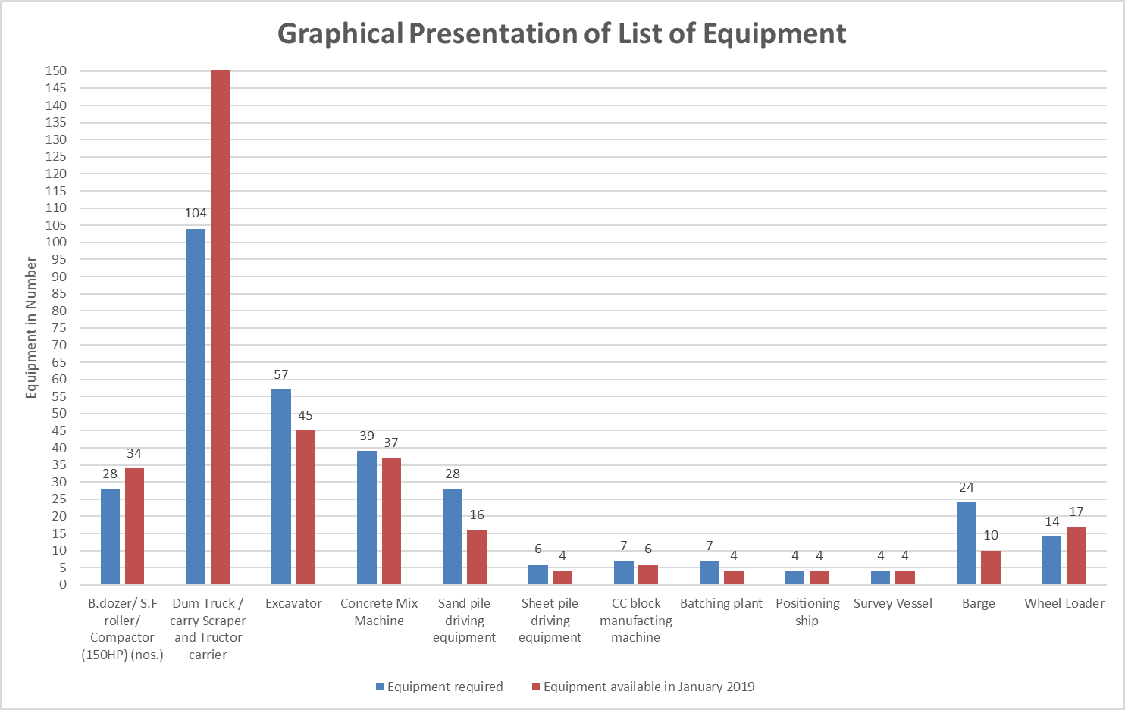

Figure 3‑29: Graphical Presentation of List of Equipment Contractor of Package-1

### **Finances of Contractor Package-1**

Contract modifications Variation Order No.2 for using CC blocks instead of hard rock has been agreed upon and materialised.

Table 3‑44: Monthly Forecast of Payment for Package-W/-01 is furnished below

| **IPC No.** | **Month of Submission** | **Forecast Value of IPC** | **Remark** |
| --- | --- | --- | --- |
| IPC-15 | Nov. 2018 | 274,583,612.82 | IPC No. 15 has been submitted to PMU on 6 December 2018 with the value of BDT: 256,330,133.58 with recommendation for payment. |
| IPC-16 | Jan. 2019 | 374,242,132.20 | IPC No. 16 has been submitted to Engineer on 26 February 2019 with the value of BDT: 158,606,842.50. The IPC-16 was reviewed and sent to PMU on 06 March 2019 with recommendation for payment. |
| IPC-17 | Feb. 2019 | 259,251,532.92 | IPC No. 17 has been submitted to Engineer on 24 April 2019 with the value of BDT: 224,334,901.33. The IPC-17 was reviewed and sent to PMU on 12 May 2019 with recommendation for payment. |
| IPC-18 | Mar. 2019 | 255,766,969.30 | IPC No. 18 has been submitted to Engineer on 29 May 2019 with the value of BDT: 33,53,06,596.19 The IPC-18 is under review by the Engineer. |
| IPC-19 | Apr. 2019 | 453,144,934.37 |  |
| IPC-20 | May. 2019 | 453,144,934.37 |  |
| IPC-21 | Jun. 2019 | 585,558,351.72 |  |
| **Total** | | **2,655,692,467.71** |  |

### **S-Curve of Package-1**

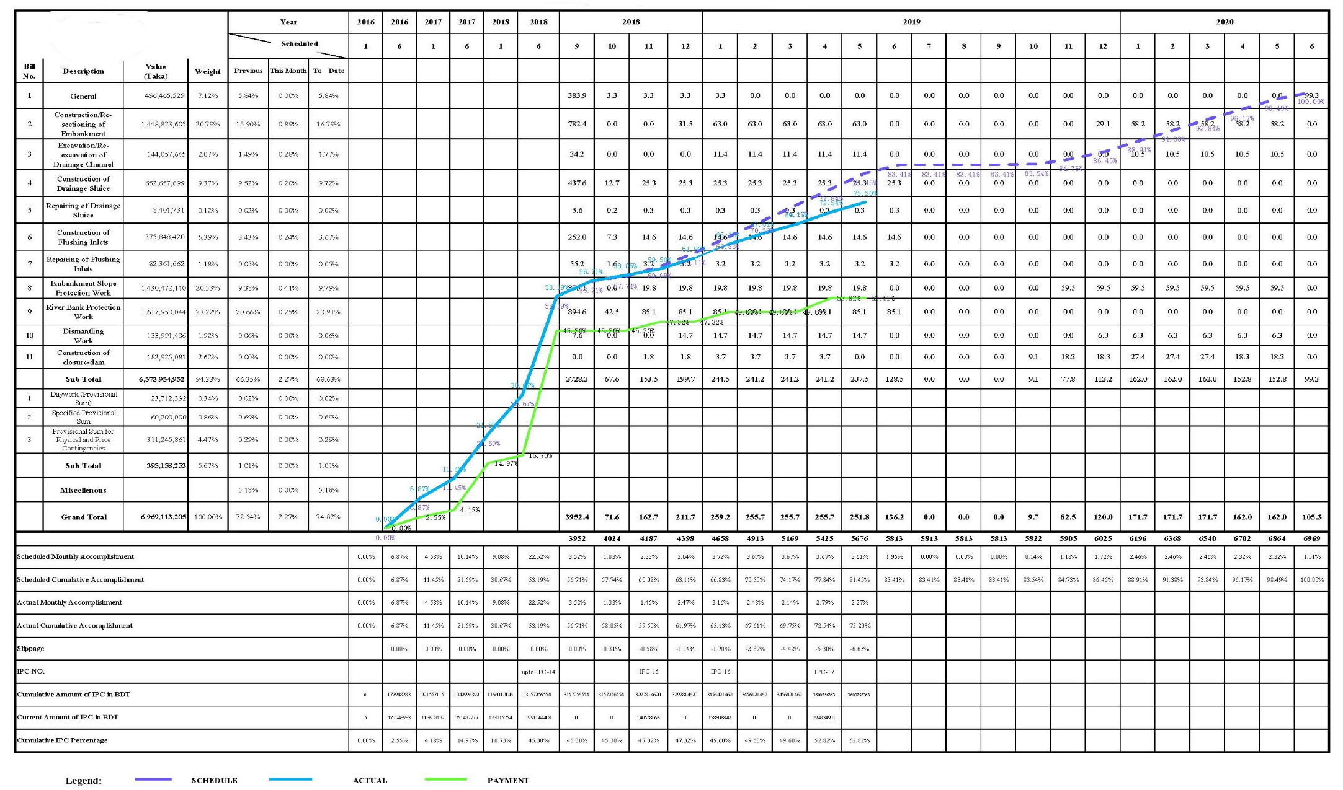

Figure 3‑30: S-Curve of Package-1

### **Physical Progress (Mile Stone Matrix)**

Table 3‑45: Physical Works of Package-1 as on 31 May 2019

|  |  |  |  |  |  |  |  |  |  |  |
| --- | --- | --- | --- | --- | --- | --- | --- | --- | --- | --- |
| **Item** | **Unit** | **Contract Quantity** | **Program FY 2018-2019** | | **Prior Cumulative** | | **Current Month** | | **Current Cumulative** | |
| **Full** | **Part** | **Completed** | **Partially Completed** | **Completed** | **Partially Completed** | **Completed** | **Partially Completed** |
| Embankment Construction/Re-sectioning | Km | 200.617[[1]](#footnote-1) | 110 | 0 | 111.76 | 52.570 | 0.720 | 51.826 | 112.48 | 51.826 |
| 55.84% | 44.18% | 0.36% | 59.11% | 56.19% | 59.11% |
| Drainage Channel Excavation/Re-excavation | Km | 151.210[[2]](#footnote-2) | 101 | 0 | 43.98 | 0.000 | 23.490 | 0 | 67.47 | 0 |
| 29.09% | - | 15.53% | - | 44.62% | - |
| Drainage Sluice Construction | No. | 38[[3]](#footnote-3) | 19 | 0 | 30 | 8 | 2 | 6 | 32 | 6 |
| 78.95% | 93.18% | 5.26% | 92.00% | 84.21% | 92.00% |
| Drainage Sluice Repair | No. | 2 | 2 | 0 | 0 | 2 | 0 | 2 | 0 | 2 |
| 0.00% | 88.00% | 0.00% | 88.00% | 0.00% | 88.00% |
| Flushing Inlet Construction | No. | 30[[4]](#footnote-4) | 22 | 0 | 20 | 9 | 0 | 9 | 20 | 9 |
| 66.67% | 82.15% | 0.00% | 82.15% | 66.67% | 82.15% |
| Flushing Inlet Repair | No. | 14[[5]](#footnote-5) | 15 | 0 | 4 | 9 | 2 | 7 | 6 | 7 |
| 28.57% | 68.82% | 14.29% | 70.12% | 42.86% | 70.12% |
| Embankment Slope Protection Work | Km | 19.966[[6]](#footnote-6) | 10 | 0 | 12.7394 | - | -0.251[[7]](#footnote-7) | - | 12.488 | - |
| 63.81% |  | -1.26% |  | 62.55% |  |
| River Bank Protection Work | Km | 4.450 | 1.8 | 0 | 3.950 | - | 0.100 | - | 4.050 | - |
| 88.76% |  | 2.25% |  | 91.01% |  |
| Closure Dam Construction | No. | 1 | 1 | 0 | - | 63% of the foundation works | - | 63% of the foundation works | - | 63% of the foundation works |

Table 3‑46: Physical Works Polder Wise of Package-1 as on 31 May 2019



Table 3‑47: Detailed information of Construction Status of Embankment of Package-1









Table 3‑48: Detailed information of Construction Status of Drainage Channel of Package-1



Table 3‑49: Detailed information of Construction Status of Drainage Sluices of Package-1



Table 3‑50: Detailed Information of Construction Status of Flushing Sluices of Package-1



Table 3‑51: Detailed Information of Repair of Drainage & Flushing Sluices of Package-1



Table 3‑52: Detailed Information of Slope Protection Works of Package-1



Table 3‑53: Detailed Information of Bank Protection Works of Package-1



Table 3‑54: Detailed Information of Construction of Closure Dam of Package-1



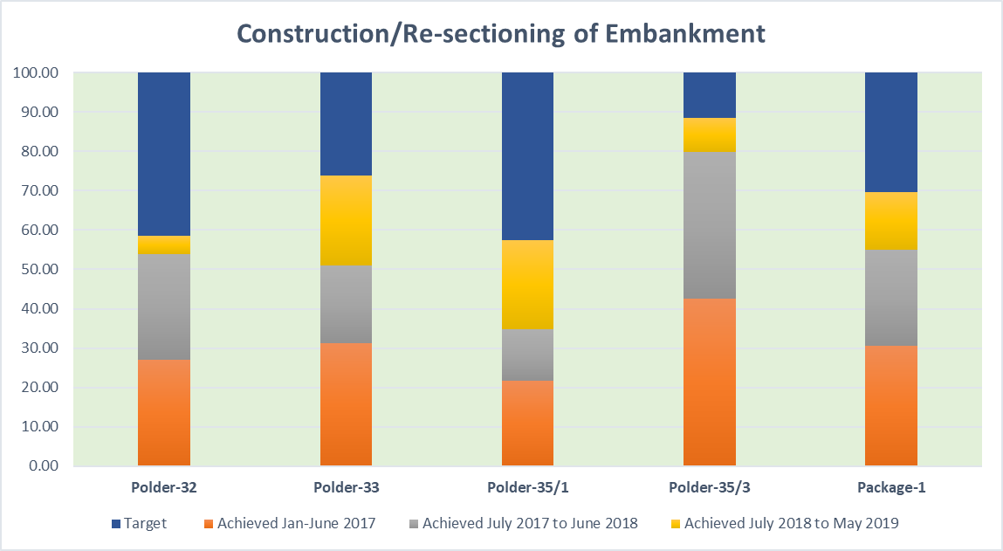

Figure 3‑31: Construction/Re-sectioning of Embankment of Package-1

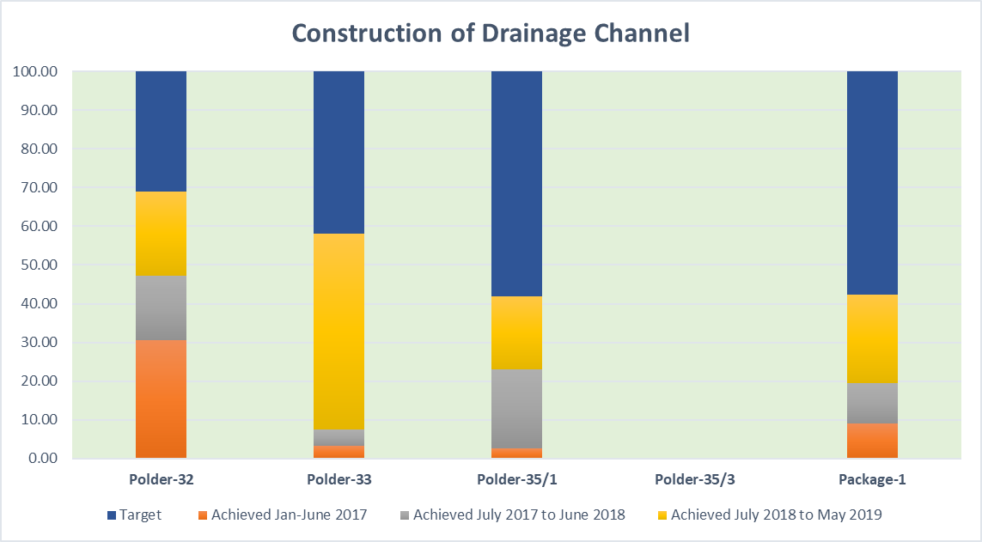

Figure 3‑32: Drainage Channel of Package-1

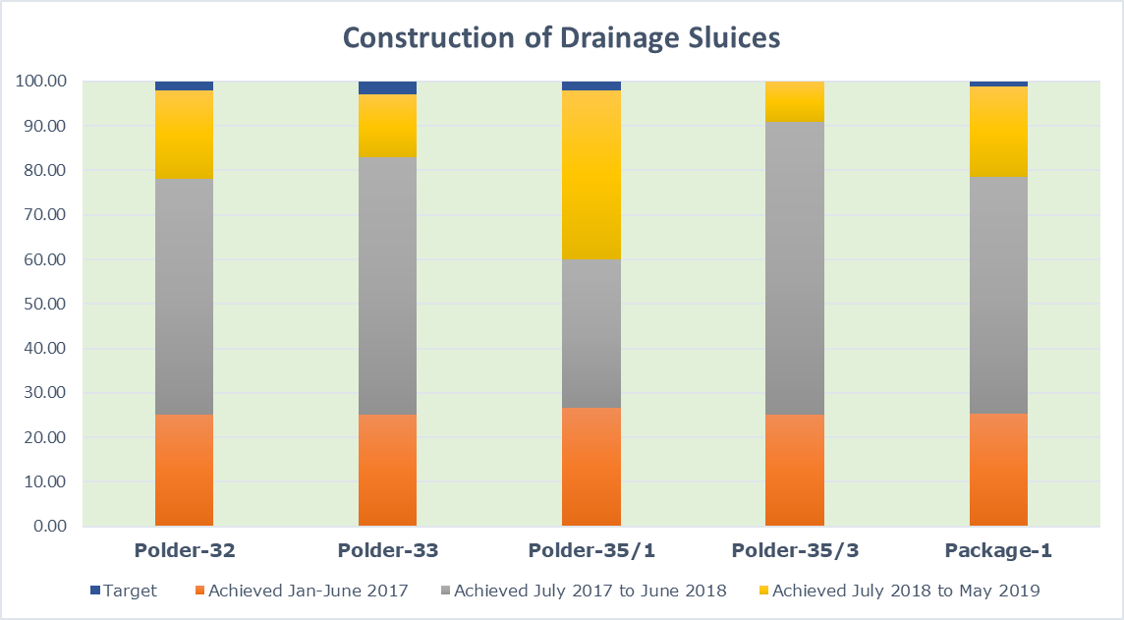

Figure 3‑33: Construction of Drainage Sluices of Package-1

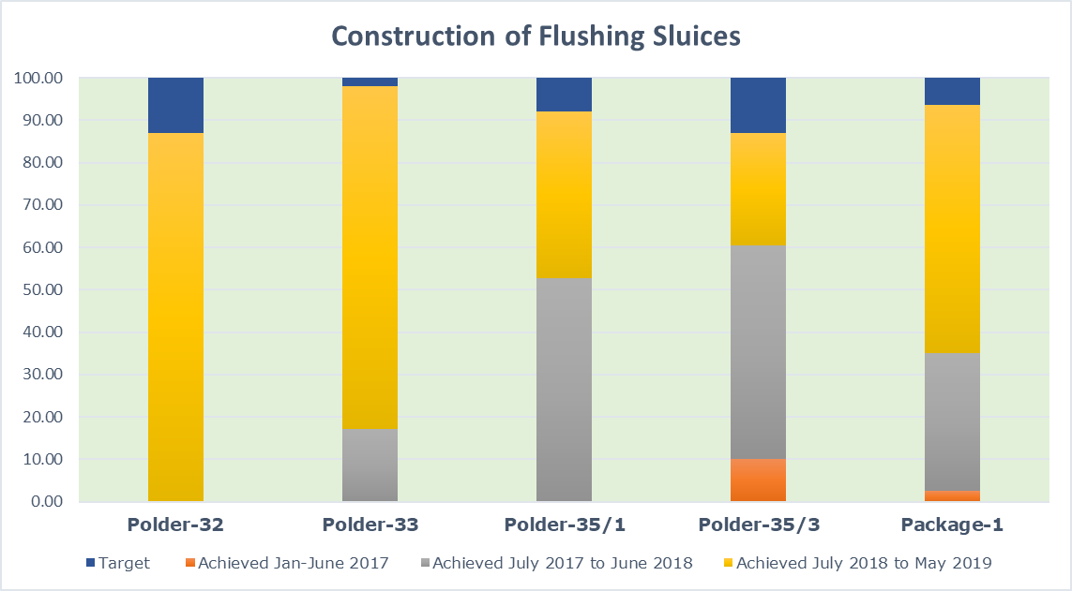

Figure 3‑34: Construction of Flushing Sluice of Package-1

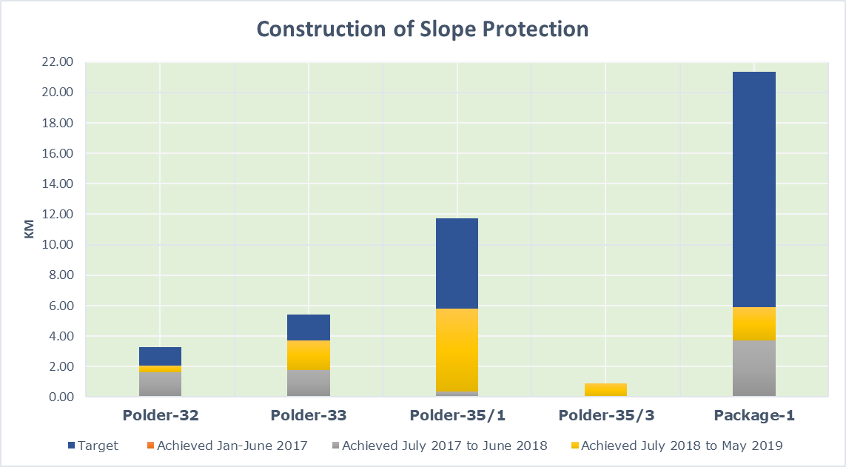

Figure 3‑35: Construction of Slope Protection of Package-1

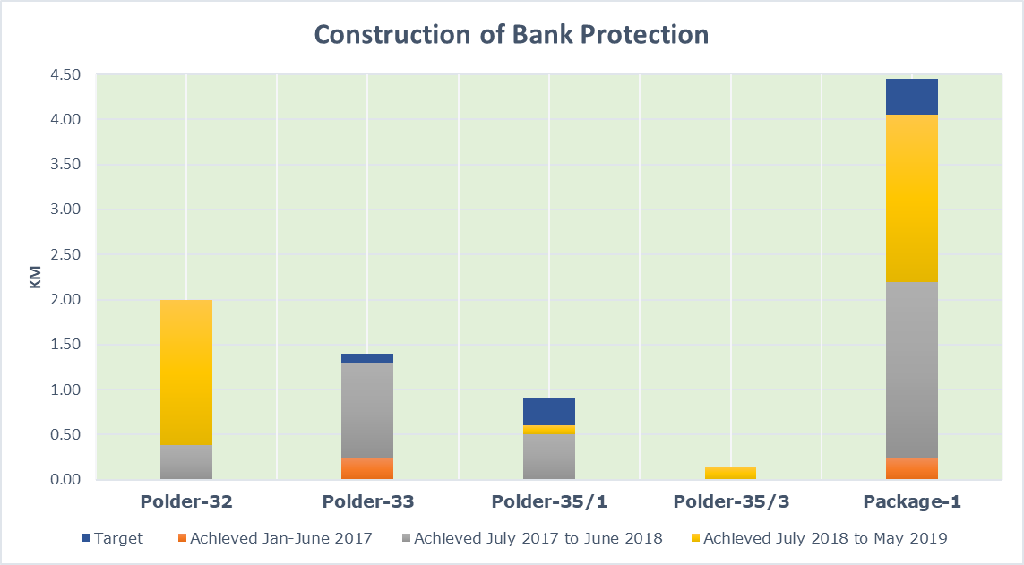

Figure 3‑36: Construction of Bank Protection of Package-1

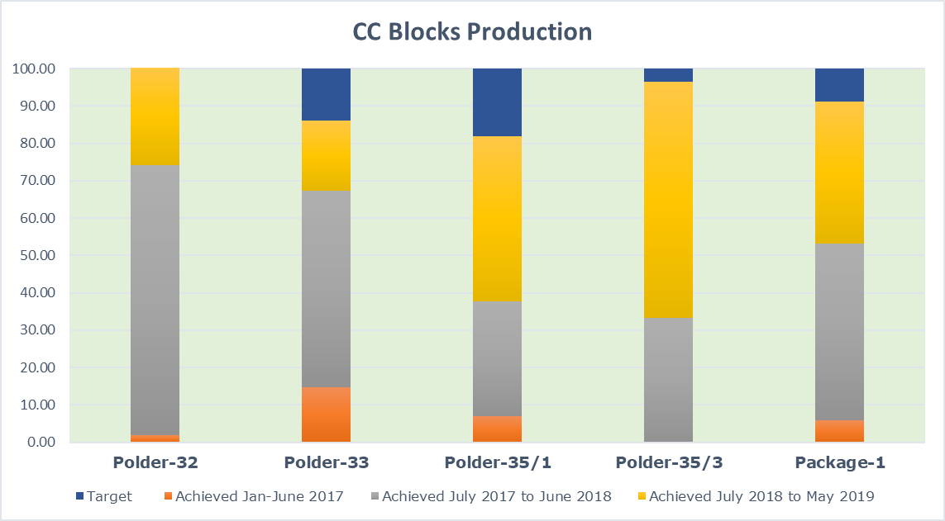

Figure 3‑37: CC Blocks Production of Package-1

Table 3‑55: Progress as on May 2019

|  |  |  |  |  |
| --- | --- | --- | --- | --- |
| **Item** | **Unit** | **Contract Quantity** | **Status 31 May 2019** | |
| Embankment Construction/Re-sectioning | Km | 200.617 | 112.480 | (F) |
| 51.826 | (P) |
| Drainage Channel Excavation/Re-excavation | Km | 151.210 | 67.470 | (F) |
| Drainage Sluice Construction | No. | 38 | 32 | (F) |
| 6 | (P) |
| Drainage Sluice Repair | No. | 2 | 0 | (F) |
| 2 | (P) |
| Flushing Inlet Construction | No. | 30 | 20 | (F) |
| 9 | (P) |
| Flushing Inlet Repair | No. | 14 | 6 | (F) |
| 7 | (P) |
| Embankment Slope Protection Work | Km | 19.966 | 12.488 | (F) |
| River Bank Protection Work | Km | 4.45 | 4.050 | (F) |
| Closure Dam Construction | No. | 1 | 63% of the foundation works | |

Table 3‑56: CC Blocks Production as on May 2019



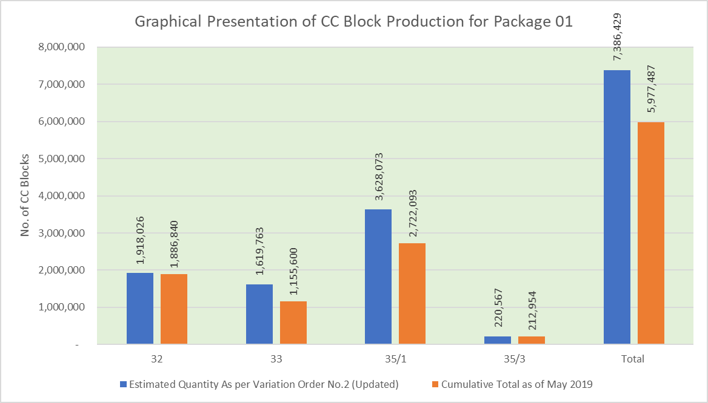

Figure 3‑38: Graphical Presentation of CC Block Production for Package-1

|  |  |
| --- | --- |
| D:\CEIP-II\Picture of DS & FS in 4 Polder._Dec 18\Monthly Progress Report (MPR) December 2018\Picture of Polder-33\Completed\DS-4\4.jpg | D:\CEIP-II\Picture of DS & FS in 4 Polder._Dec 18\Monthly Progress Report (MPR) December 2018\Picture of Polder-33\Completed\DS-7\1.jpg |
| Figure 3‑39: DS-4 of Polder-33 | Figure 3‑40: DS-7 of Polder-33 |
| D:\CEIP-II\Picture of DS & FS in 4 Polder._Dec 18\Monthly Progress Report (MPR) December 2018\Picture of Polder-33\Completed\DS-13\4.jpg | D:\CEIP-II\Picture of DS & FS in 4 Polder._Dec 18\Monthly Progress Report (MPR) December 2018\Picture of Polder-33\Completed\DS-9\2.jpg |
| Figure 3‑41: DS-13 of Polder-33 | Figure 3‑42: DS-9 of Polder-33 |
| D:\CEIP-II\Picture of DS & FS in 4 Polder._Dec 18\Monthly Progress Report (MPR) December 2018\Picture of Polder-33\Completed\DS-10\1.jpg | D:\CEIP-II\Picture of DS & FS in 4 Polder._Dec 18\Monthly Progress Report (MPR) December 2018\Picture of Polder-33\Completed\DS-12\3.jpg |
| Figure 3‑43: DS-10 of Polder-33 | Figure 3‑44: DS-12 of Polder-33 |
| D:\CEIP-II\Picture of DS & FS in 4 Polder._Dec 18\Monthly Progress Report (MPR) December 2018\Picture of Polder-33\Completed\FS-17\1.jpg | D:\CEIP-II\Picture of DS & FS in 4 Polder._Dec 18\Monthly Progress Report (MPR) December 2018\Picture of Polder-35-1\Completed\DS-05\3.jpg |
| Figure 3‑45: FS-17 of Polder-33 | Figure 3‑46: DS-5 of Polder-35/1 |
| D:\CEIP-II\Picture of DS & FS in 4 Polder._Dec 18\Monthly Progress Report (MPR) December 2018\Picture of Polder-35-1\Completed\DS-06\1.jpg | D:\CEIP-II\Picture of DS & FS in 4 Polder._Dec 18\Monthly Progress Report (MPR) December 2018\Picture of Polder-35-1\Completed\FS-02\4.jpg |
| Figure 3‑47: DS-6 of Polder-35/1 | Figure 3‑48: FS-2 of Polder-35/1 |
| D:\CEIP-II\Picture of DS & FS in 4 Polder._Dec 18\Monthly Progress Report (MPR) December 2018\Picture of Polder-35-1\Completed\FS-13\4.jpg | D:\CEIP-II\Picture of DS & FS in 4 Polder._Dec 18\Monthly Progress Report (MPR) December 2018\Picture of Polder-35-3\Completed\DS-01\DS-02.jpg |
| Figure 3‑49: FS-13 of Polder-35/1 | Figure 3‑50: DS-1 of Polder-35/3 |
| D:\CEIP-II\Picture of DS & FS in 4 Polder._Dec 18\Monthly Progress Report (MPR) December 2018\Picture of Polder-35-3\Completed\DS-03\1.jpg | D:\CEIP-II\Picture of DS & FS in 4 Polder._Dec 18\Monthly Progress Report (MPR) December 2018\Picture of Polder-32\Completed\DS-2\FS--2.jpg |
| Figure 3‑51: DS-3 of Polder-35/3 | Figure 3‑52: FS-2 of Polder-32 |

Total nos. of Flushing sluice to be repaired as per contract was 30 nos. out of which 16 nos. has been dropped and those are reflected in detailed in Table 3‑57 and Table 3‑58 below:

Table 3‑57: Information of Repair of Flushing Sluices and Drainage Sluices

|  |  |  |  |  |  |
| --- | --- | --- | --- | --- | --- |
| **Sl No.** | **Name of Polder** | **Total Nos. as per Contract** | **Current Status** | **Total Dropped** | **Remarks** |
| 01. | Polder-32 | 20 nos. | 6 Nos. | 14 Nos. | Mostly fallen outside of the retired embankment. |
| 02. | Polder-33 | 5 Nos. | 3 Nos. | 2 Nos. | As it has been constructed by the local shrimp culture owners, |
| 03. | Polder-35/1 | 3 Nos. | 3 Nos. | 0. | Due to unrepairable |
| 04. | Polder-35/3 | 2 Nos. | 2 Nos. | 0 | - |
| **Total =** | | **30 Nos.** | **14 Nos.** | **16 Nos.** |  |

Remaining (30-16) = 14 nos. are in the program out of which 6 nos. have been completed and 7 nos. are in progress and remaining 1 no. has not yet started for want of data which are supposed to be supplied by the contractor.

Total 2 nos. of Drainage Sluices under repair have in program and the work of which are in progress and will be completed by June 2019.

Table 3‑58: List of Flushing Sluices Dropped from the repairing Program

|  |  |
| --- | --- |
| **Flushing Sluices** | **Reasons for dropping** |
| ***Polder 32*** | |
| FFDFR-01 | Not repairable |
| FS-04 | Not repairable |
| FM-01 | Not repairable |
| FM-02 | Sluice is now in no use. |
| FM-07 | No need repair, connected with the private pond. |
| FM-11 | No need repair, connected with the private pond. |
| FM-12 | Sluice could not be identified. |
| FO-02 | Outside the Rtd. Embankment |
| FO-03 | Not repairable |
| FO-04 | Outside the Rtd. Embankment |
| FO-05 | Outside the Rtd. Embankment |
| FO-06 | Outside the Rtd. Embankment |
| FH-09 | Engulf due of river erosion. |
| FH-18 | Private structure |
| ***Polder 33*** | |
| FS-02 | Private structure, repair not needed. |
| FS-18 | Private structure, repair not needed. |

### **Emergency Works in Package-CEIP-1/W-01**

The emergency works under this Package have taken up to close the breaching of existing embankment at some vulnerable locations. The main target of these emergency works was to stop the intrusion of saline water into the Polders to save the crops. In the Contract, there was a provision for an amount under Environmental Mitigation Works (Specified Provisional Sum). After exhaustion of the above-mentioned amount to meet up the cost of the rest emergency works, the expenditures are being meet up from the Physical & Price Contingencies. The status of expenditure up to May 2019 are shown below:

Table 3‑59: Summary of Emergency works under the head of “Environmental Mitigation Works”

|  |  |  |  |
| --- | --- | --- | --- |
| **Sl.** | **Name of Polder** | **Total Length** | **Total Cost Estimate (BDT)** |
| 01 | Polder-32 | 4.187 | 21,314,699 |
| 02 | Polder-33 | 1.454 | 8,616,598 |
| 03 | Polder-35/1 | 0.941 | 7,981,316 |
| 04 | Polder-35/3 | 1.04 | 2,078,530 |
| **Total =** | | **7.622** | **39,991,142** |

* Total available budget as per contract: BDT: 40,000,000.00

Table 3‑60: Summary of Emergency works under the head of “Physical & Price Contingency”

|  |  |  |  |
| --- | --- | --- | --- |
| **Sl. No.** | **Name of Polder** | **Total Length** | **Total Cost Estimate (BDT)** |
| 01 | Polder-32 | 4.192 | 18,398,767 |
| 02 | Polder-33 | 1.517 | 11,943,068 |
| 03 | Polder-35/1 | 1.53 | 20,170,105 |
| 04 | Polder-35/3 | 2.879 | 8,401,201 |
| **Total =** | | **10.118** | **58,913,141** |

* Total available budget as per Variation Order-02 (Updated): BDT: 300,000,000.00

Table 3‑61: Details of Emergency Works under the head of “Environmental Mitigation Works”

| **Sl. No.** | **Polder No.** | **Chainage** | | **Total Length (Km)** | **Name of locations** | **Date of Approval by the Engineer** | **Estimated Cost in BDT** | **Head of Expenditure** | **FY Year** |
| --- | --- | --- | --- | --- | --- | --- | --- | --- | --- |
| **From** | **To** |
| 1 | Polder-32 | 2.883 | 3.144 | 0.261 | Gunari of Sutharkhali | 20-Mar-16 | 972,969.00 | Environmental Mitigation Works | FY 2015-16 |
| 2 | Polder-32 | 7.561 | 7.991 | 0.430 | Kalibari | 14-Mar-16 | 1,307,000.00 | Do | FY 2015-16 |
| 3 | Polder-32 | 8.161 | 8.350 | 0.189 | Kalibari | 14-Mar-16 | 614,000.00 | Do | FY 2015-16 |
| 4 | Polder-32 | 8.491 | 8.628 | 0.137 | Kalibari | 14-Mar-16 | 1,009,000.00 | Do | FY 2015-16 |
| 5 | Polder-32 | 7.681 | 7.981 | 0.300 | Sutarkhali | 7-May-17 | 1,433,223.43 | Do | FY 2016-17 |
| 6 | Polder-32 | 8.030 | 8.160 | 0.130 | Sutarkhali | 5-Jun-17 | 639,091.00 | Do | FY 2016-17 |
| 7 | Polder-32 | 8.164 | 8.292 | 0.128 | Sutarkhali | 16-Apr-17 | 811,931.00 | Do | FY 2016-17 |
| 8 | Polder-32 | 8.140 | 8.217 | 0.077 | Kalibari | 22-Jan-17 | 256,000.00 | Do | FY 2016-17 |
| 9 | Polder-32 | 8.566 | 8.649 | 0.083 | Sutarkhali | 16-May-17 | 619,153.00 | Do | FY 2016-17 |
| 10 | Polder-32 | 12.393 | 12.693 | 0.300 | Jaynagar | 23-Mar-16 | 1,027,000.00 | Do | FY 2015-16 |
| 11 | Polder-32 | 18.575 | 18.690 | 0.115 | Hatkhola | 20-Apr-16 | 817,000.00 | Do | FY 2015-16 |
| 12 | Polder-32 | 16.680 | 16.900 | 0.220 | Jhaliakhali of Kamarkhola | 23-Mar-16 | 608,000.00 | Do | FY 2015-16 |
| 13 | Polder-32 | 18.840 | 19.960 | 1.120 | Hatkhola | 3-Mar-16 | 817,000.00 | Do | FY 2015-16 |
| 14 | Polder-32 | 19.179 | 19.236 | 0.057 | Kamarkhola | 24-Apr-17 | 460,436.32 | Do | FY 2016-17 |
| 15 | Polder-32 | 30.050 | 30.148 | 0.098 | Sutarkhali | 22-Jun-17 | 7,702,000.00 | Do | FY 2016-17 |
| 16 | Polder-32 | 36.155 | 36.232 | 0.077 | Sutarkhali | 24-Apr-17 | 337,118.92 | Do | FY 2016-17 |
| 17 | Polder-32 | 43.118 | 43.147 | 0.029 | Sutarkhali | 24-Apr-17 | 103,342.00 | Do | FY 2016-17 |
| 18 | Polder-32 | 44.561 | 44.931 | 0.370 | Sutarkhali | 20-Mar-16 | 1,039,924.00 | Do | FY 2015-16 |
| 19 | Polder-32 | 44.907 | 44.935 | 0.028 | Sutarkhali | 11-May-17 | 108,959.00 | Do | FY 2016-17 |
| 20 | Polder-32 | 45.062 | 45.100 | 0.038 | Shibsha River | 27-Mar-17 | 631,551.00 | Do | FY 2016-17 |
| 21 | Polder-33 | 0.130 | 0.280 | 0.150 | Banisanta | 2-Jun-16 | 386,000.00 | Do | FY 2015-16 |
| 22 | Polder-33 | 0.600 | 1.300 | 0.700 | Banisanta | 2-Jun-16 | 1,159,000.00 | Do | FY 2015-16 |
| 23 | Polder-33 | 1.190 | 1.432 | 0.242 | Banisanta | 25-Mar-16 | 456,000.00 | Do | FY 2015-16 |
| 24 | Polder-33 | 17.447 | 17.547 | 0.100 | Ramnagar | 19-Jan-16 | 3,601,000.00 | Do | FY 2015-16 |
| 25 | Polder-33 | 1.220 | 1.332 | 0.112 | Baniashanta | 25-May-17 | 663,558.00 | Do | FY 2016-17 |
| 26 | Polder-33 | 48.800 | 48.875 | 0.075 | Banisanta | 15-Mar-17 | 1,175,520.00 | Do | FY 2016-17 |
| 27 | Polder-33 | 48.800 | 48.875 | 0.075 | Banisanta | 15-Mar-16 | 1,175,520.00 | Do | FY 2016-17 |
| 28 | Polder-35/1 | 2.100 | 2.466 | 0.366 | Baleswar | 8-May-17 | 609,128.55 | Do | FY 2016-17 |
| 29 | Polder-35/1 | 20.082 | 20.163 | 0.081 | Sarankhola | 1-Apr-16 | 100,000.00 | Do | FY 2015-16 |
| 30 | Polder-35/1 | 24.430 | 24.500 | 0.070 | Sarankhola | 23-Apr-17 | 1,793,272.30 | Do | FY 2016-17 |
| 31 | Polder-35/1 | 24.703 | 24.864 | 0.161 | Southkhali | 21-Jun-17 | 2,080,957.39 | Do | FY 2016-17 |
| 32 | Polder-35/1 | 24.673 | 24.864 | 0.191 | Bogi | 19-Jun-17 | 2,080,957.39 | Do | FY 2016-17 |
| 33 | Polder-35/1 | 63.050 | 63.106 | 0.056 | Morelgonj | 1-Mar-16 | 1,317,000.00 | Do | FY 2015-16 |
| 34 | Polder-35/1 | 63.112 | 63.128 | 0.016 | Same as 63.050 to 63.106 | 1-Mar-16 | 0.00 | Do | FY 2015-16 |
| 35 | Polder-35/3 | 3.394 | 3.494 | 0.100 | MollikerBer | 27-Apr-17 | 418,530.02 | Do | FY 2016-17 |
| 36 | Polder-35/3 | 7.176 | 7.905 | 0.729 | Panchamala of Dema | 22-Mar-16 | 533,000.00 | Do | FY 2016-17 |
| 37 | Polder-35/3 | 9.558 | 9.597 | 0.039 | Panchamala of Dema | 22-Mar-16 | 23,000.00 | Do | FY 2016-17 |
| 38 | Polder-35/3 | 9.815 | 9.887 | 0.072 | Panchamala of Dema | 22-Mar-16 | 34,000.00 | Do | FY 2016-17 |
| 39 | Polder-35/3 | 29.865 | 29.965 | 0.100 | Radhaballab | 27-Mar-16 | 1,070,000.00 | Do | FY 2015-16 |
| **Total** |  | **39** | **39** | **7.62** |  |  | **39,991,142** |  |  |

Table 3‑62: Detailed of Emergency Works under the head of “Physical & Price Contingencies”

| **Sl. No.** | **Polder No.** | **Chainage** | | **Total Length (Km)** | **Name of locations** | **Date of Approval by the Engineer** | **Estimated Cost in BDT** | **Head of Expenditure** | **FY Year** |
| --- | --- | --- | --- | --- | --- | --- | --- | --- | --- |
| **From** | **To** |
| 1 | Polder-32 | 2.805 | 2.850 | 0.045 | Gunari of Sutharkhali | 7-Jun-18 | 287,852.00 | Physical & Price Contingency | FY 2017-18 |
| 2 | Polder-32 | 2.765 | 2.858 | 0.093 | Gunari of Sutharkhali | 1-Aug-18 | 474,946.00 | Do | FY 2018-19 |
| 3 | Polder-32 | 3.093 | 3.633 | 0.540 | Gunari of Sutharkhali | 2-Aug-16 | 277,000.00 | Do | FY 2016-17 |
| 4 | Polder-32 | 3.130 | 3.180 | 0.050 | Gunari of Sutharkhali | 11-Sep-17 | 317,883.95 | Do | FY 2017-18 |
| 5 | Polder-32 | 3.103 | 3.241 | 0.138 | Gunari of Sutharkhali | 31-Oct-16 | 593,800.00 | Do | FY 2016-17 |
| 6 | Polder-32 | 8.060 | 8.100 | 0.040 | Kalibari | 18-Nov-17 | 77,000.00 | Do | FY 2018-19 |
| 7 | Polder-32 | 8.321 | 8.414 | 0.093 | Kalibari | 1-May-17 | 530,000.00 | Do | FY 2017-18 |
| 8 | Polder-32 | 8.350 | 8.385 | 0.035 | Kalibari | 1-Dec-16 | 60,000.00 | Do | FY 2016-17 |
| 9 | Polder-32 | 8.586 | 8.729 | 0.143 | Kamarkhola | 27-Aug-17 | 922,055.59 | Do | FY 2017-18 |
| 10 | Polder-32 | 8.600 | 8.670 | 0.070 | Kalibari | 26-Jun-17 | 150,000.00 | Do | FY 2017-18 |
| 11 | Polder-32 | 8.650 | 8.713 | 0.063 | Kamarkhola | 6-Jul-17 | 113,492.00 | Do | FY 2017-18 |
| 12 | Polder-32 | 13.604 | 13.644 | 0.040 | Sutarkhali | 21-Aug-17 | 311,091.06 | Do | FY 2017-18 |
| 13 | Polder-32 | 16.078 | 16.326 | 0.248 | Jhaliakhali of Kamarkhola | 25-Jul-17 | 1,181,802.00 | Do | FY 2017-18 |
| 14 | Polder-32 | 16.030 | 16.300 | 0.270 | Jhaliakhali of Kamarkhola | 25-Mar-18 | 1,033,085.00 | Do | FY 2017-18 |
| 15 | Polder-32 | 16.078 | 16.326 | 0.248 | Jhaliakhali of Kamarkhola | 28-Sep-17 | 1,154,217.71 | Do | FY 2017-18 |
| 16 | Polder-32 | 16.135 | 16.395 | 0.260 | Jhaliakhali of Kamarkhola | 5-Jun-18 | 1,712,969.00 | Do | FY 2017-18 |
| 17 | Polder-32 | 16.240 | 16.300 | 0.060 | Jhaliakhali of Kamarkhola | 25-May-18 | 30,358.00 | Do | FY 2017-18 |
| 18 | Polder-32 | 16.298 | 16.525 | 0.227 | Jaliakhali | 7-May-16 | 1,200,000.00 | Do | FY 2017-18 |
| 19 | Polder-32 | 16.400 | 16.445 | 0.045 | Jhaliakhali of Kamarkhola | 1-Aug-18 | 258,751.00 | Do | FY 2018-19 |
| 20 | Polder-32 | 16.504 | 16.592 | 0.088 | Jhaliakhali of Kamarkhola | 4-Jun-18 | 539,967.00 | Do | FY 2017-18 |
| 21 | Polder-32 | 19.150 | 19.225 | 0.075 | Kamarkhola | 5-Apr-17 | 40,000.00 | Do | FY 2017-18 |
| 22 | Polder-32 | 19.165 | 19.265 | 0.100 | Kamarkhola | 2-Aug-16 | 625,000.00 | Do | FY 2017-18 |
| 23 | Polder-32 | 19.141 | 19.277 | 0.136 | Kamarkhola | 22-Aug-17 | 122,307.32 | Do | FY 2017-18 |
| 24 | Polder-32 | 24.759 | 24.859 | 0.100 | Sharankhola | 14-Nov-16 | 1,859,614.00 | Do | FY 2017-18 |
| 25 | Polder-32 | 25.659 | 25.719 | 0.060 | Kamarkhola | 17-Nov-16 | 415,302.00 | Do | FY 2016-17 |
| 26 | Polder-32 | 31.345 | 31.387 | 0.042 | Sutarkhali | 27-Apr-17 | 84,867.18 | Do | FY 2017-18 |
| 27 | Polder-32 | 36.179 | 36.268 | 0.089 | Sutarkhali | 22-Jun-17 | 164,657.00 | Do | FY 2016-17 |
| 28 | Polder-32 | 36.317 | 36.365 | 0.048 | Sutarkhali | 1-Aug-18 | 307,884.00 | Do | FY 2018-19 |
| 29 | Polder-32 | 36.225 | 36.341 | 0.116 | Sutarkhali | 11-Aug-18 | 150,000.00 | Do | FY 2017-18 |
| 30 | Polder-32 | 41.570 | 41.620 | 0.050 | Sutarkhali | 22-May-18 | 468,884.00 | Do | FY 2017-18 |
| 31 | Polder-32 | 43.115 | 43.155 | 0.040 | Thursday Bazar, Sutarkhali | 1-Aug-18 | 129,624.00 | Do | FY 2018-19 |
| 32 | Polder-32 | 44.900 | 45.120 | 0.220 | Sutarkhali | 20-Aug-18 | 508,047.00 | Do | FY 2018-19 |
| 33 | Polder-32 | 44.957 | 45.083 | 0.126 | Kalabogi | 1-May-16 | 926,000.00 | Do | FY 2018-19 |
| 34 | Polder-32 | 45.506 | 45.518 | 0.012 | Kalabogi | 10-May-17 | 32,000.00 | Do | FY 2017-18 |
| 35 | Polder-32 | 45.549 | 45.731 | 0.182 | Sutarkhali | 12-Jul-17 | 1,338,310.00 | Do | FY 2017-18 |
| 36 | Polder-33 | 1.086 | 1.127 | 0.041 | Banishanta | 19-Sep-17 | 432,185.30 | Do | FY 2017-18 |
| 37 | Polder-33 | 1.155 | 1.184 | 0.029 | Same as 1.086 to 1.127 | 19-Sep-17 | 0.00 | Do | FY 2017-18 |
| 38 | Polder-33 | 0.005 | 0.060 | 0.055 | Banishanta | 1-Jun-17 | 344,069.00 | Do | FY 2016-17 |
| 39 | Polder-33 | 1.070 | 1.116 | 0.046 | Dhangmari | 25-May-17 | 31,798.00 | Do | FY 2017-18 |
| 40 | Polder-33 | 1.200 | 1.242 | 0.042 | Baniashanta | 20-Aug-18 | 294,835.00 | Do | FY 2018-19 |
| 41 | Polder-33 | 0.235 | 0.280 | 0.045 | Baniashanta | 13-Aug-18 | 416,831.00 | Do | FY 2018-19 |
| 42 | Polder-33 | 17.465 | 17.595 | 0.130 | Ramnagar | 1-Aug-16 | 865,000.00 | Do | FY 2016-17 |
| 43 | Polder-33 | 21.730 | 21.800 | 0.070 | Dacope | 11-Aug-18 | 464,469.00 | Do | FY 2018-19 |
| 44 | Polder-33 | 48.575 | 48.658 | 0.083 | Banishanta | 16-Aug-16 | 594,000.00 | Do | FY 2017-18 |
| 45 | Polder-33 | 48.653 | 48.741 | 0.088 | Banisanta | 13-Aug-18 | 1,672,456.00 | Do | FY 2018-19 |
| 46 | Polder-33 | 48.767 | 48.836 | 0.069 | Same amount of Ch. 48.653 to 48.741 | 13-Aug-18 | 0.00 | Do | FY 2018-19 |
| 47 | Polder-33 | 48.892 | 48.972 | 0.080 | Banisanta | 11-Sep-18 | 497,585.00 | Do | FY 2018-19 |
| 48 | Polder-33 | 48.850 | 49.100 | 0.250 | Banisanta | 16-May-18 | 2,480,308.98 | Do | FY 2017-18 |
| 49 | Polder-33 | 48.868 | 49.087 | 0.219 | Banisanta | 1-Aug-18 | 1,097,128.00 | Do | FY 2018-19 |
| 50 | Polder-33 | 48.930 | 49.050 | 0.120 | Banisanta | 24-Aug-16 | 1,780,283.00 | Do | FY 2016-17 |
| 51 | Polder-33 | 49.000 | 49.045 | 0.045 | Banisanta | 10-Oct-17 | 324,000.00 | Do | FY 2018-19 |
| 52 | Polder-33 | 49.022 | 49.099 | 0.077 | Banisanta | 11-Oct-17 | 337,240.00 | Do | FY 2018-19 |
| 53 | Polder-33 | 49.047 | 49.075 | 0.028 | Banisanta | 21-Sep-17 | 310,880.00 | Do | FY 2018-19 |
| 54 | Polder-35/1 | 20.020 | 20.308 | 0.288 | Sarankhola | 1-Jul-16 | 2,800,000.00 | Do | FY 2017-18 |
| 55 | Polder-35/1 | 23.812 | 24.014 | 0.202 | Southkhali | 24-Apr-18 | 394,032.65 | Do | FY 2017-18 |
| 56 | Polder-35/1 | 23.988 | 24.028 | 0.040 | Sarankhola | 24-May-18 | 355,507.00 | Do | FY 2018-19 |
| 57 | Polder-35/1 | 24.252 | 24.329 | 0.077 | Southkhali | 29-Jul-18 | 1,961,705.54 | Do | FY 2018-19 |
| 58 | Polder-35/1 | 24.273 | 24.340 | 0.067 | Southkhali | 27-Nov-17 | 1,370,419.82 | Do | FY 2017-18 |
| 59 | Polder-35/1 | 24.400 | 24.457 | 0.057 | Sarankhola | 1-Aug-16 | 812,000.00 | Do | FY 2016-17 |
| 60 | Polder-35/1 | 24.366 | 24.454 | 0.088 | Bagi | 30-Oct-17 | 1,372,087.83 | Do | FY 2017-18 |
| 61 | Polder-35/1 | 24.475 | 24.537 | 0.062 | Bagi | 19-Sep-17 | 761,484.52 | Do | FY 2016-17 |
| 62 | Polder-35/1 | 24.525 | 24.605 | 0.080 | Bagi | 9-May-18 | 1,539,821.57 | Do | FY 2017-18 |
| 63 | Polder-35/1 | 24.594 | 24.666 | 0.072 | Bagi | 30-Oct-17 | 1,352,571.65 | Do | FY 2017-18 |
| 64 | Polder-35/1 | 24.164 | 24.251 | 0.087 | Sarankhola | 16-May-18 | 1,847,015.74 | Do | FY 2017-18 |
| 65 | Polder-35/1 | 23.788 | 23.833 | 0.045 | Sarankhola |  | 535,205.00 | Do | FY 2018-19 |
| 66 | Polder-35/1 | 24.590 | 24.765 | 0.175 | Southkhali | 12-Sep-18 | 2,063,945.09 | Do | FY 2018-19 |
| 67 | Polder-35/1 | 24.759 | 24.859 | 0.100 | Southkhali | 30-Nov-17 | 1,801,033.32 | Do | FY 2017-18 |
| 68 | Polder-35/1 | 24.865 | 24.955 | 0.090 | Southkhali | 3-Dec-17 | 1,203,275.08 | Do | FY 2017-18 |
| 69 | Polder-35/3 | 0.127 | 0.168 | 0.041 | MollikerBer | 27-Jul-16 | 550,000.00 | Do | FY 2016-17 |
| 70 | Polder-35/3 | 0.130 | 0.170 | 0.040 | MollikerBer | 7-May-17 | 287,000.00 | Do | FY 2017-18 |
| 71 | Polder-35/3 | 2.826 | 2.948 | 0.122 | MollikerBer | 27-Apr-17 | 408,850.00 | Do | FY 2017-18 |
| 72 | Polder-35/3 | 5.500 | 5.570 | 0.070 | Basbaria | 25-Jul-17 | 20,270.00 | Do | FY 2018-19 |
| 73 | Polder-35/3 | 7.000 | 7.007 | 0.007 | Panchamala of Dema | 5-Jul-17 | 14,000.00 | Do | FY 2018-19 |
| 74 | Polder-35/3 | 9.867 | 9.917 | 0.050 | MollikerBer | 22-Mar-16 | 26,000.00 | Do | FY 2016-17 |
| 75 | Polder-35/3 | 9.873 | 10.083 | 0.210 | Panchamala of Dema | 23-Jul-18 | 1,635,916.00 | Do | FY 2018-19 |
| 76 | Polder-35/3 | 9.900 | 10.050 | 0.150 | Dema | 7-May-17 | 1,046,761.94 | Do | FY 2016-17 |
| 77 | Polder-35/3 | 10.000 | 10.040 | 0.040 | Panchamala of Dema | 19-Jul-17 | 45,269.00 | Do | FY 2017-18 |
| 78 | Polder-35/3 | 10.040 | 10.085 | 0.045 | Panchamala of Dema | 18-Jul-17 | 51,276.00 | Do | FY 2017-18 |
| 79 | Polder-35/3 | 10.085 | 10.120 | 0.035 | Panchamala of Dema | 19-Aug-17 | 39,819.00 | Do | FY 2018-19 |
| 80 | Polder-35/3 | 10.120 | 10.160 | 0.040 | Panchamala of Dema | 20-Aug-17 | 45,269.00 | Do | FY 2018-19 |
| 81 | Polder-35/3 | 13.055 | 13.155 | 0.100 | Radhabollov of Karapara | 23-Jul-18 | 1,564,711.00 | Do | FY 2018-19 |
| 82 | Polder-35/3 | 13.283 | 13.315 | 0.032 | Same amount of ch. 13.055 to 13.155 | 23-Jul-18 |  | Do | FY 2018-19 |
| 83 | Polder-35/3 | 13.345 | 13.400 | 0.055 | Same amount of ch. 13.055 to 13.155 | 23-Jul-18 |  | Do | FY 2018-19 |
| 84 | Polder-35/3 | 13.209 | 13.242 | 0.033 | Radhaballab | 8-Oct-16 | 445,000.00 | Do | FY 2017-18 |
| 85 | Polder-35/3 | 13.343 | 13.366 | 0.023 | Same as 13.209 to 13.242 | 8-Oct-16 |  | Do | FY 2017-18 |
| 86 | Polder-35/3 | 13.483 | 13.510 | 0.027 | Same as 13.209 to 13.242 | 8-Oct-16 |  | Do | FY 2017-18 |
| 87 | Polder-35/3 | 13.110 | 13.148 | 0.038 | Radhabollov | 3-Jun-17 | 379,048.09 | Do | FY 2016-17 |
| 88 | Polder-35/3 | 13.569 | 13.602 | 0.033 | Same as 13.110 to 13.148 | 3-Jun-17 | 0.00 | Do | FY 2016-17 |
| 89 | Polder-35/3 | 13.350 | 13.387 | 0.037 | Bagerhat | 18-Sep-17 | 268,708.79 | Do | FY 2017-18 |
| 90 | Polder-35/3 | 13.067 | 13.187 | 0.120 | Radhaballab | 27-Mar-16 | 1,120,000.00 | Do | FY 2015-16 |
| 91 | Polder-35/3 | 13.573 | 13.610 | 0.037 | Radhaballab | 27-Mar-16 | 123,000.00 | Do | FY 2015-16 |
| 92 | Polder-35/3 | 29.600 | 29.700 | 0.100 | Khagraghat | 26-Aug-17 | 40,395.00 | Do | FY 2018-19 |
| 93 | Polder-35/3 | 29.800 | 29.950 | 0.150 | Same as Ch. 29.600 to 29.700 | 26-Aug-17 |  | Do | FY 2018-19 |
| 94 | Polder-35/3 | 30.000 | 30.070 | 0.070 | Rampal | 12-Jun-17 | 17,000.00 | Do | FY 2017-18 |
| 95 | Polder-35/3 | 36.625 | 36.665 | 0.040 | Rampal | 31-Aug-16 |  | Do | FY 2016-17 |
| 96 | Polder-35/3 | 37.130 | 37.325 | 0.195 | MollikerBer | 19-Jul-17 | 30,064.00 | Do | FY 2018-19 |
| 97 | Polder-35/3 | 37.500 | 37.550 | 0.050 | Rampal | 17-Jul-17 | 9,543.00 | Do | FY 2017-18 |
| 98 | Polder-35/3 | 37.624 | 37.774 | 0.150 | MollikerBer | 17-Jul-17 | 34,000.00 | Do | FY 2017-18 |
| 99 | Polder-35/3 | 38.585 | 38.904 | 0.319 | MollikerBer | 28-Aug-16 | 158,010.00 | Do | FY 2016-17 |
| 100 | Polder-35/3 | 38.560 | 38.980 | 0.420 | MollikerBer | 20-Jul-17 | 41,290.00 | Do | FY 2017-18 |
| **Total** |  | **100** | **100** | **10.12** |  |  | **58,913,141** |  |  |

## Task C: Supervise Construction & Administer Contract of Package-2

### **Introduction**

This MPR covers all major site activities executed in each Polder up to 30 May, 2019.The Contract was signed 8 March 2017 for the execution of Rehabilitation/Reconstruction and upgrading of six Polders in total, namely Polder-39/2C, 40/2, 41/1, 43/2C, 47/2 & 48 under CEIP-1 (Contract No: CEIP-1/W-02)

The contractor completed the administrative work site visits & dossier for the 5% advanced payment and took possession of sites and the employee has paid the 10% advanced payment to the contractor.

Upon receipt of the first instalment 5% Advanced Payment, the Contractor proceeded with the procurement of goods and services to create the team and physical facilities, equipment and/or tools and started work on site.

### **Physical Progress (Mile Stone Matrix)**

Table 3‑63: Physical Works of Package-2 as on 31 May 2019

|  |  |  |  |  |  |  |  |  |  |  |
| --- | --- | --- | --- | --- | --- | --- | --- | --- | --- | --- |
| **Item** | **Unit** | **Contract Quantity** | **Program FY 2018-2019** | | **Prior Cumulative** | | **Current Month** | | **Current Cumulative** | |
| **Full** | **Part** | **Completed** | **Partially Completed** | **Completed** | **Partially Completed** | **Completed** | **Partially Completed** |
| Embankment Construction/Re-sectioning | Km | 208.710 | 47.90 | 0 | 18.82 | 12.280 | 0.000 | 12.28 | 18.82 | 12.280 |
| 9.02% | 25.12% | 0.00% | 25.12% | 9.02% | 25.12% |
| Drainage Channel Excavation/Re-excavation | Km | 154.632[[8]](#footnote-8) | 40.50 | 0 | 12.88 | 0.000 | 3.889 | 0 | 16.77 | 0 |
| 8.33% | - | 2.52% | - | 10.84% | - |
| Drainage Sluice Construction | No. | 50 | 22 | 0 | 0 | 19 | 0 | 19 | 0 | 19 |
| 0.00% | 51.68% | 0.00% | 55.13% | 0.00% | 55.13% |
| Drainage Sluice Repair | No. | 6 | 5 | 0 | 0 | 1 | 0 | 1 | 0 | 1 |
| 0.00% | 0.08% | 0.00% | 0.08% | 0.00% | 0.08% |
| Flushing Inlet Construction | No. | 53[[9]](#footnote-9) | 17 | 0 | 0 | 15 | 0 | 15 | 0 | 15 |
| 0.00% | 63.15% | 0.00% | 63.15% | 0.00% | 63.15% |
| Flushing Inlet Repair | No. | 30 | 8 | 0 | 0 | 2 | 0 | 2 | 0 | 2 |
| 0.00% | 0.13% | 0.00% | 0.13% | 0.00% | 0.13% |
| Embankment Slope Protection Work | Km | 9.480 | 1.8 | 0 | 0.00 | - | 0.000 | - | 0.00 | - |
| 0.00% | - | 0.00% | - | 0.00% | - |
| River Bank Protection Work | Km | 5.395 | 2.95 | 0 | 1.260 | - | 0.090 | - | 1.350 | - |
| 23.35% | - | 1.67% | - | 25.02% | - |
| Construction of Road Pavement | Km | 51.00 | 0 | 0 | - | - |  | - |  | - |
| Construction of RCC Flood Wall | Km | 17.00[[10]](#footnote-10) | 0 | 0 | - | - |  | - |  | - |
| Closure Dam Construction | No. | 8 | 0 | 0 | - | - | - | - | - | - |

Table 3‑64: Detailed Information Polder Wise for Package-2



Table 3‑65: Detailed Information of Construction of Embankment for Package-2









N.B: The progress of Construction / Re-Sectioning of Embankment in Package-2 is in a preliminary stage for Land Problem. Hence, the chainages of embankment so far started has been incorporated in the above table and the remaining chainage may be treated as untouched.

Table 3‑66: Detailed Information of Construction of Drainage Channel for Package-2



Table 3‑67: Detailed Information of Construction Status of Drainage Sluice for Package-2



Table 3‑68: Detailed Information of Construction Status of Flushing Sluice for Package-2



Table 3‑69: Detailed Information of Repair of Drainage & Flushing Sluice for Package-2



Table 3‑70: Detailed Information Slope Protection Work for Package-2



Table 3‑71: Detailed Information Bank Protection Work for Package-2



Table 3‑72: Detailed Information Construction of Closure Dam for Package-2



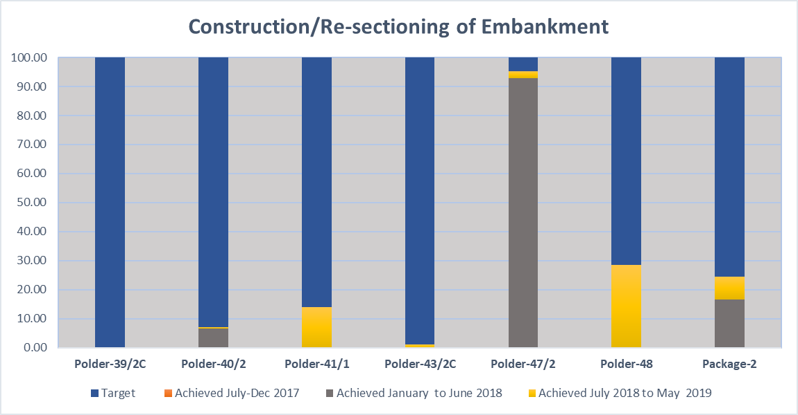

Figure 3‑53: Construction / Re-sectioning of Embankment of Package-2

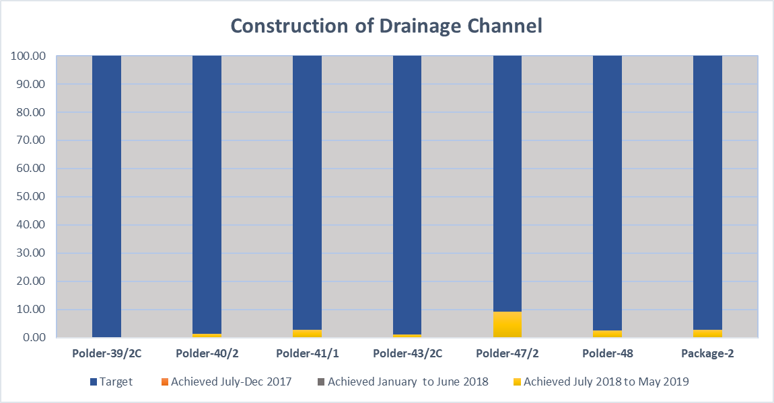

Figure 3‑54: Construction of Drainage Channel of Package-2

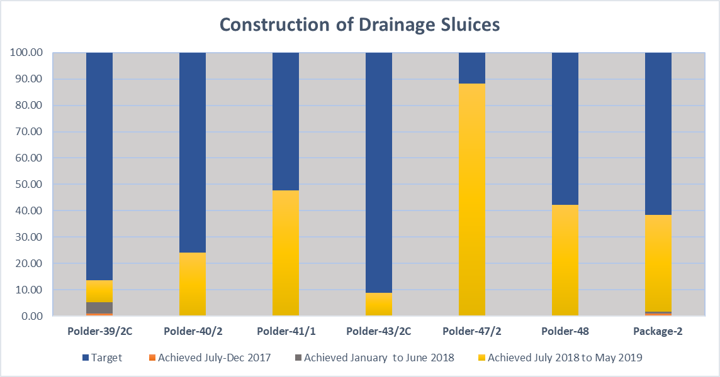

Figure 3‑55: Construction of Drainage Sluice of Package-2

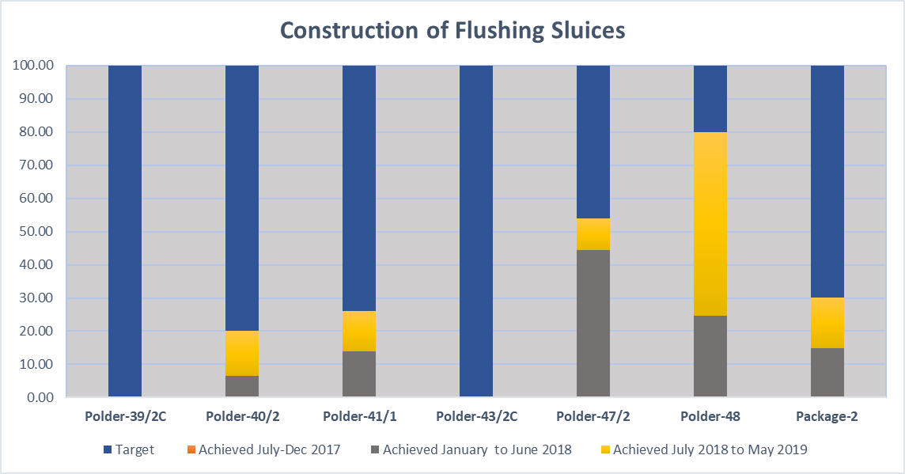

Figure 3‑56: Construction of Flushing Sluice of Package-2

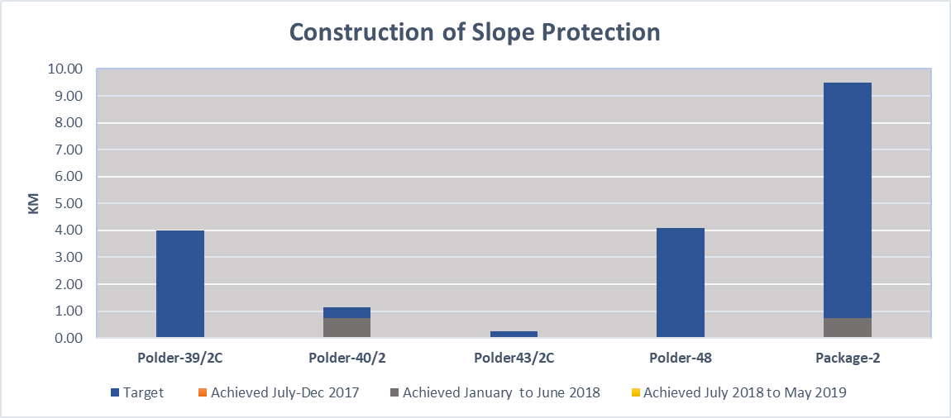

Figure 3‑57: Construction of Slope Protection of Package-2

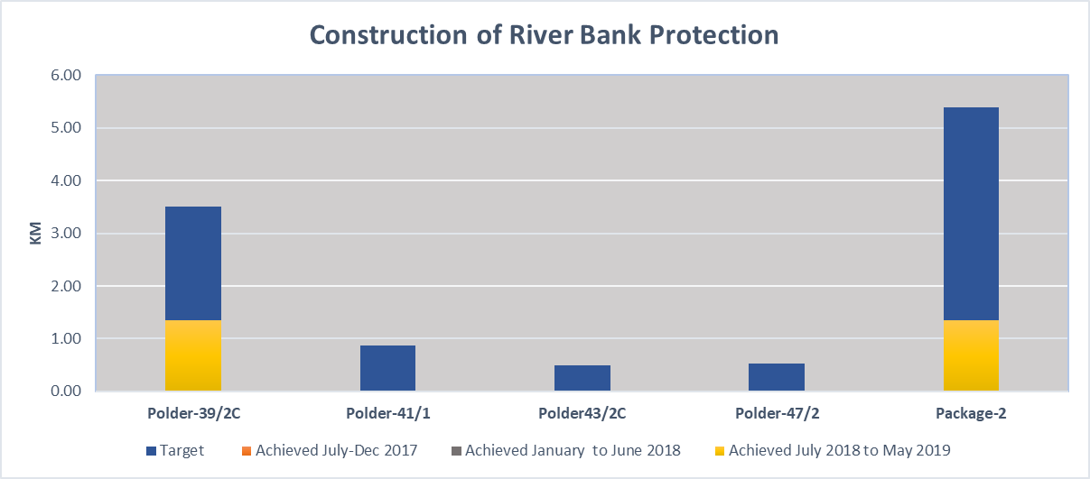

Figure 3‑58: Construction of River Bank Protection of Package-2

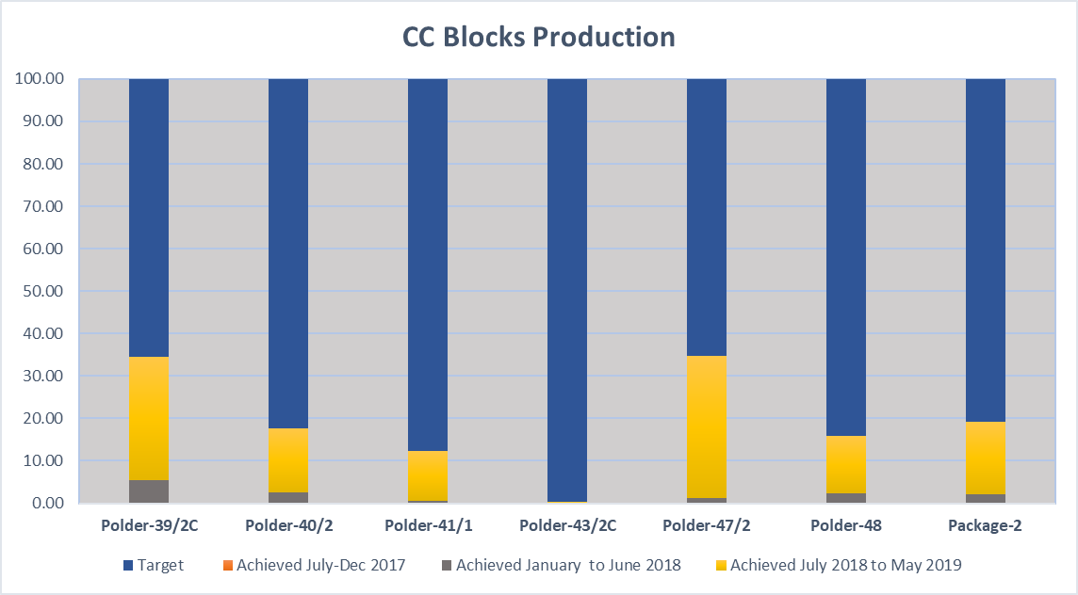

Figure 3‑59: CC Blocks Production of Package-2

Table 3‑73: Progress of Package-2 as on May 2019

|  |  |  |  |  |
| --- | --- | --- | --- | --- |
| **Item** | **Unit** | **Contract Quantity** | **Status 31 May 2019** | |
| Embankment Construction/Re-sectioning | Km | 208.710 | 18.82 | (F) |
| 12.280 | (P) |
| Drainage Channel Excavation/Re-excavation | Km | 154.632 | 16.77 | (F) |
| Drainage Sluice Construction | No. | 50 | 0 | (F) |
| 19 | (P) |
| Drainage Sluice Repair | No. | 6 | 0 | (F) |
| 1 | (P) |
| Flushing Inlet Construction | No. | 53 | 0 | (F) |
| 15 | (P) |
| Flushing Inlet Repair | No. | 30 | 0 | (F) |
| 2 | (P) |
| Embankment Slope Protection Work | Km | 9.480 | 0.00 | (F) |
| River Bank Protection Work | Km | 5.395 | 1.350 | (F) |
| Construction of Road Pavement | Km | 51.00 | 0.000 |  |
| Construction of RCC Flood Wall | Km | 17.00 | 0.000 |  |
| Closure Dam Construction | No. | 8 | 0 |  |

Table 3‑74: CC Blocks Production as on May 2019



### **Advance Payments**

The contractor has received 2nd instalment of 5% Advance Payment having Total expenditure incurred against advance payment is BDT: 1028.40 M.

The site works of Package-2 are going on with sufficient machineries and equipment.

Contractor of Package-2 has mobilized its Chinese Engineers and supporting personnel and its local labour force and this will be increasing onward. Shipment of heavy equipment at all sites from China has mainly been done. The deployment list of contractor staff (Chinese People) is appended below in Table 3‑75. The Contractor has established their site offices at Bhandaria, Kalapara, Barguna, Patharghata and their field head quarter at Patuakhali.

Table 3‑75: Contractor Staffs available in Package-2

|  |  |  |  |  |  |  |  |  |  |  |
| --- | --- | --- | --- | --- | --- | --- | --- | --- | --- | --- |
| **SN** | **Description** | **Total Nos.** | **Dhaka** | **P’khali** | **Polder-39/2C** | **Polder-40/2** | **Polder-41/1** | **Polder-43/2C** | **Polder-47/2** | **Polder-48** |
| 1 | Management |  | 0 | 0 | 0 | 0 | 0 | 0 | 0 | 0 |
| 2 | Technical Staff | 146 | 0 | 3 | 34 | 10 | 32 | 13 | 24 | 30 |
| 3 | Admin/Support | 45 | 6 | 6 | 8 | 6 | 6 | 3 | 5 | 5 |
| 4 | Operator/Driver | 176 | 2 | 3 | 74 | 20 | 29 | 9 | 16 | 23 |
| 5 | Skilled Labour | 311 | 0 | 0 | 4 | 60 | 42 | 10 | 130 | 65 |
| 6 | Unskilled Labour | 986 | 5 | 8 | 301 | 155 | 255 | 70 | 69 | 123 |
| **Total=** | | **1,664** | **13** | **20** | **421** | **251** | **364** | **105** | **244** | **246** |

### **Equipment mobilization**

Equipment including, machines, tools, barges, etc. have been purchased and deployed at site. Equipment including Excavators, Dump trucks, Rollers, Pay Loaders, Automated CC Block manufacturing plants and Tippers are at site.

The target of the 1st dry season is to manufacture CC block in connection with River Bank Protection work. Thus 5 nos. automated CC block manufacturing Machines are installed at the CC blocks manufacturing Yard in Polder-39/2C. Some CC block will also be manufactured manually, for which CC block manufacturing started in Polder-40/2, Polder-41/1, Polder-43/2C, Polder-47/2, & Polder-48.

A length of 18.82 km full and 12.28 km Partially Embankment Re-sectioning work has been completed.

Construction of 15Nos. Flushing Sluices and 19Nos. Drainage Sluices are in Progress.

Table 3‑76: Mobilisation List of Equipment for Package-2

| **S/N** | **Description** | **Sub-Total** | **39/2C** | **40/2** | **41/1** | **43/2C** | **47/2** | **48** | Remarks |
| --- | --- | --- | --- | --- | --- | --- | --- | --- | --- |
| *1* | *2* | *5* | *6* | *7* | *8* | *9* | *10* | *11* | *12* |
| 1 | Bulldozer | 7 | - | 1 | 2 | 1 | 2 | 1 |  |
| 2 | Excavator | 53 | 4 | 6 | 29 | 2 | 6 | 6 | Partially belongs to Sub-contractor |
| 3 | Loader | 21 | 10 | 3 | 2 | 1 | 2 | 3 |  |
| 4 | Compaction Roller | 4 | 1 | 1 | 1 |  | 1 |  |  |
| 5 | Water Tanker | 5 | 1 | 1 | 1 |  | 1 | 1 |  |
| 6 | Fork Lift | 65 | 61 |  | 2 |  |  | 2 |  |
| 7 | Dump Truck | 78 | 15 | 16 | 12 | 2 | 9 | 23 |  |
| 8 | Pick Up | 3 | 2 |  | 1 |  |  |  |  |
| 9 | Light Truck | 3 | 1 |  | - |  | 1 | 1 |  |
| 10 | Flat Truck | 11 | 4 | 1 | 3 |  | 1 | 2 |  |
| 11 | Crane Truck | 3 | - |  | 1 |  | 1 | 1 |  |
| 12 | Lorry-Mounted Crane | 1 | 1 |  | - |  |  |  |  |
| 13 | Diesel Tanker | 4 | 1 |  | 1 |  | 1 | 1 |  |
| 14 | Hydraulic Breaking Hammer | 3 | 1 |  | 1 |  | 1 |  |  |
| 15 | Pile Driver Clamps | 9 | 2 | 1 | 2 |  | 2 | 2 |  |
| 16 | Pile Driver | 6 | 2 |  | 4 |  |  |  |  |
| 17 | Belt Conveyor | 8 | 6 |  | - |  | 1 | 1 |  |
| 18 | CC Block Manufacturing Machine | 5 | 5 |  | - |  |  |  |  |
| 19 | Concrete Transportation Pump | 4 | 2 |  | - |  |  | 2 |  |
| 20 | Concrete Mixing Plant | 1 | - |  | - |  |  | 1 |  |
| 21 | Concrete Mixer | 37 | 7 | 3 | 8 |  | 7 | 12 |  |
| 22 | Steel Bar Bending Machine | 5 | 1 | 1 | 1 |  | 1 | 1 |  |
| 23 | Steel Bar Cutting Machine | 2 | 1 |  | 1 |  |  |  |  |
| 24 | Boat | 3 | 2 |  | 1 |  |  |  |  |
| 25 | Tugboat | 2 | 2 |  | - |  |  |  |  |
| 26 | Barge | 4 | - |  | - |  | 2 | 2 |  |
| 27 | Motorcycle | 4 | 2 |  | 1 |  |  | 1 |  |
| 28 | Generator | 38 | 16 | 3 | 8 |  | 6 | 5 |  |
| 29 | Air Compressor | 7 | 1 | 1 | 1 |  | 2 | 2 |  |
| 30 | Level Machine | 9 | 3 | 1 | 2 |  | 1 | 2 |  |
| 31 | GPS | 4 | 1 |  | 1 | 1 | 1 |  |  |
| 32 | Total Station | 1 | 1 |  |  |  |  |  |  |
| 33 | Deep Water Measuring Instrument | 48 | - | 12 | 1 |  | 26 | 9 |  |
| 34 | Submersible Pump | 128 | 19 | 16 | 32 | 27 | 25 | 9 |  |
| 35 | Slush Pump | 59 | 24 | 3 | 6 |  | 15 | 11 |  |
| 36 | Fresh Water Pump | 89 | 30 | 3 | 7 |  | 2 | 47 |  |
| 37 | Self-Priming Pump | 11 | 11 |  |  |  |  |  |  |
| 38 | Single-Cylinder Diesel Engine Pump | 16 | - |  | 8 |  | 4 | 4 |  |
| 39 | Business Car | 4 | 1 | 1 | 1 | - | - | 1 |  |
| **Total=** | | **765** | **241** | **74** | **141** | **35** | **121** | **153** |  |

|  |  |
| --- | --- |
| 1 (4) | 三号场地砌块堆码 |
| Figure 3‑60: CC Blocks dumping for slope protection work (KM51+041-53+418) in Polder 39/2C | Figure 3‑61: *Manufactured CC Blocks piled at the permanent storing yard #A2 in Polder 39/2C* |
| 砌块边坡摆放 | DS-2     5 |
| Figure 3‑62: *Completed section of slope protection work (KM51+041-53+418) in Polder 39/2C* | Figure 3‑63: *Form dismantling for slope protection work of DS-02 in Polder 40/2* |
| DS-5  3 | 砼预制块生产 |
| Figure 3‑64: *Form work for end sill of DS-05 in Polder 40/2* | Figure 3‑65: *CC Blocks manufacturing at yard #2 (KM13+000) in Polder 41/1* |

|  |  |
| --- | --- |
| DS-4水渠挖方 | FS-2水闸修复2 |
| Figure 3‑66: Excavation / Re-sectioning for drainage channel of DS-04 (KM0+000-0+260) in Polder 41/1 | Figure 3‑67: *Repairing for FS-02 in Polder 41/1* |
| 堤坝土方 1 | 水渠开挖 |
| Figure 3‑68: *Earth work for embankment KM0+900-1+300 in Polder 43/2C* | Figure 3‑69: *Excavation / Re-sectioning for drainage channel of DS-07 (KM0+000-2+440) in Polder 43/2C* |
| DS-07 混凝土浇筑 1 | 排水渠开挖 |
| Figure 3‑70: *RCC for floor (R/S) of DS-07 in Polder 43/2C* | Figure 3‑71: *Excavation / Re-sectioning for drainage channel of DS-03 in Polder 47/2* |

|  |  |
| --- | --- |
| DS1水闸CS预制块施工照片 | 预制块施工照片1 |
| Figure 3‑72: CC Blocks placing for loose apron (C/S) & slope of DS-01 in Polder 47/2 | Figure 3‑73: *CC Blocks manufacturing at yard #1 (KM7+000) in Polder 47/2* |
| F:\KMC research\CEIP-1 PACKAGE-1\Site Investigation Report of Polder 32\NEW PIC\20180104_140935.jpg | Back filling for DS-01 |
| Figure 3‑74: *Discuss with EPs in chainage km 44+000 to km 44+500* | Figure 3‑75: *Back filling for DS-01 in Polder 48* |
| Earth work for embankment 16+134-17+000 1 | Sythetic bags placing for emergency work 31+280-408 |
| Figure 3‑76: *Earth work for embankment KM16+134-17+000 in Polder 48* | Figure 3‑77: *Synthetic bags placing for emergency slope protection work 31+280-31+408 in Polder 48* |

### **Plans for execution of works**

The contractor was advised to proceed with the top priority set of civil works, namely all bank protection works across four Polders (Polder-39/2c, 41/1, 47/2 & 43/2C) during the dry sessions 2017-2020. As per the rate of progress of land availability and land acquisition plans, it is noted that a part of the land acquisition at five Polders (except the Polder-39/2C) does not pose any problem.

**Program for June’ 2019**

**Polder-39/2C:**

**CC block manufacturing yard 1: (A) at Nazmula**

* To manufacture monthly scheduled 100, 000 Nos. Of CC blocks of 400 x 400 x 400mm;

**CC block manufacturing yard 2: (A1) at Charkhali**

* To manufacture monthly scheduled 50,000 Nos. Of CC blocks of 400 x 400 x 400mm;

**CC block manufacturing yard 3: (B) at Talikhali**

* To manufacture monthly scheduled 100, 000 Nos. Of CC blocks of 400 x 400 x 400mm;

**Other Construction**

* To complete railing of DS-12;
* To complete Construction of DS-07.
* CC Blocks dumping: 350,000 nos.

**Polder-40/2:**

* To complete railing of FS-4/1 and installation of gates.
* To cast CC Block
* To progress the Construction of embankment from Km 6.650 to Km 7.500 & km 9.00 to

Km 13.00.

* To progress the construction work of DS-2, DS-3, DS-4/5, FS-9 & FS-10.

**Polder-41/1:**

* To cast CC Block.
* To complete railing of FS-08, FS-09, FS-15 and installation of gates.
* To progress the construction work of DS-1, DS-5, DS-6, DS-7, DS-8, DS-9, FS-1 & FS-3.
* To complete the excavation of Napit Khali Khal and Charnala Khal.

Polder-43/2C

* To progress the re-sectioning work of embankment from km 0.900 to km 4.028.
* To start the construction work of FS-1 (A).
* To progress the work of DS-7.
* To complete the re-excavation of Taltoli drainage khal of DS-7.

**Polder-47/2:**

* To complete operating platform & railing of FS-1, FS-6, FS-7 and installation of gates.
* To cast CC Block.
* To progress construction work of DS-1, DS-2, DS-3 & DS-4.
* To complete the excavation work of Dhankola Khal, Eidkhola Khal, Kichikata Khal & Piarpur Khal.

**Polder-48:**

* To complete railing of FS-4 and installation of gates.
* To cast CC Blocks
* To progress the construction work of DS-1, DS-3/2, DS-3/4, FS-1 and FS-3
* To progress the re-sectioning work of embankment from Km 16.000 to Km 17.50 & Km 34.000 to Km 34.60
* To complete the slope protection work of sea dyke.
* To complete the excavation work of Charchapli Khal & Kaliapara Khal

Other structures and embankment works are to be started in FY 2019-2020. Site activities on all structures will through first, second and third dry season. The majority of the sites works are scheduled during the remaining dry seasons.

### **Construction of Regional of Building at Patuakhali and others building at Kalapara and Pathorghata**

**Regional office building at Patuakhali:**  Contractor has prepared a detailed design of the Regional Office Building at Patuakhali which has been submitted to PMU and approved by PD, PMU, CEIP-1. Approved detailed design has been sent to the contractor to start the building at Patuakhali. and the contractor has been issued a letter to commence construction. The Contractor has started the mobilization for construction of Regional office building.

**Vertical Extension of BWDB’s existing office building at Kalapara:** The Building has been completed and handed over to the competent authority.

**Rest house re-construction at Pathorghata: The process for** Re-construction work of Rest House was taken up in due time but kept postponed as per verbal instruction of the Employer. The construction work of Boundary Wall is in progress.

**Laboratory Building at Patuakhali:** The building has been completed and handed over.

### **Emergency works in Polder-40/2, 41/1, 47/2 & 48:**

**Emergency work in Polder-40/2 (km 12.92 to km 12.989, km 13.215to km 13.411 and km 13.992 to km 14.077: cost BDT 2.795 millions):** Earth work in connection with emergency Ring-dyke Construction in polder-40/2 along the alignment of the damaged embankment is complete.

Placing of Geo-textile bags on the river side slope of Ring-dyke to protect the slope from wave action is completed.

**Emergency work in Polder-41/1: (km 5.139 to km 5.189:** Cost BDT 0.585 million) Dumping of earth filled Synthetic bag along the river side slope of the damaged embankment in Polder-41/1 has been completed.

Over all progress is 100%

**Emergency work in Polder-47/2: (km 6.168 to km 6.618):** Backing of the Embankment by earth filling is complete. Subsequent wave action needed additional temporary protection by sand filled Geo-bags and palisading works, which has been completed.

**Emergency work in Polder-48:**

1. (Km 31.060 to km 31.220; km 31.280 to km 31.408; km 34.305 to km 34.525): Sea dyke slope protection work by Geo-bag, Gunny bag, Bullah, Bamboo etc has been completed.
2. Emergency work from km 31.060 to km 31.220 and km 31.280 to km 31.408 has been started from 9th April, 2019 and the work is in progress.

|  |  |
| --- | --- |
|  |  |
| Figure 3‑78: Emergency Work of Polder-48 | |

Table 3‑77: Summary of Emergency works under the head of “Environmental Mitigation Works”



**Total available budget as per Contract is BDT: 12,000,000.00**

Table 3‑78: Summary of Emergency works under the head of “Physical & Price Contingency”



Table 3‑79: Detailed of Emergency Works under the head of “Provisional Sum”

|  |  |  |  |  |  |  |  |  |  |
| --- | --- | --- | --- | --- | --- | --- | --- | --- | --- |
| **Sl. No.** | **Polder No.** | **Chainage** | | **Length (Km)** | **Name of location** | **Engineer Approved Date** | **Estimated Cost in BDT** | **Remarks** | **Year** |
| **From** | **To** |
| 1 | Polder-39/2C | 54.195 | 54.372 | 0.177 | Nadmulla | 16-May-18 | 1,666,992.00 | Environmental Mitigation Work (Specified Provisional Sum) | FY 2017-18 |
| 2 | Polder-40/2 | 12.920 | 12.989 | 0.069 | Tafalbaria Pathorghata | 14-Nov-17 | 2,795,174.46 | Do | FY 2017-18 |
| 3 | Polder-40/2 | 13.215 | 13.411 | 0.196 | Amount 2795174.46 | 14-Nov-17 |  | Do | FY 2017-18 |
| 4 | Polder-40/2 | 13.992 | 14.077 | 0.085 | Amount 2795174.46 | 14-Nov-17 |  | Do | FY 2017-18 |
| 5 | Polder-41/1 | 5.139 | 5.189 | 0.050 | Burir Char Barguna | 22-Aug-17 | 560,125.89 | Do | FY 2017-18 |
| 6 | Polder-47/2 | 6.168 | 6.618 | 0.450 | Kalapara | 2-Oct-17 | 1,454,046.70 | Do | FY 2017-18 |
| 7 | Polder-47/2 | 6.635 | 6.660 | 0.025 | Kalapara |  | 154,515.16 | Do | FY 2017-18 |
| 8 | Polder-47/2 | 6.453 | 6.478 | 0.025 | Kalapara | 15-Jul-18 | 168,575.92 | Do | FY 2017-18 |
| 9 | Polder-47/2 | 31.28 | 31.408 | 0.128 |  |  | 1,418,282.41 | Do | FY 2017-18 |
| 10 | Polder-47/2 | 34.305 | 34.525 | 0.220 |  |  | 3,677,570.07 | Do | FY 2017-18 |
| **Total** |  |  |  | **1.425** |  |  | **11,895,282.61** |  |  |

Table 3‑80: Detailed of Emergency Works under the head of “Physical & Price Contingency”

|  |  |  |  |  |  |  |  |  |  |
| --- | --- | --- | --- | --- | --- | --- | --- | --- | --- |
| **Sl. No.** | **Polder No.** | **Chainage** | | **Length (Km)** | **Name of location** | **Engineer Approved Date** | **Estimated Cost in BDT** | **Remarks** | **Year** |
| **From** | **To** |
| 1 | Polder-39/2C | 0.275 | 0.440 | 0.165 | Bhandaria, Bamuner Khal | 24-Mar-18 | 1,677,973.00 | Physical and Price Contingency | FY 2017-18 |
| 2 | Polder-47/2 | 6.300 | 6.375 | 0.075 | Kalapara | 01-Aug-18 | 555,379.53 | Do | FY 2017-18 |
| 3 | Polder-47/2 | 6.550 | 6.592 | 0.042 | Kalapara | 01-Aug-18 | 290,209.45 | Do | FY 2017-18 |
| 4 | Polder-47/2 | 6.670 | 6.692 | 0.022 | Kalapara | 01-Aug-18 | 109,704.67 | Do | FY 2017-18 |
| 5 | Polder-47/2 | 6.710 | 6.727 | 0.017 | Kalapara | 01-Aug-18 | 103,196.95 | Do | FY 2017-18 |
| 6 | Polder-48 | 31.060 | 31.220 | 0.160 | Kuakata |  | 1,233,611.30 | Do | FY 2017-18 |
| 7 | Polder-48 | 31.280 | 31.408 | 0.128 | Kuakata | 29-Jul-18 | 1,418,282.41 | Do | FY 2018-19 |
| 8 | Polder-48 | 34.305 | 34.525 | 0.220 | Kuakata | 29-Jul-18 | 3,677,570.07 | Do | FY 2018-19 |
| **Total** |  |  |  | **0.829** |  |  | **9,065,927.38** |  |  |

### **Finance (Invoices) Contractor Package-2**

IPC-01 of Contractor package-2 concerned the first instalment of the 5% Advanced payment and was paid on 28 June 2017.

IPC-02 concerned the second instalment of the 5% Advanced payment which was recommended by the Engineer and was paid by the Employer on June 2018

IPC-3 was recommended by the Engineer and paid by the Employer on 20 June 2018

IPC-4 was submitted to the Employer on 29th October 2018 by the Engineer with recommendation for payment.

IPC-5 was submitted to the Engineer on 27 December 2019 and it was sent by the Engineer to the Employer on 10 January 2019 with recommendation for payment.

IPC-6 was submitted to the Engineer on 28 February 2019 and the IPC was sent by the Engineer to the Employer on 14 March 2019 with recommendation for payment.

IPC-7 has been submitted to the Engineer on 28 April 2019 and the IPC was sent by the Engineer to the Employer on 05 May 2019 with recommendation for payment.

### **Contract Modifications**

The block sizes 60cmx60cmx60cm & 60cmx60cmx40cm have been incorporated in the approved design for the slope protection work of Polder-48. But the provision of these sizes of blocks were not in the Contract BOQ. Hence the Contractor submitted a Variation Order for these new sizes of blocks and the Variation Order was reviewed by the Consultants and a Draft Variation Order was submitted to the PMU. The Project Director has given some observations on the Draft Variation Order and accordingly the Draft Variation Order is under process of finalization in consultation with the PMU.

### **S-Curve of Package-2**

The revised work program has been submitted by the Contractor in October 2018.The revised work program has been reviewed by the Consultants and sent to PMU. The S-curve has been prepared based on the revised program and the same has been incorporated in the Monthly Progress Report of May 2019.

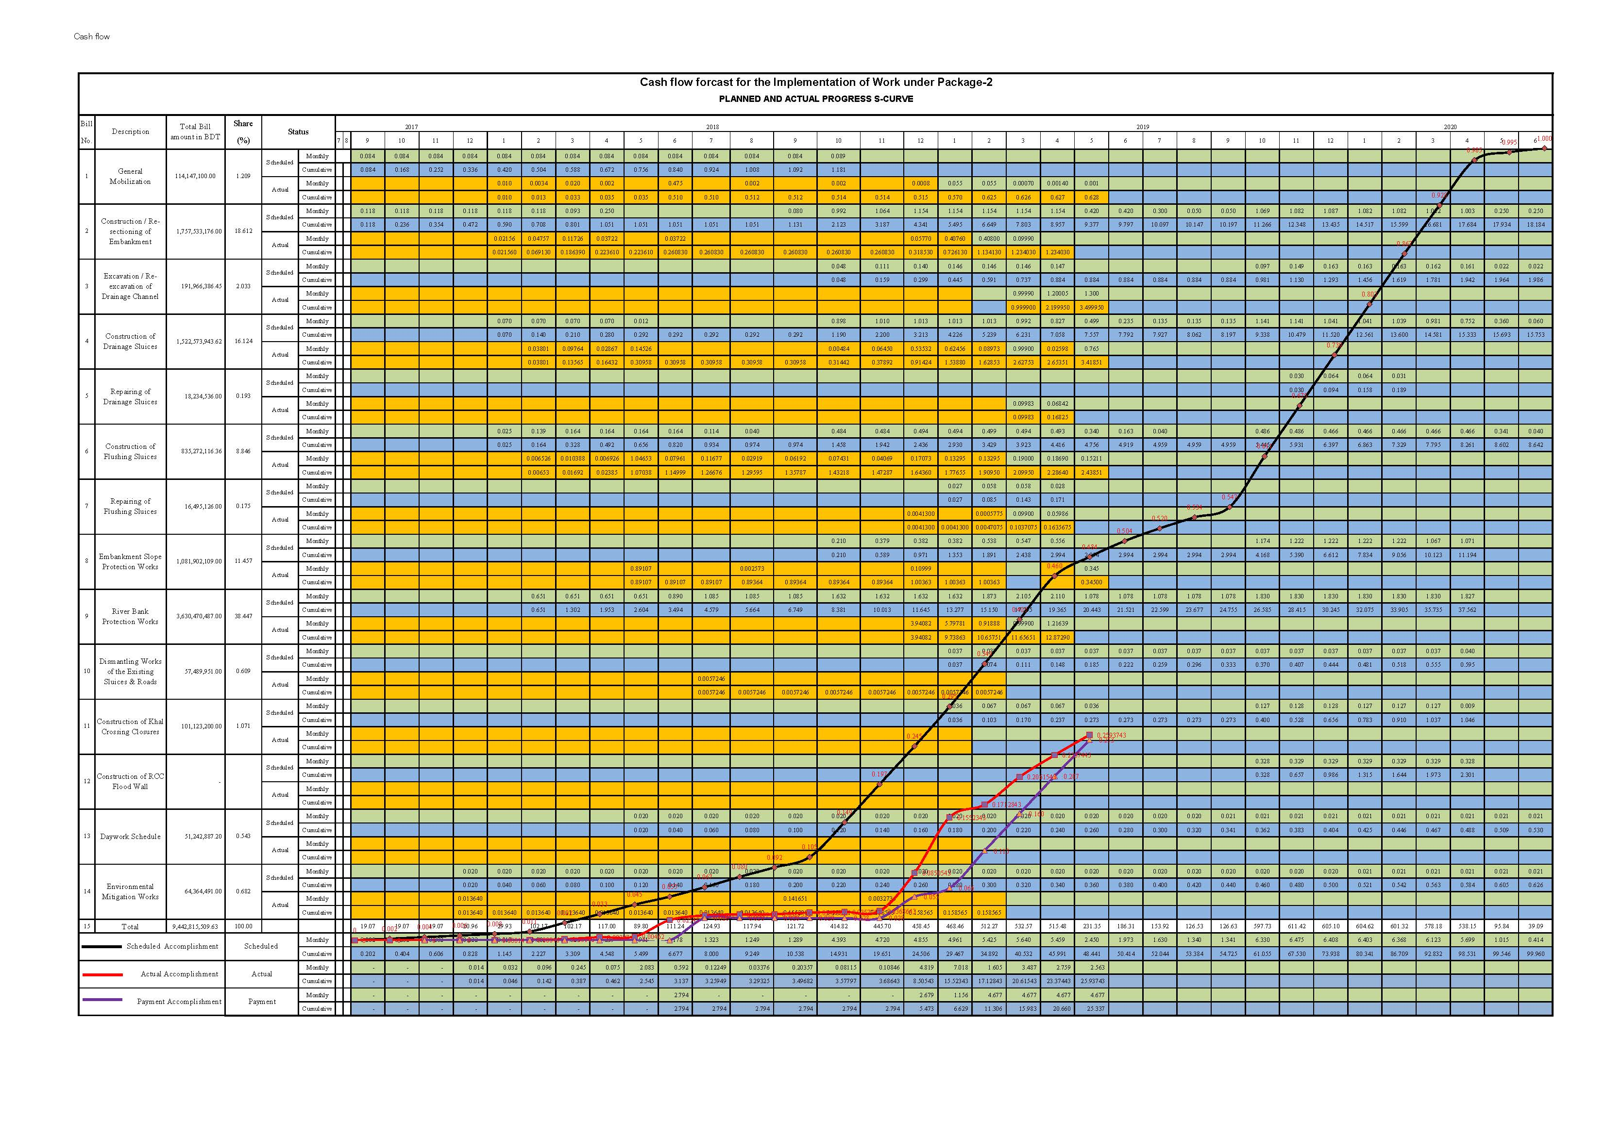

Figure 3‑79: S-Curve for Package-2

### **RAP implementation**

See sections here above, Package-2.

### **LAP implementation**

See sections here above, Package-2.

### **Progress on Purchase of vehicles**

1. **Purchase of Vehicle (Pkg-2)**
2. Three number Cross Country Vehicle have been procured and delivered to the PD on 26 June 2018.
3. Two number Pickups and five number Motor Cycles have been procured and delivered to the field office of the Consultants on 10 January 2019.

## Task D: Project Management Support Services

### **Financial Projection**

No data yet were established to show financial disbursements. The preparation of October need stakeholders’ discussions/deliberations to determine the figures and numbers. Disbursements of funds for IPCs are well-known and the planned future disbursements depend on the work plan works scheduling. IPC is submitted when the monetary value of the works done over a new period reaches a threshold value (percentage of the contract value). In general, during a good construction season, each IPC amount of every month to be minimum US$ 3.01 Million and US$ 8.27 Million for Package-1 & Package-2 respectively considering extension of time up to June 2020 for Package-1 and completion time June 2020 of Package-2 (accelerated program).

The Contractors have submitted the S-curves of Package-1 & 2 based on the revised work program, hence the financial projection has been reflected in the MPR of May 2019. The next IPCs are, however, expected by June 2019 for both the packages

**Monthly Forecast of Payment of Package-W-02:**

Table 3‑81: Tentative forecast of Payment of Package-2

|  |  |  |  |  |
| --- | --- | --- | --- | --- |
| **IPC No.** | **Month of Submission** | **Forecast Value of IPC** | | **Remark** |
| No.04 | Oct. 2018 | 252,984,708.63 | | IPC No. 04 was submitted with the value of BDT: 252,984,708.63 which was reviewed by the Consultants and sent to PMU. The Project Director has returned back the IPC No. 4 with some observations. The IPC has been corrected based on the observations and sent to PMU with the recommendation for payment. |
| No.05 | Dec. 2018 | 728,380,000.00 | | IPC No. 05 was submitted by the Contractor with the value of BDT: 109,166,283.55 which was reviewed by the Consultants and sent to PMU on 10 January 2019 with the recommendation for payment. |
| No.06 | Jan. 2019 | 229,100,000.00 | | IPC No. 06 was submitted by the Contractor with the value of BDT: 441,633,749.60 which was reviewed by the Consultants and sent to PMU on 14 March 2019 with the recommendation for payment. |
| No.07 | Mar. 2019 | 442,400,000.00 | | IPC No. 07 was submitted by the Contractor with the value of BDT: 685,706,756.39 which was reviewed by the Engineer and submitted to the Employer on 05 May 2019 with recommendation for payment. |
| No.08 | Apr. 2019 | 237,000,000.00 | |  |
| No.09 | May 2019 | 244,900,000.00 | |  |
| No.10 | Jun. 2019 | 244,900,000.00 | |  |
| **Total** | | **2,379,664,708.63** |  | |

### **Modification of Consultancy Contract**

Modified Consultancy Contract No.2 has been approved and signed between the Employer and the Consultants. Some local personnel have already been deployed to the sites of Contract Package-2 and other personnel will be deployed as per requirement. Modified Consultancy ContractNo.3 has been revised and submitted to the Project Director to consider for smooth running of the Project.

### **Support to PMU**

The same support activities are being provided and enhanced as in the case of Package-1 PMS tasks.

## Consultant Inputs

### **Staffing and staff changes approved or in process during the month**

Table 3‑82: Overview of Staffing (including Proposed Replacements)

| **Description of Staffs** | **Position** | **Original Staff** | **Current Staff** | **Remarks** |
| --- | --- | --- | --- | --- |
| **A. International Key Staff** | Team Leader | Jean Henry Laboyrie | Derk Jan (Dick) Kevelam |  |
| Design Engineer | Alec Sleigh | Arend jan van de kerk |  |
| River Training Engineer | Bert te Slaa | Bert te Slaa |  |
| Sociologist/Resettlement Specialist | Dr. Salim Zaman | Dr. Salim Zaman |  |
| Quantity Surveyor - 1 | Barbara Hellet | Mr. Rainier Manansala Dela Cruz |  |
| Construction Resident Engineer - 1 | Trevor Morish Hale | Trevor Morish Hale |  |
| Construction Resident Engineer - 2 | Gerard Pichel | Mr. Richard David Mann |  |
| Contract Management Specialist | Rob Brouwer | Rob Brouwer |  |
| Procurement Specialist | Barbara Hellet | Barbara Hellet |  |
| Environmental Specialist | Henk Blok | Henk Blok |  |
| Morphological Modeler | Henrik Rene Jensen | Henrik Rene Jensen |  |
| Environmental Specialist | Anders Malgrem Hansen | Anders Malgrem Hansen |  |
| Quantity Surveyor - 2 | Andrew Cook | Andrew Cook |  |
| **B. International Non-Key Staff** | Sociologist/Resettlement Specialist | Roy Timmer | Dr. Salim Zaman |  |
| Geo-Technical Engineer | Joost van der Schrier | Joost van der Schrier |  |
| Estuary and River Morphology Modeler | Bo Brahtz Christensen | Bo Brahtz Christensen |  |
| River and Coastal Expert | Ranjit Galappatti | Ranjit Galappatti |  |
| **A. National Key Staff** | Deputy Team Leader | Md. Habibur Rahman | Md. Habibur Rahman |  |
| Deputy Resident Engineer - 1 | Mazibur Rahman Khan | Mr. A.K.M. Sayeed Uddin |  |
| Deputy Resident Engineer - 2 | Md. Gulzer Hossain | Mr. Mohammad Ali |  |
| Re-settlement Specialist/Sociologist | Kh. Khairul Matin | Md. Zainal Abedin |  |
| Design Engineer | Md. Anwar Hossain Bhuiyan | Md. Anwar Hossain Bhuiyan |  |
| **A. National Non-Key Staff** | Geo-Technical Engineer | Md. Nurul Islam | Md. Nurul Islam |  |
| Design Engineer | Mr. Mahbubur Rahman | Mr. Mahbubur Rahman |  |
| Environmentalist | Sheikh Muhammad Abdur Rashid | Sheikh Muhammad Abdur Rashid |  |
| Sociologist/Resettlement Specialist | Md. Ferdous Rahman | Md. Ferdous Rahman |  |
| Geographical Information System Expert | Md. Monirul Haque | Md. Monirul Haque |  |
| Procurement Specialist | Md. Humayun Kabir | Md. Aminur Rahman |  |
| Senior Estimator - 1 | Md. Ansar Ali Mia | Md. Ansar Ali Mia |  |
| Senior Estimator - 2 | Md. Nazrul Islam | Md. Nazrul Islam |  |
| Survey Engineer - 1 | Pankaj Kumar Moitra | Pankaj Kumar Moitra |  |
| Survey Engineer - 2 | Md. Amirul Islam | Md. Amirul Islam |  |
| Survey Engineer - 3 | ABM Anwar Haidar | Abu Taiub Mia |  |
| Junior Design Engineer - 1 | Ms. Selina Akhter | Ms. Selina Akhter |  |
| Junior Design Engineer - 2 | Ms. Shaikh Naureen Laila | Ms. Selina Akhter |  |
| Auto CAD Specialist - 1 | Ms. Marjan Mallik | Md. Asadujjaman |  |
| Auto CAD Specialist - 2 | Biprojit Paul | Ms. Nahid Farjana |  |
| River and Coastal Expert | Md.Zahirul Haque Khan | Md.Zahirul Haque Khan |  |
| Construction Supervision Engineer -1 | Md. Mukhlesur Rahman | Md. Mukhlesur Rahman |  |
| Construction Supervision Engineer - 2 | Shyamal Kumar Dutta | Shyamal Kumar Dutta |  |
| Construction Supervision Engineer - 3 | SK Golam Quader | Md. Mainul Islam |  |
| Construction Supervision Engineer - 4 | Abdul Jalil | Md. Didarul Alam |  |
| Quality Control Specialist - 1 | Md. Abdur Razzaque Khan | Md. Sheik Farid |  |
| Quality Control Specialist - 2 | Md. Sekendar Ali | Md. Rafiqul Alam |  |
| Procurement / Contract Management Specialist | Md. Tafazzal Ali | Md. Aminur Rahman |  |
| Environmental Specialist | Dr. Quazi Alamgir Kabir | Abu Bakr Siddique |  |
| Resettlement Specialist/Sociologist | Md. Mustafizur Rahman | Md. Mustafizur Rahman | N/A |
| Land Acquisition Officer | Benu Gopal Dey | Kh. Mahabub Alam |  |
| Geo-Technical and Foundation Specialist | Mizanur Rahman | Ashraf Ul Abedin | N/A |
| Mechanical Engineer - 1 | Monojit Kumar Bagchi | Monojit Kumar Bagchi | N/A |
| Mechanical Engineer - 2 | Md. Rashidul Islam | Md. Rashidul Islam |  |
| Agronomist | Dr. Santosh Kumer Sarker | Dr. Santosh Kumer Sarker | N/A |
| Fisheries Expert | Md. Mokammel Hossain | Md. Mokammel Hossain | N/A |
| Senior Estimator - 2 | Md. Nazrul Islam | Md. Nazrul Islam | N/A |
| Economist | Md. Aminul Islam | Md. Aminul Islam |  |
| Construction Supervision Engineer - 5 | Md. Sadiqul Islam (Modified Contract) | Md. Sadiqul Islam |  |
| Construction Supervision Engineer - 6 | Md. Ghiasuddin Ahmad (Modified Contract) | Md. Ghiasuddin Ahmad |  |
| Quality Control Specialist - 3 | Md. Ali Jinnah (Modified Contract) | Md. Ali Jinnah |  |
| Quality Control Specialist - 4 | Md. Harun Ur Rashid (Modified Contract) | Md. Harun Ur Rashid |  |
| **A. Others Staffs** | Field Engineer | Md. Hasibur Rahman | Md. Hasibur Rahman |  |
| Field Engineer | Md. Lakidul Islam | Md. Lakidul Islam |  |
| Field Engineer | Md. Samsul Alam -1 | Md. Samsul Alam -1 |  |
| Field Engineer | Md. Jamal Uddin | Md. Jamal Uddin |  |
| Field Engineer | Md. Sazzad Hossain | Md. Sazzad Hossain |  |
| Field Engineer | Tajuddin Ahmed | Tajuddin Ahmed |  |
| Field Engineer | S.M. Noor-A-Alom | S.M. Noor-A-Alom |  |
| Field Engineer | Khandaker Shamim Ahmed | Khandaker Shamim Ahmed |  |
| Field Engineer | Shakil Ahmed | Shakil Ahmed |  |
| Field Engineer | Md. Monirul Islam | Md. Monirul Islam |  |
| Field Engineer | Md. Shohel Rana | Md. Shohel Rana |  |
| Field Engineer | Md. Abdulla Al Mamun | Md. Abdulla Al Mamun |  |
| Field Engineer | Md. Mizanur Rahman | Md. Mizanur Rahman |  |
| Field Engineer | Joy Prokash Mondal | Joy Prokash Mondal |  |
| Field Engineer | Md. Mahadi Hasan | Md. Mahadi Hasan |  |
| Field Engineer | Md. Rakibul Islam Nahid | Md. Rakibul Islam Nahid |  |
| Field Engineer | Md. Rakibul Islam | Md. Rakibul Islam |  |
| Field Engineer | Shahidul Islam-1 | Shahidul Islam-1 |  |
| Field Engineer | Md. Lutfor Rahman | Md. Lutfor Rahman |  |
| Field Engineer | Md. Sumon Mia | Md. Sumon Mia |  |
| Field Engineer | Sufia Parvin | Sufia Parvin |  |
| Field Engineer | Zulfiqure Azeez | Zulfiqure Azeez |  |
| Field Engineer | Shahidul Islam-2 | Shahidul Islam-2 |  |
| Field Engineer | Md. Badarudduza | Md. Badarudduza |  |
| Office Manager | Md. Shahadat Hossain | Md. Shahadat Hossain |  |
| Office Manager (Khulna) | Jakir Hossen | Jakir Hossen |  |
| Office Manager (Patuakhali) | Mehede Hasan | Mehede Hasan |  |
| Accounts Officer | Md. Fazlul Karim Khan | Md. Fazlul Karim Khan |  |
| Office Secretary | Mahmuda Islam | Mahmuda Islam |  |
| Lab Technician | Md. Aminur Rahman | Md. Aminur Rahman |  |
| Lab Technician | Md. Kuddus Molla | Md. Kuddus Molla |  |
| Lab Technician | Lokshon Chandra Biswas | Md. Tuhin Miah |  |
| Computer Operator | Md. Abdulla Al Mamun | Md. Abdulla Al Mamun |  |
| Computer Operator | Md. Delowar Hossain | Md. Delowar Hossain |  |
| Computer Operator (Khulna) | Hosnewara Khatun | Hosnewara Khatun |  |
| Office Peon | Md. Jahangir Alam | Md. Jahangir Alam |  |
| Messenger | Sheikh Rabiul Islam | Sheikh Rabiul Islam |  |
| Chowkidar (Khulna) | Ariful Islam | Ariful Islam |  |
| Office Peon (Khulna) | Md. Sojib Hossen | Md. Sojib Hossen |  |
| Office Peon (Patuakhali) | Md. Rownaqul Islam | Md. Rownaqul Islam |  |
| Office Peon (Patuakhali) | Md. Babul Akhther | Md. Babul Akhther |  |
| Cleaner | Md. Shohidul Islam | Md. Shohidul Islam |  |

### **Monthly Forecast of Payment for Consultancy Services:**

**Tentative information on financial forecast of Payment for Consultancy Services is furnished in the Table below:**

Table 3‑83: Tentative information on financial of payment for DDCS & PMS Consultants

| **Invoice No.** | **Invoice Month** | **Submission Month** | **Value of Invoice (BDT)** | **Remarks** |
| --- | --- | --- | --- | --- |
| **Local Currency** | | |  |  |
| LC-22 | July-August 18 | October 18 | 20,605,743.00 |  |
| LC-23 | September-October 18 | November 18 | 17,000,000.00 |  |
| LC-24 | November-December 18 | January 19 | 16,000,000.00 |  |
| LC-25 | January - February 19 | March 19 | 20,000,000.00 |  |
| LC-26 | March-April 19 | May 19 | 17,000,000.00 |  |
| LC-27 | May-June 19 | June 19 | 15,000,000.00 |  |
| **Total** | | | **105,605,743.00** |  |
| **Foreign Currency** | | |  |  |
| FC-22 | July-August 18 | October 18 | 135,136.00 |  |
| FC-23 | September-October 18 | November 18 | 135,000.00 |  |
| FC-24 | November-December 18 | January 19 | 130,000.00 |  |
| FC-25 | January - February 19 | March 19 | 140,000.00 |  |
| FC-26 | March-April 19 | May 19 | 130,000.00 |  |
| FC-27 | May-June 19 | June 19 | 130,000.00 |  |
| **Total** | | | **800,136.00** |  |

### **Finance (Invoices) RHDHV/DDCS&PMS Consultants**

Table 3‑84: Overview of Consultants Invoices since Project Inception

|  |  |  |  |  |  |  |
| --- | --- | --- | --- | --- | --- | --- |
| **Sl No. of Invoices** | **Payment in EURO** | | | **Payment in BDT** | | |
| **Amount invoiced** | **Date submitted** | **Date paid** | **Amount invoiced** | **Date submitted** | **Date paid** |
| Advance Payment | 481,134.90 | 30-Dec-14 | 1-Apr-15 | 59,249,809.60 | 30-Dec-14 | 1-Apr-15 |
| Invoice No 1 | 50,908.14 | 25-May-15 | 11-Jun-15 | 1,119,426.94 | 15-June-15 | 16-Jun-15 |
| Invoice No 2 | 129,241.61 | 25-May-15 | 11-Jun-15 | 5,952,195.13 | 17-June-15 | 16-Jun-15 |
| Invoice No 3 (Part) | 60,000.00 | 21-June-15 | 22-Jun-15 | 7,967,524.20 | 30-Jun-15 | 30-Jun-15 |
| Invoice No 3 (Part) | 70,282.49 | 0.00 | 06-Oct-15 | 33,150,070.88 | 30-Jun-15 | 27-Sep-15 |
| Invoice No 4 | 206,972.03 | 27-Sep-15 | 02-Dec-15 | 14,332,732.78 | 27-Sep-15 | 29-Nov-15 |
| Invoice No 5 | 169,555.53 | 15-Nov-15 | 10-Dec-15 | 25,991,948.77 | 30-Nov-15 | 10-Jan-16 |
| Invoice No 6 | 74,062.24 | 17-Jan-16 | 04-Feb-16 | 14,590,698.64 | 03-Jan-16 | 27-Jun-16 |
| Invoice No 7 | 201,749.51 | 01-June-16 | 30-Jun-16 | 15,016,503.44 | 19-June-16 | 30-Jun-16 |
| Invoice No 8 | 140,967.65 | 01-June-16 | 30-Jun-16 | 692,718.66 | 19-June-16 | 30-Jun-16 |
|  | 0.00 |  |  | 36,351,389.86 | 19-June-16 | 10-Nov-16  (Partly Paid) |
| Invoice No 9 | 153,881.30 | 30-June-16 | 30-Jun-16 | 19,138,626.07 | 27-Nov-16 | 02-Mar-17 |
| Invoice No 10 | 243,824.28[[11]](#footnote-11) | 23-Oct-16 | 09-Nov-16 | 15,095,311.81 | 27-Nov-16 | 02-Mar-17 |
| Invoice No 11 | 224,255.11 | 06-Nov-16 | 1-Jun-17 | 15,623,144.38 | 07-Dec-16 | 18-May-17 |
| Invoice No 12 | 211,748.62 | 15-Jan-17 | 1-Jun-17 | 51,335,041.98 | 15-Jan-17 | 18-May-17 |
| Invoice No 13 | 149,954.66 | 10-Apr-17 | 1-Jun-17 | 25,796,446.77 | 16- Mar-17 | 18-May-17 |
| Invoice No 14 | 51,073.50 | 3-May-17 | 18-06-17 | 9,847,754.23 | 1 Jun-17 | 29-Jun-17 |
| Invoice No 15 | 359,744.20 | 16-Oct-17 | 10-Dec-17 | 18,863,496.23 | 29-Jun-17 | 29-Jun-17 (Partly Payment) |
| 0.00 | 16-Oct-17 | 10-Dec-17 | 3,123,876.54 | 10-Dec-17 | 10-Dec-17 (Partly Payment) |
| Invoice No. 16 | 82,732.65 | 26-Oct-17 | 10-Dec-17 | 28,318,643.89 | 10-Dec-17 | 29-Jan-18 |
| Invoice No. 17 | 129,562.33 | 22-Nov-17 | 03-Dec-17 | 1,597,5427.00 | 10-Dec-17 | 29-Jan-18 |
| Invoice No. 18 | 216,541.94 | 25-Feb-18 | 30-Apr-18 | 18284749.64 | 19-Apri-18 | 30-Apr-18 |
| Invoice No. 19 | 126,541.94 | 15-Apr-18 | 30-Apr-18 | 25067376.46 | 19-Apri-18 | 30-Apr-18 |
| Invoice No. 20 | 90,204.56 | 4-Jun-18 | 9-Jun-18 | 36,031,005.53 | 27-May-18 | 9-Jun-18 |
| Invoice No. 21 | 85,705.24 | 21-June-18 | 30-June-18 | 18,677,806.77 | 30-June-18 | 30-June-18 |
| Invoice No. 22 | 135,163.94 | 10-Sep-18 | 23-Dec-18 | 20,437,707.45 | 10-Oct-18 | 09-Dec-18 |
| Invoice No. 23 | 122,330.66 | 01-Jan-19 | 30-Mar-19 | 127,219,58.17 | 20-Dec-18 |  |
| Invoice No. 24 | 94,865.43 | 01-Jan-19 |  | 12123246.79 | 11-Feb-19 | 25-Mar-19 |
| Invoice No. 25 | 101,908.93 | 14-Mar-19 |  |  |  |  |
| **Total Amount Invoiced =** | **2,182,333.71** |  |  | **548,281,957.61** |  |  |

Annex 1: Updated Physical Site Works: Package-1 & 2

**Package-1**



**Package-2**



ac

Note: RCC Flood Wall will not be constructed. Hence, its weight is considered zero.

Annex 3: Labour Influx Report

Initial information on labour influx risks, requirements and implication for work package W-01 under CEIP-1

|  |  |  |
| --- | --- | --- |
|  | 1. PROJECT DATA | |
| 1.1 | Name of Project | Coastal Embankment Improvement Project - Phase I (P128276) |
| 1.2 | Contract Package | Package-1 |
| 1.3 | Date of Commencement | January 2016 |
| 1.4 | Date of Completion | June 2020 (As per approved extension of time) |
| 1.5 | Location | Polder-32 and Polder-33 under Khulna district; & Polder-35/1; Polder-35/3 under Bagerhat District |
| 1.6 | Name and Contact Information  (email/phone) of Contractor | CHWE, mainland China |
| 1.7 | Name and Contact Information (email/phone) of all sub- Contractors | Project Manager Mr. Yang Dong; No sub-contractors; about 170 Chinese labor and skilled workers influx; 01 Indian workers; local labor and foremen about 600 persons; |
| 1.8 | Type of Works (single site, linear, clustered and construction duration) | Civil engineering/hydraulic works: earthen embankment; water control sluices; river bank protection works; embankment slope protection works; closure dam; offices and site buildings; excavation of sedimented internal channels (khals); social re-afforestation; single and localized sites, stand-alone site for construction of one structure or one stretch of embankment etc.;  These are the standard engineering interventions in a typical coastal polder in Bangladesh, since ‘time  immemorial’; no rocket science; a lot of manual labour work activities, for men and women both; |

|  |  |  |
| --- | --- | --- |
| 2. INITIAL SCREENING LABOR INFLUX REQUIREMENTS AND IMPLICATIONS | | |
| 2.1 | Will the project potentially involve an influx of migrant workers? If yes, are there also foreign laborers mobilized on site? | Yes, there are Migrant workers influx at Project area, relatively small numbers and scattered all over the many construction sites; foreign laborer’s yes, only Chinese, around 200 persons including middle technicians and Master of Science level engineers;  The mobilization of foreign worker started in November 2015 and on ward. |
| 2.2 | Is the influx of non-local workforce significant for the local community? | Not significant because there are many stand-alone construction sites and the number of Chinese/foreign workers per stand-alone site is about 3 to 5 Chinese men; this is not disruptive for the social cohesion of the local site; local stand-alone construction sites are mostly far away from community centers (rural setting, remote sites; sluices are not located inside a community);  In the camp site, there have a separate place for their living, dining. Also, police from local Thana/authority provide the security for the safety of Chinese workers. There have two or three local translators; if any problem arises, they will arrange communication with local people.  Even now there is no complain from local people, mentioned that in camp site also have a register to note down |

|  |  |  |
| --- | --- | --- |
| 2. INITIAL SCREENING LABOR INFLUX REQUIREMENTS AND IMPLICATIONS | | |
|  |  | to take proper action within appropriate time.  At least certain percentage of local people would have been mobilized in civil work that would be beneficial for the local people. |
| 2.3 | What are the opportunities for local laborers? | Of course, there were opportunities for local worker in civil work. Local residents are poor people with virtually no mobility or transport facilities and are employed in agriculture, aquaculture and civil construction works such as road, buildings etc in ‘urban’ areas, mostly intermittent job contracts. There is some small business such as small shops, chicken and duck breeding/farm, aquaculture, and motorbike repair workshops etc. which do not employ many people; e.g. Polder-35/1 is located 100 km away from the city of Khulna, hence not much influx from Khulna to Polder-35/1; due to few numbers of small rudimentary road tracks, there is hardly any economic traffic to the 4 Polders; one needs to cross many rivers with (small) ferries; labour market is non-existent for local laborers;  Recently for polder-32, 294 local workers engaged for construction workers; P-33, 295 local workers; P-35/1, 591 local workers and P-35/3; 187 local workers. There are no women because, for heavy civil work women are not suitable.  By negotiating we fixed the salary, so there is no unsatisfactory and no complain. |
| 2.4 | Frequency of outsider’s visit | Chinese laborers are generally permanently stationed and working; they live together inside a fenced compound, with professional security guards;  Non-local labours are regular, but they have the seasonal vacation during rainy season. |
| 2.5 | Environmental sensitivity of the project site | Refer to the four approved EIA Reports of the 4 Polders; in general, the close location of the border lines of the Sundarbans mangrove forest prompt the Chinese Contractor to take care/be alerted of the possible negative  impacts on the water, noise, environment, biodiversity of the Sundarbans; |
| 2.6 | Community experience with similar projects? | Much community experience yes as all 139 coastal polders were built back in the 1970s and 1980s and had undergone many subsequent small and big interventions, emergency works, repair and recovery after huge flood disaster events etc; local laborers are fully familiar with similar types of civil engineering works;  And also familiar with the similar movement of non-local labour because in coast region in different time  different improvement work has done throughout the specific period. |

|  |  |  |
| --- | --- | --- |
| 3. SOCIO-ECONOMIC CONSIDERATIONS | | |
| 3.1 | How similar are local and migrant labour backgrounds? (cultural, religious and demographic considerations) | The background particularly cultural, religious and demographic point of view is dissimilar in many ways and similar in some ways. They have different language, ethnicity, belief system even political system but it does not create any problem to perform the job or pose any risk for the project. The migrant is few in number that does  There is no issue at all, because the non-local workers are busy in day time for work. Also, the work site is located in different place from their residence.  No negative impact on job market because this project makes the more opportunity of job for local people.  Group means not like two separate parts. Both local and non-local workers are working as a part of the project as like a team work. |

|  |  |  |
| --- | --- | --- |
| 3.2 | Are there increased competitions for resources (e.g. accommodation, water, food, fuel) with the local community? | Absolutely not; |
| 3.3 | Given local community characteristics any specific  adverse impacts anticipated? | No adverse impact is anticipated at the moment; |

|  |  |  |  |  |
| --- | --- | --- | --- | --- |
| 4. LOCAL COMMUNITY (Please provide Polder wise description of Facilities) | | | | |
| 4.1 | Size of Local Population | Bangladesh is highly densely populated country but the project area has lesser density. It is found from the RAP document that inside the Polder-32, 33, 35/1 and 35/3 the total population  amounts to 38397, 62305, 99182 and 33075 respectively. | | |
| 4.2 | Working age population and capacity (education, skills, experience) | The labour force (age between 15 and 59 year), the actual number of people available for work is 61%. The labour force includes both the employed and the unemployed. According to BBS, 30% of the people fall in the age group 1-15 year. The literacy rate in the project area roams around 58% whereas the national figure is 51.8%. The livelihood of 66.1% of people depends on agriculture activities; | | |
| 4.3 | Working age population capacity | *Education* | *Skill* | *Experience* |
| No information is available | No information | No information |
| 4.4 | Local capacity for infrastructure, services, utilities, health (please provide a short brief) | Inside the 4 Polders, both earthen and pucca roads are available and there are waterways also. There is academic institution, market, religious institution, local government offices, providing necessary public services to the local people. Motor bikes play important role to communicate in project areas. Auto rickshaw is main transportation vehicle;  No there is no impact of these facility due to the inflow of chines people. | | |
| 4.5 | Availability of accommodation, food, water (please provide a short brief) | Contractor provides adequate accommodation, water and food, protective sheds etc to their workers;  Yes, these facilities are easily available for rent and consumption | | |

|  |  |  |
| --- | --- | --- |
| 4. LOCAL COMMUNITY (Please provide Polder wise description of Facilities) | | |
| 4.6 | Are there any security considerations? | Not from the local governments;  Contractor is now paying for the security force mainly in work site cum residential sites. |
| 4.7 | Are there any marginalized, vulnerable, ethnic?  indigenous- communities? | Some marginalized and vulnerable people are in the project side like other places of the country  but there are no ethnic and indigenous groups. |

|  |  |  |
| --- | --- | --- |
|  | 5. MAINTENANCE OF OTHER LABOR RECORDS | |
| 5.1 | Is a copy of photo ID of each labourer kept?  with the Contractor/ Sub-contractor? | Yes. NID for local workers and visa copy for Chinese workers; no sub-contractors; |
| 5.2 | Is contact information of labour’s next-of-kin  kept for each labourer? | Yes. Family members are mostly close-by. Chinese contractor recruits mainly from the locality; |

|  |  |  |  |  |  |  |  |  |
| --- | --- | --- | --- | --- | --- | --- | --- | --- |
| 1. LABOR PROFILE (Please provide Polder wise information)   *This data is to be collected for each Polder where civil works has commenced, and cover the regular labour, temporary labour, labour hired through sub-contractors or labour contractors / groups.* | | | | | | | | |
| 6.1 | Number of laborers by sex | *Male* | | | *Female* | | | *Total* |
| 1185 | | | 6 | | | 1191 |
| 6.2 | Number of laborers by skill | *Skilled* | | *Semi-skilled* | | *Unskilled* | | *Total* |
| 818 | | 278 | | 95 | | 1191 |
| 6.3 | Number of laborers by origin | *Local (same or adjoining district)* | | *Other districts* | | *Other Country* | | *Total*  1191 |
| 728 | | 367 | | 96 | |
| 6.4 | Number of laborers by age | *18-25* | | | *25-50* | | *Above 50* | *Total* |
| 716 | | | 446 | | 29 | 1191 |
| 6.5 | Source of labour | *Contractor* | *Subcontractor* | | *Independent* | | *Other* | *Total*  1191 |
| 1191 | 0 | | 0 | | 0 |

|  |  |  |  |  |  |
| --- | --- | --- | --- | --- | --- |
|  | 7. FACILITIES (Please provide Polder wise description of Facilities) | | | | |
| 7.1 | Details of labour camps | Number | Permanent/Temp. | Location | Distance from nearest  village/habitation |
| 8 | *Permanent* | Every CC block | Almost within 100m |
|  |  | 12 | *Temporary* | yard and every  work site |  |
| 7.2 | Type of housing in labour camp on leased land  (temporary shelters / kuchha /pukka) | Work site have temporary shelter but cc block yard has pukka house | | | |
| 7.3 | Is there any housing on public land like roadsides, open fields and other spaces? | No. Only housing exist inside the constructional premises. | | | |
| 7.4 | Is there any housing in rented accommodation in residential areas? If so, who is it rented by? | Yes, for the Chinese and Bangladeshi senior staff. Contractor rents the buildings themselves | | | |
| 7.5 | How many laborers have families on/near worksite? | The migrant workers do not live with their family. Sometime their family member visits here for  very short time. The local worker mostly lives with their family | | | |
| 7.6 | Likelihood of family members accompanying (visiting) | They hardly visit the project side. Laboure’s have family homes close by; daily transport is done  by motorbikes or by vehicles of Contractor | | | |
| 7.7 | Is drinking water available on site and at the campsite? | Yes | | | |
| 7.8 | Are latrines and urinals provided on site and at the campsite? | Yes | | | |
| 7.9 | Are First Aid facilities provided on site? | Yes | | | |
| 7.10 | Does a doctor visit the worksite / campsite regularly? | Yes | | | |
| 7.11 | Is there a tie-up with a hospital or dispensary near the worksite / campsite | Yes | | | |
| 7.12 | Is there a facility for cooking / canteen facility for all labour? | Yes | | | |
| 7.13 | Are leisure activities / facilities available for all labour | Yes | | | |
| 7.14 | Is transport to and from the worksite provided to labour? | Yes, for migrant labourer but no provision for unskilled local labourer. | | | |

|  |  |  |
| --- | --- | --- |
|  | 8. SUPERVISION BY LABOR OFFICIALS | |
| 8.1 | Has the worksite / campsite been inspected by a  labour official? | In 20-22 November, 2017 and 04-06 February, 2018 WB team visited the work area of CEIP-1, |
| 8.2 | How many times has the worksite / campsite been inspected by a labour official since commencement of work? | Six times since commencement from WB. From the part of PMU and BEDB, visited the woks site frequently, as per the need basis. |
| 8.3 | What documents were inspected by labour officials? | Accident /injury register, salary sheet/record |
| 8.4 | What documents were maintained and which ones were not? | Safety training record, accident register, safety guideline document, compliance register, GRM system notice. Nothing missing, if anything required please give us the valuables suggestion.  We will ensure it in work site. |
| 8.5 | What directions were given by labour officials? | About personal health and safety |
| 8.6 | What are the directions? Mode of compliance with such | Action taken in field level as soon as possible |
| 8.7 | Are you facing any legal proceedings on labour?  issues in Labour Court/ Other? | None; |

|  |  |  |
| --- | --- | --- |
|  | 9. ACCIDENTS, EMERGENCIES AND INCIDENTS (Please provide Polder wise description of Facilities) | |
| 9.1 | What is the nature of accidents / emergencies usually occurring at a worksite like yours? | No accident so far has been taken place |
| 9.2 | Is a functioning First Aid available at the campsite / worksite? | Yes |
| 9.3 | Is functioning fire-fighting equipment available at the campsite / worksite? | Yes |
| 9.4 | Which is the nearest doctor / clinic / dispensary? | Within some kilometers, alert by mobile hand phone of which the number is known to all  Chinese people (Chinese medical doctor available); doctor covers the four Polders |
| 9.5 | Which is the nearest hospital? | The nearest hospital is situated at Upazila head quarter. But there some clinic or satellite clinic inside the polder. If any worker required critical services then he/she refer to Khulna or Dhaka. The contractor has own car for every camp site and CC block manufacturing site to transport he/she to Khulna or Dhaka. |
| 9.6 | Which is the nearest Police Station? | In any Polder, there is Police office close-by, within 10 km range.  On the other hand, a team of 2-3 nos. police available in work camp site and cc block manufacturing site cum residential site. If required they will help us. But even no situations arise to do this. |
| 9.7 | Are details of nearest doctor / clinic / dispensary /hospital / Police station available and prominently displayed at worksite / campsite? | Yes |
| 9.8 | What is the system of informing next of kin? | For the migrant worker, there is focal person to deal with the issue. The contact numbers of all workers are well documented. For the local worker, the system is same. Bengali senior staff employed by the Chinese contractor. |
| 9.9 | What is your familiarity with accident reporting | Chinese Contractor holds regular drills on procedures and protocols to enact in case of |

|  |  |  |
| --- | --- | --- |
|  | 9. ACCIDENTS, EMERGENCIES AND INCIDENTS (Please provide Polder wise description of Facilities) | |
|  | procedures? | accidents |
| 9.10 | What is your familiarity with police reporting procedures? | We are well familiar to local police reporting system and we have their contact number and relation. So far, no such incident whereby Police is to be called upon. It is worthy to mention  that Contractor site camps are secured by police protection permanently. |
| 9.11 | Is there any mechanism to address the work place Sexual Harassment of Women at the project sites? | Yes (sanctions are known to Chinese workers and their bosses). Mechanism is there. We have gender policy. There is complaint system to mitigate sexual harassment. Finally, legal step can  be applied where necessary; |

**Initial information on labour influx risks, requirements and implication for work package W-02 under CEIP-1**

|  |  |  |
| --- | --- | --- |
|  | 1. PROJECT DATA | |
| 1.1 | Name of Project | Coastal Embankment Improvement Project - Phase I (CEIP-1) |
| 1.2 | Contract Package | Package-2 |
| 1.3 | Date of Commencement | 12th July, 2017 |
| 1.4 | Date of Completion | 11th January, 2021 |
| 1.5 | Location | Polder-39/2C, Polder-40/2, Polder-41/1, Polder-43/2C, Polder-47/2 and Polder-48 |
| 1.6 | Name and Contact Information (email/phone) of Contractor | Chongqing International Construction Corporation  cicobangladesh@gmail.com/+8801917264485 |
| 1.7 | Name and Contact Information (email/phone) of all sub-Contractors | None |
| 1.8 | Type of Works (single site, linear, clustered and construction duration) | 1. Upgrading via new construction and re-sectioning of embankments with a length of about 208.71km; 2. Excavation and re-excavation of drainage channels in the Polders with a total length of about 188km; 3. Construction of 50 drainage sluices; 4. Repairing of 6 drainage sluices; 5. Construction of 71 flushing sluices; 6. Repairing of 8 flushing sluices; 7. Construction of embankment slope protection works with a total length of some 9.48km; 8. Construction of river bank protection works with a total length of 4.92 km; 9. Construction of 8 Khal Closing Closures with varying widths between 35m to 60m; 10. Dismantling of 36 drainage sluices, 70 flushing sluices and road pavement for about 50 km; 11. Construction of RCC Flood wall with a length of about 17km; 12. Construction of Road Pavement with a length of about 51km.   Construction duration: 42 months |

|  |  |  |
| --- | --- | --- |
| 1. INITIAL SCREENING LABOR INFLUX REQUIREMENTS AND IMPLICATIONS | | |
| 2.1 | Will the project potentially involve an influx of migrant workers? If yes, are there also foreign laborers mobilized on site? | Yes, scattering all over the construction sites. There are no foreign labours mobilized onsite. |
| 2.2 | Is the influx of non-local workforce significant for the local community? | Yes, these benefits are typically related to economic opportunities through employment and/or training by the project, or through selling goods and services. Other benefits include the provision of local infrastructure (e.g., access roads, power or water connection) which is developed for the project and which serves the community beyond the project duration. |
| 2.3 | What are the opportunities for local laborers? | It will bring more employment opportunities to the local labours. It will improve the education status because of workers’ training. |
| 2.4 | Frequency of outsider’s visit | Normal |
| 2.5 | Environmental sensitivity of the project site | Fuel supply for cooking and heating, fuel storage area, by-pass road construction, sanitation, water supply and construction work. |
| 2.6 | Community experience with similar projects? | Embankment construction, Bridge construction and road pavement construction |

|  |  |  |
| --- | --- | --- |
| 1. SOCIO-ECONOMIC CONSIDERATIONS | | |
| 3.1 | How similar are local and migrant labour backgrounds? (cultural, religious and demographic considerations) | The labour no matter where they from are Bangladesh citizen. They almost have the same cultural and religious background. The demographics are shifted just from one region to another and there is no change on total demographics of Bangladesh. |
| 3.2 | Are there increased competitions for resources (e.g. accommodation, water, food, fuel) with the local community? | More water, electricity, medical services, transport, education and social services will be required with the execution of works. |
| 3.3 | Given local community characteristics any specific adverse impacts anticipated? | It will bring more influx of additional population and increased pressure on accommodations and rents, increase in traffic and related accidents |

|  |  |  |  |  |
| --- | --- | --- | --- | --- |
| 1. LOCAL COMMUNITY (Please provide Polder wise description of Facilities) | | | | |
| 4.1 | Size of Local Population | Polder-39/2C: 84853, Polder-40/2: 41317, Polder 41/1: 41051, Polder-43/2C: 14851, Polder-47/2: 5411, Polder-48: 26260 | | |
| 4.2 | Working age population and capacity (education, skills, experience) | No information | | |
| 4.3 | Working age population capacity | *Education* | *Skill* | *Experience* |
| No information | No information | No information |
| 4.4 | Local capacity for infrastructure, services, utilities, health (please provide a short brief) | the health centre and hospital are available in local place. | | |
| 4.5 | Availability of accommodation, food, water (please provide a short brief) | Accommodation, water and food is available to the local community. | | |
| 4.6 | Are there any security considerations? | Yes | | |
| 4.7 | Are there any marginalized, vulnerable, ethnic, indigenous- communities? | No | | |

|  |  |  |
| --- | --- | --- |
|  | 1. MAINTENANCE OF OTHER LABOR RECORDS | |
| 5.1 | Is a copy of photo ID of each labourer kept with the Contractor/ Sub-contractor? | Yes, NID for local workers and visa copy for Chinese workers; no sub-contractors; |
| 5.2 | Is contact information of labour’s next-of-kin kept for each labourer? | No |

|  |  |  |  |  |  |  |  |  |
| --- | --- | --- | --- | --- | --- | --- | --- | --- |
| 1. LABOR PROFILE (Please provide Polder wise information)   *This data is to be collected for each Polder where civil works has commenced, and cover the regular labour, temporary labour, labour hired through sub-contractors or labour contractors / groups.* | | | | | | | | |
| 6.1 | Number of laborers by sex | *Male* | | | *Female* | | | *Total* |
| 1644 | | | 10 | | | 1654 |
| 6.2 | Number of laborers by skill | *Skilled* | | *Semi-skilled* | | *Unskilled* | | *Total* |
| 339 | | 510 | | 795 | | 1654 |
| 6.3 | Number of laborers by origin | *Local (same or adjoining district)* | | *Other districts* | | *Other Country* | | *Total*  1654 |
| 983 | | 661 | | 0 | |
| 6.4 | Number of laborers by age | *18-25* | | | *25-50* | | *Above 50* | *Total* |
| 754 | | | 886 | | 4 | 1654 |
| 6.5 | Source of labour | *Contractor* | *Subcontractor* | | *Independent* | | *Other* | *Total*  1654 |
| 1644 | 0 | | 0 | | 0 |

|  |  |  |  |  |  |
| --- | --- | --- | --- | --- | --- |
|  | 1. FACILITIES (Please provide Polder wise description of Facilities) | | | | |
| 7.1 | Details of labour camps | Number | Permanent/Temp. | Location | Distance from nearest village/habitation |
| 5 | *Temporary* | Near the project site | Within 1 km |
| 7.2 | Type of housing in labour camp on leased land  (temporary shelters / kuchha /pukka) | Temporary shelter | | | |
| 7.3 | Is there any housing on public land like roadsides, open fields and other spaces? | Yes, there are housings on open field. | | | |
| 7.4 | Is there any housing in rented accommodation in residential areas? If so, who is it rented by? | Yes, it is rented by the Chinese Contractor as temporary shelter. | | | |
| 7.5 | How many laborers have families on/near worksite? | No information | | | |
| 7.6 | Likelihood of family members accompanying (visiting) | Not allowed | | | |
| 7.7 | Is drinking water available on site and at the campsite? | Yes | | | |
| 7.8 | Are latrines and urinals provided on site and at the campsite? | Yes | | | |
| 7.9 | Are First Aid facilities provided on site? | Yes | | | |
| 7.10 | Does a doctor visit the worksite / campsite regularly? | No, sometimes. | | | |
| 7.11 | Is there a tie-up with a hospital or dispensary near the worksite / campsite | Yes | | | |
| 7.12 | Is there a facility for cooking / canteen facility for all labour? | No | | | |
| 7.13 | Are leisure activities / facilities available for all labour | Yes | | | |
| 7.14 | Is transport to and from the worksite provided to labour? | Yes, for migrant labourer but no provision for unskilled local labourer. | | | |

|  |  |  |
| --- | --- | --- |
|  | 1. SUPERVISION BY LABOR OFFICIALS | |
| 8.1 | Has the worksite / campsite been inspected by a labour official? | No |
| 8.2 | How many times has the worksite / campsite been inspected by a labour official since commencement of work? | None |
| 8.3 | What documents were inspected by labour officials? | None |
| 8.4 | What documents were maintained and which ones were not? | None |
| 8.5 | What directions were given by labour officials? | None |
| 8.6 | What is the mode of compliance with such directions? | None |
| 8.7 | Are you facing any legal proceedings on labour issues in Labour Court/ Other? | No |

|  |  |  |
| --- | --- | --- |
|  | 1. ACCIDENTS, EMERGENCIES AND INCIDENTS (Please provide Polder wise description of Facilities) | |
| 9.1 | What is the nature of accidents / emergencies usually occurring at a worksite like yours? | Drowning |
| 9.2 | Is a functioning First Aid available at the campsite / worksite? | Yes |
| 9.3 | Is functioning fire-fighting equipment available at the campsite / worksite? | Yes |
| 9.4 | Which is the nearest doctor / clinic / dispensary? | Polder-39/2C: Digital X-ray Clinic, 5 minutes by car away from the campsite, 01717-997-914, Kamrunnasar.  Polder-41/1: DR. Abudus salam M.B.B.S Ex-medical officer of Barguna general hospital, clinic-sharif x-ray clinic, Dispensary mouir medical hall.  Polder-47/2: 1 km from our working site to the nearest dispensary  Polder-48: 100 m from our temporary camps to the nearest dispensary but the doctor and clinic are 1 km away. |
| 9.5 | Which is the nearest hospital? | Polder-39/2C: Upazila Health Complex, 5 minutes by car away from the campsite, 01735-950-462, Fakrel Islam.  Polder-41/1: Barguna sader hospital  Polder-47/2: 10 km from our working site to the nearest hospital.  Polder-48: the nearest hospital is 3 km towards the seaside. |
| 9.6 | Which is the nearest Police Station? | Polder-39/2C: Bandarie Police staion, 5 minutes by car away from the campsite, 01713-374-337, Kamruzzaman.  Polder-41/1: Barguna sader police station.  Polder-47/2: 8 km from our working site to the nearest police station.  Polder-48: the nearest police station is 3 km approximately around the third bridge. |
| 9.7 | Are details of nearest doctor / clinic / dispensary / hospital / Police station available and prominently displayed at worksite / campsite? | Polder-39/2C: Yes, such information shall be printed on paper and displayed at the site office.  Polder-41/1: DR. Abudus salam M.B.B.S Ex-medical officer of Barguna general hospital, clinic-sharif x-ray clinic, Disppensary mouir medical hall, Barguna sader hospital, Barguna sader police station, above mentioned details information is true and they are able to respond within short period and mentioned location is very nearest to our worksite.  Polder-47/2: Yes. such information shall be printed on paper and displayed at the site office.  Polder-48: Yes, such information shall be printed on paper and displayed at the site office. |
| 9.8 | What is the system of informing next of kin? | A phone number chat including all the Chinese people has been distributed to all working site/ campsite, anything happening at site will be reported immediately to the person who is in charge of corresponding issue. |
| 9.9 | What is your familiarity with accident reporting procedures? | For any accident happened at site, the foreman shall report to the site office and site manager immediately, and site office shall write on the accident log book for records. Then site office shall report to the corresponded local government office. |
| 9.10 | What is your familiarity with police reporting procedures? | So far, no such incident whereby Police is to be called upon. The Contractor camps are secured by police. |
| 9.11 | Is there any mechanism to address the work place Sexual Harassment of Women at the project sites? | No, because all male workers at the project sites and no female workers. |

Annex 3: Key Performance Indicators and Targets per PAD/DPP

Results Framework and Monitoring

|  |  |  |  |  |  |  |  |  |  |  |  |  |  |  |  |  |  |  |  |
| --- | --- | --- | --- | --- | --- | --- | --- | --- | --- | --- | --- | --- | --- | --- | --- | --- | --- | --- | --- |
| **Project Development Objectives** | | | | | | | | | | | | | | | | | | | |
| **Indicator Name** | **Core** | **Unit of Measure** | **Base**  **line** | **Cumulative Target Values** | | | | | | | | | | | | **Data Source/** | | **Responsible for** | **Remarks** |
| **YR1**  **14/15** | | **YR2 15/16** | | **YR3**  **16/17** | | **YR4 17/18** | **YR5 18/19** | **YR6 19/20** | **YR7 20/21** | **End Target** | | **Frequency** | **Meth.** | **Data Collection** |  |
| Gross area protected |  | 1000 x ha | - | - | | - | | - | | 36.5 | 67.7 | 77.9 | 100.8 | 100.8 | | Annual | BWDB | M&E |  |
| *Achievement* |  | | | | - | | - | | - |  |  |  |  | |  |  |  |  |  |
| Direct project beneficiaries from increased resilience to climate change (number) of which female (percentage) % | **X** | 1000 x person | 0 | 0 | | 0 | | 0 | | 230 | 480 | 530 | 760 | 760 (50%) | | Annual | BWDB | M&E |  |
| *Achievement* |  | | | | 0 | | 0 | | 0 |  |  |  |  | |  |  |  |  |  |
| Increase cropping intensity |  | (%) | 140 | - | | - | | - | | 155 | 167 | 171 | 180 | 180 | | Annual | BWDB | M&E |  |
| *Achievement* |  | | | | - | | - | | - |  |  |  |  | |  |  |  |  |  |
| Contingent Emergency Appropriation |  | Triggered, if requested [Y/N] | NA | NA | | NA | | NA | | NA | NA | NA | NA | NA | | NA | BWDB | NA |  |
| *Achievement* |  | | | | NA | | NA | | NA |  |  |  |  | |  |  |  |  |  |
| **Intermediate Results Indicators** | | | | | | | | | | | | | | | | | | |  |
| **Indicator Name** | **Core** | **Unit of Measure** | **Base**  **line** | **Cumulative Target Values** | | | | | | | | | | | | **Frequency** | **Data Source/ Meth.** | **Responsible for Data Collection** | **Remarks** |
| **YR1**  **14/15** | | **YR2 15/16** | | **YR3**  **16/17** | | **YR4 17/18** | **YR5 18/19** | **YR6 19/20** | **YR7 20/21** | **End Target** | |  |  |  |  |
| Length of upgraded embankment |  | km | 0 | - | | 20 | | 121 | | 309 | 452 | 551 | 623 | 623 | | Annual | BWDB | M&E |  |
| *Achievement* |  | | | | - | | 0.8 | | 27.9 | 63.55 | 131.30 |  |  | |  |  |  |  | 64.106 km are in progress |
| Drainage structures replaced and upgraded |  | No. | - | - | | 3 | | 23 | | 59 | 89 | 113 | 129 | 129 | | Annual | BWDB | M&E |  |
| *Achievement* |  | | | | - | | 0 | |  | 20 | 32 |  |  | |  |  |  |  | 25 nos. are in progress |
| Regulators upgraded |  | No. | - | - | | 4 | | 28 | | 73 | 106 | 123 | 134 | 134 | | Annual | BWDB | M&E |  |
| *Achievement* |  | | | | - | | 0 | | 0 |  |  |  |  | |  |  |  |  |  |
| Flushing inlets upgraded |  | No. | 0 | - | | 9 | | 52 | | 127 | 178 | 214 | 244 | 244 | | Annual | BWDB | M&E |  |
| *Achievement* |  | | | | - | | 0 | |  | 15 | 20 |  |  | |  |  |  |  | 24 nos. are in progress. |
| Length of Drainage Channels upgraded |  | Km | 0 | - | | 27 | | 157 | | 381 | 540 | 681 | 794 | 794 | | Annual | BWDB | M&E |  |
| *Achievement* |  | | | | - | | 0 | | 11 | 28.80 | 84.239 |  |  | |  |  |  |  |  |
| Area restored re/afforested | X | ha | - | - | | - | | - | | - | 100 | 200 | 300 | 300 | | Annual | BWDB | M&E |  |
| *Achievement* |  | | | | - | | - | | - |  |  |  |  | |  |  |  |  |  |
| **Indicator Name** | **Core** | **Unit of Measure** | **Base**  **line** | **Cumulative Target Values** | | | | | | | | | | | | **Frequency** | **Data Source/ Meth.** | **Responsible for Data Collection** | **Remarks** |
| **YR1**  **14/15** | | **YR2 15/16** | | **YR3**  **16/17** | | **YR4 17/18** | **YR5 18/19** | **YR6 19/20** | **YR7 20/21** | **End Target** | |  |  |  |  |
| Water Management Organization (WMO) |  | No. | 0 | - | | - | | - | | 1 | 2 | 3 | 4 | 4 | | Annual | BWDB | M&E/NGO |  |
| *Achievement* |  |  |  | - | | - | | - | |  |  |  |  |  | |  |  |  |  |
| Improved coastal monitoring |  | Studies | Limited data |  | |  | |  | |  | 1 |  | 2 | 2 | | Annual | BWDB | M&E |  |
| *Achievement* |  | - | - |  | |  | |  | |  |  |  |  |  | |  |  |  |  |
| BWDB days of training provided | **X** | No. | 0 | 20 | | 40 | | 60 | | 80 | 100 | 120 | 140 | 160 | | Annual | BWDB |  | Project total needs to be 140 (or PY7 should be 160). |
| *Achievement* |  |  |  | 33  (341) | | 33  (341) | | 33  (341 | |  |  |  |  |  | |  |  |  | Reported duration in days (plus per-day) |
| Client days of training provided - Female | **X** | No. | 0 |  | |  | |  | |  |  |  |  | 60 | | Annual | BWDB |  |  |
| *Achievement* |  |  |  | 33  (66) | | 33  (66) | | 33  (66) | |  |  |  |  |  | |  |  |  | Reported duration in days (plus per-day) |
| Grievance Redress Committee (GRC) |  | No. | 0 |  | | 4 | |  | | 10 (36) | 13 | 17 |  |  | | Annual | BWDB | M&E/NGO | GRC have been formed in all 10 Polders under Package 1&2 |
| *Achievement* |  |  |  |  | | 4  (15 GRC) | | 4  (15 GRC) | | 10 (36 GRC) | 10 (36 GRC) |  |  |  | |  |  |  | GRC formation undertaken for all polders of Package 01. Total 151 complaints / grievances have received by GRC upto May 2019. Out of 151 complaints /grievances 33 complaints have been resolved at the entry level and 114 cases have resolved through investigations and formal hearing by GRC) and the rest 04 cases have been trying to resolve through investigations and formal hearing by GRC).. A total number of 45 grievances have been received at package-2 upto May 2019 by GRC.25 cases of them have been resolved in the entry level by the field investigation and 20 cases are under process for investigation and formal hearing by GRC. |

1. The quantity has been adjusted based on the recalculation. The value was 204.50 Km. [↑](#footnote-ref-1)
2. The quantity has been adjusted based on the recalculation. The value was 175.21 Km. [↑](#footnote-ref-2)
3. The quantity has been adjusted based on the recalculation. The value was 39 nos. [↑](#footnote-ref-3)
4. The quantity has been adjusted based on the recalculation. The value was 41 nos. [↑](#footnote-ref-4)
5. The quantity has been adjusted based on the recalculation. The value was 30 nos. [↑](#footnote-ref-5)
6. The quantity has been adjusted as compared to the previous MPR based on the recalculation. The value was 21.98 Km. [↑](#footnote-ref-6)
7. In the MPR of April, 2019 it was mistakenly shown that the section Km 48.185 to 48.485 was 100% completed but the work has just been started due to delay in completion of retired embankment. [↑](#footnote-ref-7)
8. The quantity has been adjusted as compare to the previous MPR based on the re-calculation. The values was 187.02. [↑](#footnote-ref-8)
9. The quantity has been adjusted as compare to the previous MPR based on the re-calculation. The values was 73. [↑](#footnote-ref-9)
10. The actual contract quantity will be set to zero because RCC Flood Wall is not required and not also included in the Revised DPP. [↑](#footnote-ref-10)
11. Invoice no. 10 (Not full payment) [↑](#footnote-ref-11)